
ARS SPECIAL REPORT | ARS-SR-2026-000 | 14 SEPT 2026

Idle Currents
Turning Pakistan’s Underused Power into a Global Data Centre Hub
What Pakistan Must Change in Its Electricity Laws, Regulations, Contracts and Institutions

By Reza Khan and Barrister Waqas Aziz Qureshi
31 August 2026

Suggested citation: Khan, R. and Qureshi, W. A. (2026). Idle Currents: Turning Pakistan’s Underused Power into a Global Data Centre Hub, ARS Special Report ARS-SR-2026-004. Ardent Research Solutions (Pvt.) Ltd., Islamabad. www.arspakistan.pk
This publication reflects the views of the author(s) and not necessarily those of ARS or its affiliates. Nothing in this report constitutes legal advice or a legal opinion.
ARS distinguishes between reported facts, official projections, third-party estimates and ARS analytical judgments. Where public sources conflict, competing figures are reported rather than reconciled without evidence.

About This Report
Idle Currents asks whether Pakistan can convert underused electricity into globally traded computing capacity, and what would have to change in law, regulation, contract and institutional practice before it could. It treats the question as a legal and commercial one rather than a promotional one. Electricity is abundant on paper in Pakistan. The right to buy it, at a known price, for a known term, with a known remedy if it is not delivered, is not.
The report is organised in six parts. Part I measures what Pakistan actually has rather than what it has installed, and sets out how the independent power producer model allocates payment and risk. Part II asks who under existing Pakistani law may lawfully sell electricity to a very large private consumer, examining captive generation and hydropower, the resource most often invoked in this debate and the one most often misdescribed. Part III turns to demand: what a hyperscale data centre requires, what Pakistan would actually be selling, and the five power procurement structures available. Part IV analyses the NEPRA Act, 1997 and the surrounding regulatory framework provision by provision, identifying precisely where the transaction breaks. Part V sets out the ARS reform package, the proposed legal model, a bankability scorecard applying the tests a hyperscaler's lenders and lawyers would apply, and the contractual architecture required. Part VI addresses siting, scenario economics, an implementation sequence and the risks that remain, including the risk that Pakistan solves one stranded-asset problem only to create another.
This is the first report in a continuing ARS series on Pakistan's digital infrastructure economy. Part Two will follow.
A NOTE ON METHOD
This report distinguishes throughout between observed data, calculations derived by ARS from observed data, and illustrative scenarios. Charts and tables state which category applies. Where a legal proposition is advanced, the act, section, regulation or notification is cited. Where the law is discretionary rather than mandatory, the report says so rather than describing a gap that does not exist. Nothing in this report is legal advice or a legal opinion, and no part of it should be relied upon as such.

Executive Summary
Pakistan closed the 2024-25 financial year with 41,121 MW of installed generation capacity, a reported system peak of just above 33,000 MW, and net generation of 135,078 GWh [1][3]. Divide that energy across the hours of the year and the fleet ran at an average load of roughly 15,400 MW. The country therefore maintains, insures, indexes and pays for a generation system more than two and a half times larger than the load it actually serves on average. This is not a shortage. It is a utilisation failure with a contractual cause.
The cost of that failure is visible in the tariff. For FY 2025-26 the National Electric Power Regulatory Authority determined a power purchase price of Rs 3,342.369 billion for the ex-WAPDA distribution companies, of which capacity charges were projected at between Rs 2.03 trillion and Rs 2.16 trillion, or approximately 63% of the total [8]. Almost two thirds of what Pakistani consumers pay for electricity is not payment for electricity. It is payment for the availability of plant, much of which is not called upon.
The conventional response has been to retire capacity. In FY 2024-25 the government terminated or renegotiated contracts covering 2,829 MW, which NEPRA estimated could save more than Rs 900 billion over time, and installed capacity fell from 45,888 MW to 41,121 MW [3][4]. That is one way to close the gap between capacity and load. The other way is to add load. A hyperscale data centre is the only category of new industrial demand available to Pakistan that is large, flat, growing globally, priced in foreign currency and largely indifferent to where on earth it sits, provided the power is reliable, the price is predictable and the contract is enforceable. The International Energy Agency puts global data-centre electricity consumption at 415 TWh in 2024, rising to approximately 945 TWh by 2030, with AI-optimised facilities the fastest-growing component [33]. Its updated assessment puts 2025 consumption at 485 TWh and 2030 at 950 TWh, and records that data-centre electricity demand grew 17% in 2025 against 3% growth in global electricity demand overall [34].
The arithmetic of adding load is more favourable than the arithmetic of removing plant. A plant carrying a fixed capacity charge delivers electricity at a cost per unit that falls steeply with utilisation. On an illustrative basis, moving a plant from roughly 12% utilisation to roughly 85% utilisation cuts the delivered cost per unit by around 60%, because the same fixed charge is spread across seven times as many units. Retiring capacity removes the charge. Utilising capacity removes the charge and generates revenue.
The obstacle is not physics and it is not, in the main, an absence of law. Pakistan has a competitive market architecture. Sections 23A to 23H of the Regulation of Generation, Transmission and Distribution of Electric Power Act, 1997, inserted by the 2018 Amendment Act, create licence categories for market operators, traders, suppliers and system operators [2]. Section 22 permits sales to bulk power consumers. Section 14C confers a right of open access on captive generators. The NEPRA (Wheeling of Electric Power) Regulations, 2016 allow a licensed generator to sell to a consumer of 1 MW or more anywhere in the country [21]. The Competitive Trading Bilateral Contract Market was formally launched in January 2026, with a first competitive auction of approximately 800 MW scheduled for September 2026 [11][31].
What Pakistan has is a permission architecture, not a rights architecture. Section 22 provides that the Authority "may permit" the sale of electric power to bulk power consumers. Section 14C(2) grants a right of open access to captive generators, but subjects it to availability of adequate transmission facility "determined by the national grid company or the provincial grid company", with disputes going to the regulator. Wheeling charges have moved from above Rs 22 per unit to below Rs 9 per unit, but they moved by administrative decision, and what moves by administrative decision can move back [11][25]. A lender underwriting a fifteen-year facility against a Pakistani data centre does not ask whether the transaction is permitted today. It asks who holds the discretion, on what criteria it is exercised, and what happens when it is exercised differently.
Part One reaches four findings.
First, Pakistan's surplus is a surplus of capacity, not a surplus of energy, and the two are routinely conflated. Underused capacity is real and large. Cheap surplus electricity available on demand at a fixed low price is not a thing that presently exists, because the plants that are idle are largely the expensive ones that sit low in the merit order, and the plants that are cheap are largely dispatched already. Any proposition that Pakistan can sell a hyperscaler cheap power simply because plant is idle mistakes an accounting surplus for an economic one.
Second, the independent power producer model contains a genuine and underexploited commercial opportunity, but it is an opportunity in contract restructuring rather than in generation. The value lies in converting a capacity payment that is currently a pure liability into a payment partly recovered from a new, creditworthy, dollar-earning load, and in doing so without creating any new capacity obligation. That requires a bilateral contract between a generator and a consumer, wheeled over a network neither controls, at a use-of-system charge neither sets.
Third, captive generation cannot carry a hyperscale campus on its own and Parliament has recently made the gas-fired route substantially worse. The Off the Grid (Captive Power Plants) Levy Act, 2025 imposes a levy on natural gas and RLNG consumed by captive plants, calibrated to the gap between NEPRA's industrial B3 tariff and the plant's own generation cost, stepping up to 20% from August 2026 [12][13]. The notified rate reached Rs 1,406 per MMBtu by April 2026 [14]. This is deliberate policy and it is working as intended. It also means that any data centre power strategy built on gas self-generation is building on a base that the legislature has committed itself to eroding.
Fourth, hydropower is Pakistan's strongest long-run card and its weakest short-run one. WAPDA generated 33.12 billion units in calendar year 2025 at an average cost of Rs 3.83 per unit [15]. That is genuinely cheap energy. But ARS calculation from WAPDA's own generation statement shows that the major stations ran at annual capacity factors between 36% and 51%. Ghazi Barotha, the best performer, reached 51.2%. A hyperscale campus contracts for availability above 90%. The 969 MW Neelum-Jhelum plant has been out of service since a tunnel collapse on 2 April 2024 and WAPDA told the Senate Standing Committee on Water Resources in July 2026 that it hopes to restore generation by March 2028 [16][17]. Hydro in Pakistan delivers low-cost energy on a seasonal profile. It does not deliver firm power, and selling it as though it does would be a straightforward misrepresentation to an investor.
THE ARS POSITION, IN ONE SENTENCE
Pakistan does not need to invent a data-centre electricity market from scratch; it needs to convert a discretionary permission architecture into a bankable rights architecture, and the first step is to stop describing idle capacity as though it were cheap available energy.

PART I

PAKISTAN'S POWER SURPLUS
1. Pakistan's Power Paradox
1.1 Too Much Generation, Too Little Demand
NEPRA's State of Industry Report 2025, released in January 2026 and covering the year ended 30 June 2025, records installed generation capacity of 41,121 MW, down from 45,888 MW twelve months earlier following the retirement or decommissioning of 2,829 MW of inefficient plant [3]. Reported system peak demand was just above 33,000 MW [4]. Total net generation was 135,078 GWh, the fourth consecutive annual decline from 154,056 GWh in FY 2021-22 [1].
The demand picture is worse than the headline suggests because consumer numbers have continued to grow. Grid sales in FY 2024-25 reached 111 TWh, an increase of just 1.7% against consumer growth of 5.3% [5]. Over a five-year comparison, real GDP grew at roughly 3% per annum and population at roughly 2%, while grid electricity sales contracted at approximately 1% per annum [5]. The link between economic activity and grid demand has broken.
It has broken for an identifiable reason. Pakistan added approximately 5.3 GW of cumulative net-metered rooftop solar capacity by April 2025, having installed 2.8 GW in the first ten months of FY 2024-25 alone, a tenfold increase in two years [6]. Cumulative net-metering capacity reached roughly 6.1 GW by June 2025. Consumers facing a national average tariff of Rs 34 per unit did what rational consumers do, and the grid lost the customers who used the most electricity at the highest tariff. Those customers were precisely the ones cross-subsidising the rest of the system.
Grid Generation Has Fallen for Three Consecutive Years While Capacity Was Still Being Added
Total net electricity generation, Pakistan, GWh
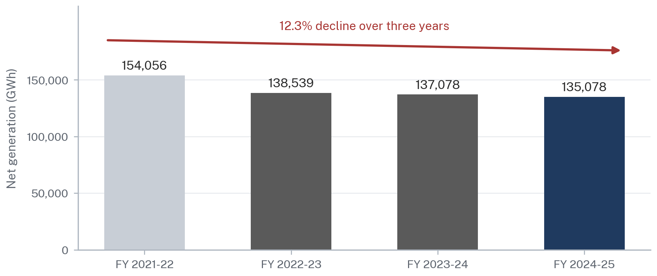
Source: NEPRA, State of Industry Report 2025. Figures are net generation on the national grid and exclude off-grid and net-metered self-generation.
Figure 1.
This is the paradox in its simplest form. Pakistan built generation capacity for a demand curve that did not arrive, financed it with contracts that pay whether or not the plant runs, priced the resulting cost into a tariff, and thereby drove away the demand that would have justified the capacity. Each turn of the cycle makes the next turn worse.
1.2 Installed Capacity versus Actual Utilisation
Installed capacity is a nameplate figure. It is what the plates on the machines say the machines could produce if everything worked, the fuel arrived, the water flowed, the network could carry the output and someone wanted to buy it. It is the least useful number in the Pakistani power debate and the most frequently quoted.
A more informative measure is average load. Net generation of 135,078 GWh spread across the 8,760 hours of a year corresponds to an average load of approximately 15,420 MW. Against installed capacity of 41,121 MW, that is a system-wide load factor of about 37.5%. Even measured against the reported peak of 33,000 MW, average load is under half. Pakistan is not running a power system at capacity. It is running a power system at slightly more than a third of capacity while paying for all of it.
Pakistan Runs a 41 GW Fleet at an Average Load of Roughly 15 GW
Installed generation capacity, reported peak demand and implied average load, FY 2024-25, MW
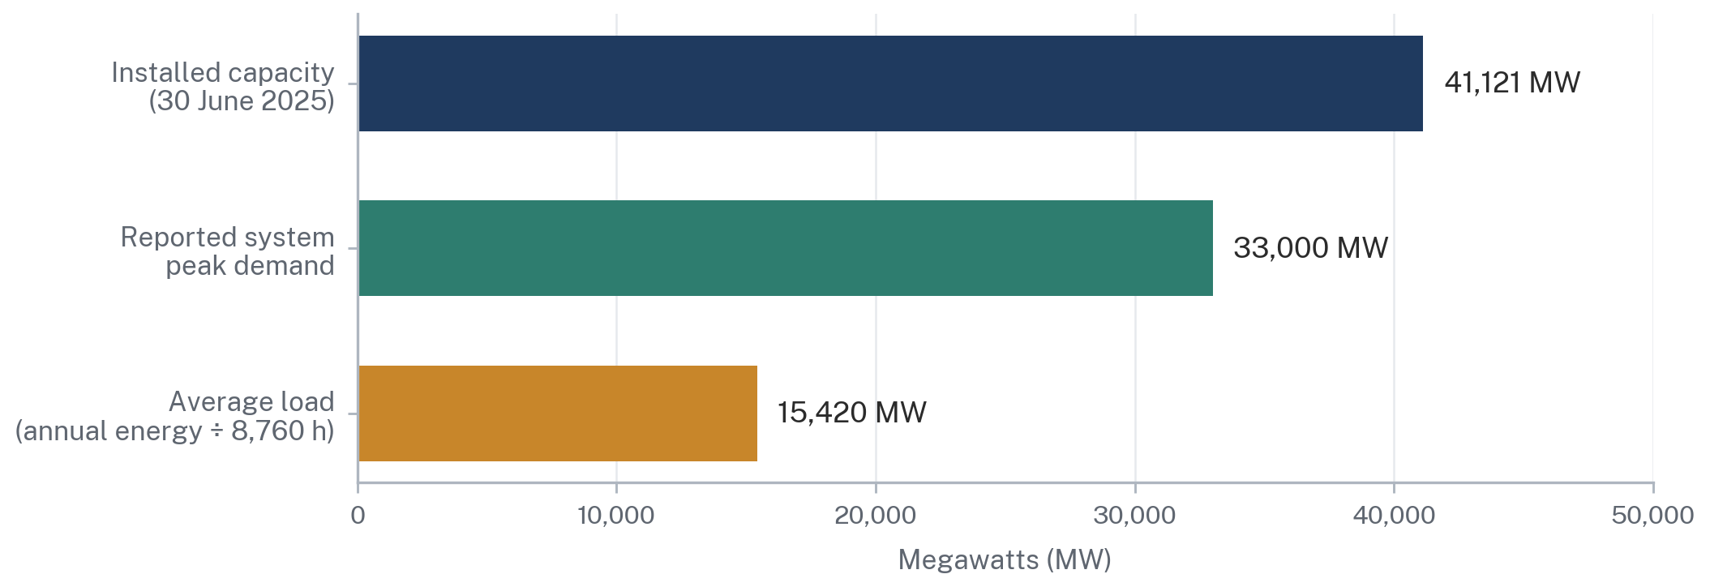
Source: NEPRA, State of Industry Report 2025, for installed capacity and peak demand. Average load is an ARS calculation from NEPRA's reported net generation of 135,078 GWh divided by 8,760 hours. Excludes captive and net-metered capacity.
Figure 2.
Two qualifications matter. Average load is not a target: no thermal system runs at a 100% load factor, because reserve margin, maintenance and the daily and seasonal shape of demand all require headroom. A well-run system might target a load factor in the region of 55% to 65%. Pakistan is well below any such benchmark. Second, published capacity figures vary by basis. Analysis presented by the Sustainable Development Policy Institute puts FY 2025 installed capacity at 46,605 MW against dependable capacity of 41,000 MW and peak demand of 28,306 MW, a nameplate-to-dependable gap of about 26% [7]. The discrepancies arise from whether K-Electric, captive plant and net-metered capacity are included, and from whether nameplate or dependable capacity is used. This report uses NEPRA's State of Industry Report 2025 figures as its primary basis and flags where an alternative basis would change the conclusion. On the central point, no basis changes the conclusion.
Fifty-Six Per Cent of the Fleet Is Thermal and Contracted on Availability
Installed generation capacity by source, 30 June 2025, MW and per cent of total
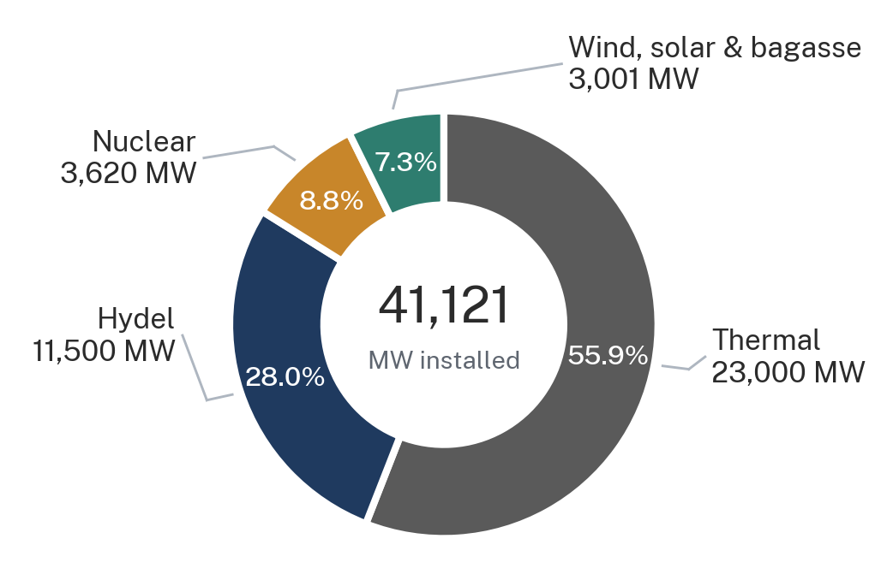
Source: NEPRA, State of Industry Report 2025; Renewables First, Pakistan Electricity Review 2026. Wind, solar and bagasse is an ARS residual after thermal, hydel and nuclear, reconciled to the reported 41,121 MW total.
Figure 3.
1.3 Peak Demand versus Base Load
A power system is dimensioned for its peak, not its average, which is why the ratio between the two matters so much. Pakistan's peak is summer-afternoon air conditioning load, concentrated in a few weeks, and its trough is a winter night. The system must hold plant available for a peak that occurs for a small number of hours and is then idle for most of the year, and the contracts under which that plant is held available pay for the holding rather than for the output.
Rooftop solar has now added a second problem to the first. Distributed solar generation hollows out midday net demand and leaves a steep evening ramp when output falls away, the pattern familiar internationally as the duck curve. Analysis of Pakistani dispatch data indicates that midday net load is depressed by several gigawatts with marginal cost collapsing into a low range, while the grid must then ramp several gigawatts within a few hours as solar drops in the late afternoon, with marginal cost spiking [7]. A system that is simultaneously over-capacitied on an annual basis and ramp-constrained on a daily basis is not a system with spare energy lying around. It is a system with a shape problem.
This is precisely why a data centre is a different kind of customer. A hyperscale campus is close to a pure base load: flat, predictable, running at a high load factor around the clock and around the year, with no seasonal peak and no ramp. It is the load shape that Pakistan's fleet was designed for and did not get. That is the strongest single argument for the proposition this report examines, and it is an argument about load shape rather than about surplus.
1.4 The Cost of Idle Capacity
The cost is quantifiable. For FY 2025-26, NEPRA determined a power purchase price of Rs 3,342.369 billion for the ex-WAPDA distribution companies. CPPA-G's petition projected capacity charges in a range of Rs 2.03 trillion to Rs 2.16 trillion, equivalent to between Rs 16.04 and Rs 16.45 per unit, and representing approximately 63% of the projected power purchase price [8]. Capacity payments had risen 46% year on year to Rs 1.9 trillion in the preceding cycle, with coal and nuclear plants accounting for the largest share of the increase [9].
Nearly Two Thirds of What Consumers Pay for Power Is Not for Electricity at All
NEPRA-determined power purchase price for the ex-WAPDA distribution companies, FY 2025-26, PKR billion
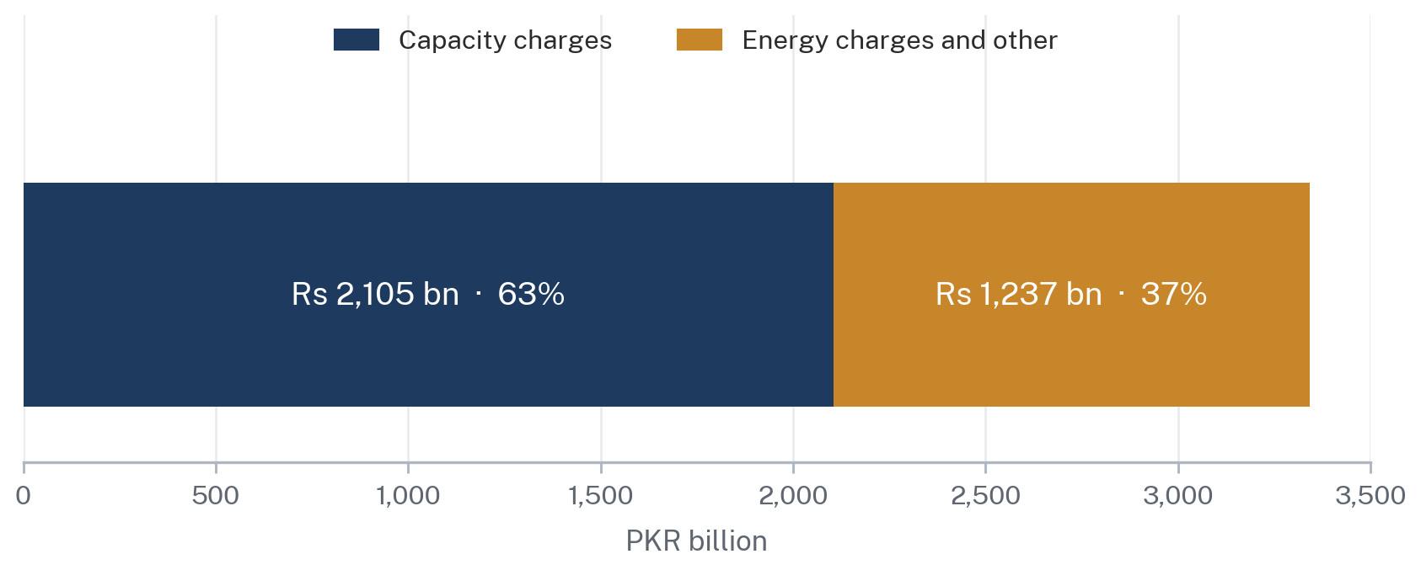
Source: NEPRA determination of the CPPA-G power purchase price forecast for FY 2025-26 of Rs 3,342.369 bn; CPPA-G projected capacity charge range of Rs 2.03-2.16 trn, approximately 63% of the projected power purchase price. The capacity figure shown is the midpoint of the CPPA-G scenario band.
Figure 4.
Two subsidiary costs deserve mention because they are specific to underutilisation. Part Load Adjustment Charges compensate plants required to run below their efficient output, and NEPRA has repeatedly flagged them: Rs 46.59 billion was incurred on PLAC in FY 2022-23 against Rs 38.20 billion the previous year [10]. Payments on account of non-project missed volume arise where a plant is available but not dispatched for reasons outside its control. Neither charge buys a single additional unit of electricity for a consumer. Both are the price of holding a fleet in a state of readiness that the demand curve does not require.
A further Rs 265 billion was attributable in FY 2024-25 to distribution company transmission and distribution losses, with a recovery shortfall of approximately Rs 132.46 billion against a bill recovery rate of 96.62% [3]. Distribution company performance contributed roughly Rs 397 billion to circular debt during the year [4]. NEPRA reported bill recovery of 96.62% against an allowed 100%.
1.5 Capacity Payments and Circular Debt
Circular debt is the residue of a system in which the contracted cost of power exceeds the revenue actually collected from consumers plus the subsidy actually paid by government. As at 30 June 2025 the stock stood at approximately Rs 1.614 trillion, down from Rs 2.393 trillion a year earlier [3]. That reduction of roughly Rs 780 billion has been the government's principal claim of reform success.
NEPRA was careful not to endorse the interpretation. The regulator cautioned that the decline did not reflect a structural improvement and noted that comparable falls in the past had been driven by temporary financial measures rather than lasting reform [3]. The Federal Minister for Energy disputed NEPRA's characterisation and offered a decomposition of the reduction: approximately Rs 193 billion from reduced distribution company losses, Rs 260 billion from renegotiated independent power producer contracts and around Rs 300 billion linked to macroeconomic improvement [35]. The Prime Minister's Office subsequently sought the Power Division's comments on the report following the ministry's objections.
The Rs 780 Billion Fall in Circular Debt Came Largely from Contract Renegotiation, Not Structural Repair
Movement in the circular debt stock, FY 2024-25, PKR billion
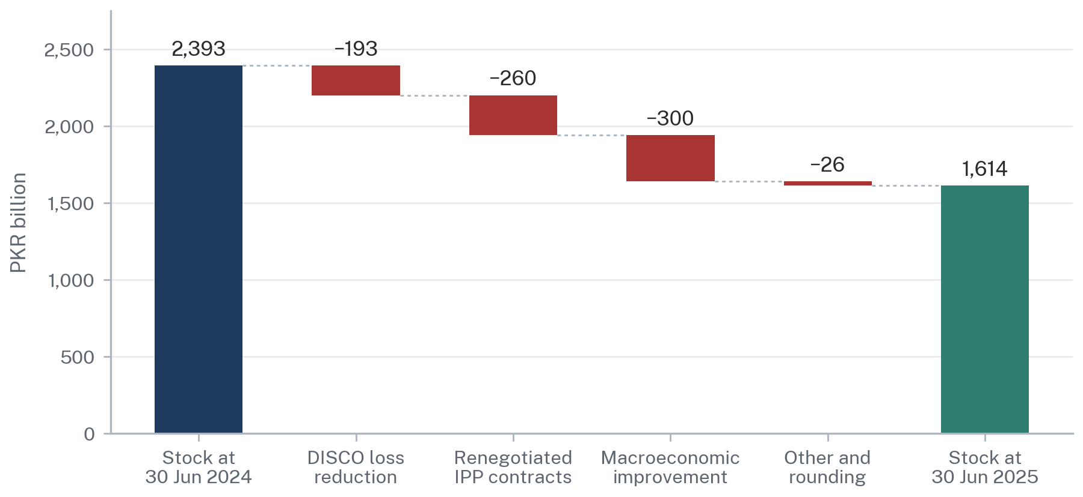
Source: NEPRA, State of Industry Report 2025, for the opening and closing stock. The decomposition is as attributed to the Federal Minister for Energy (Power Division) in response to the report; NEPRA itself cautioned that the reduction did not reflect a structural improvement. The residual is shown as rounding.
Figure 5.
For an investor the decomposition matters more than the headline. Two thirds of the reduction came from contract renegotiation and favourable macroeconomic movement, neither of which is repeatable at the same scale, and both of which are the kind of measure that a counterparty notices. A generator whose tariff was renegotiated once has learned something about the durability of its contract. So has the lender who financed it. This is directly relevant to Section 12: a state that has recently renegotiated its way out of Rs 260 billion of contractual obligation is a state that must work harder to persuade the next investor that the next contract will hold.
Servicing the remaining stock now runs through a Debt Servicing Surcharge, with NEPRA citing Rs 233 billion in this connection, and the government has indicated a six-year settlement plan [35]. The surcharge is levied on consumers. It therefore raises the tariff that drove the demand loss that created the problem.
1.6 Underused Capacity versus Actual Surplus Electricity
This distinction is the most important analytical point in Part One, and it is the one most often lost. Four different quantities are routinely described using the same word.
Four Quantities That Are Not the Same Thing
Definitions applied consistently throughout this report
Quantity | What it measures | FY 2024-25 | Relevance to a data centre
Installed capacity | Nameplate rating of all connected plant, irrespective of condition, fuel availability or network access | 41,121 MW | Almost none. It is an accounting figure.
Available capacity | Plant that can actually be dispatched at a given moment after outages, fuel constraints and hydrology | Varies hourly; materially below nameplate | The starting point for any reliability discussion.
Underutilised capacity | Available plant not dispatched because demand, merit order or network constraints do not call for it | Large; the Power Division has publicly referred to about 8,700 MW of surplus capacity [35] | This is the real opportunity, and it is a contractual opportunity.
Surplus electricity | Energy that can be delivered to a new load at a price at or near short-run marginal cost | Does not exist as a standing quantity | This is what promoters imply exists. It does not.
Source: ARS definitions, applied to NEPRA State of Industry Report 2025 figures for FY 2024-25. Figures rounded.
Table 1.
The plants that sit idle in Pakistan are, with limited exceptions, idle because they are expensive. Merit-order dispatch calls the cheapest available plant first. A plant that is not being dispatched is, by construction, one whose variable cost exceeds that of the plant being dispatched ahead of it. Adding a new 300 MW load to the system therefore does not draw on free electricity. It draws on the marginal plant, and the marginal plant in Pakistan is frequently imported-fuel thermal.
That does not defeat the argument. It reframes it. The gain from a new base load is not that the energy is free. The gain is that the capacity charge already being paid on the idle plant gets spread across a larger volume of units, so the average cost of the whole system falls even though the marginal cost of the new units is not low. The beneficiary of that spreading is the existing consumer base. The question of how much of that benefit is passed to the new consumer as a discount, and how much is retained to reduce the general tariff, is a regulatory design question that Section 10.2 addresses directly.
The Federal Government's own framing of its 2,000 MW allocation for bitcoin mining and AI data centres, announced in 2025, used the language of monetising surplus electricity and repurposing underutilised capacity into a revenue-generating asset, identifying underutilised coal plants operating at low capacity factors as the intended source [18]. The instinct is sound. The vocabulary is imprecise in ways that matter to a counterparty conducting due diligence, because a hyperscaler's energy team will immediately ask which specific plant, under which contract, at what tariff, delivered over which circuit, and with what remedy if it is not delivered. Part IV of this report takes those questions in order.
Where the Fleet Actually Ends Up: From 41 GW of Plant to About 12 GW of Collected Revenue
FY 2024-25, expressed on a common MW-equivalent basis
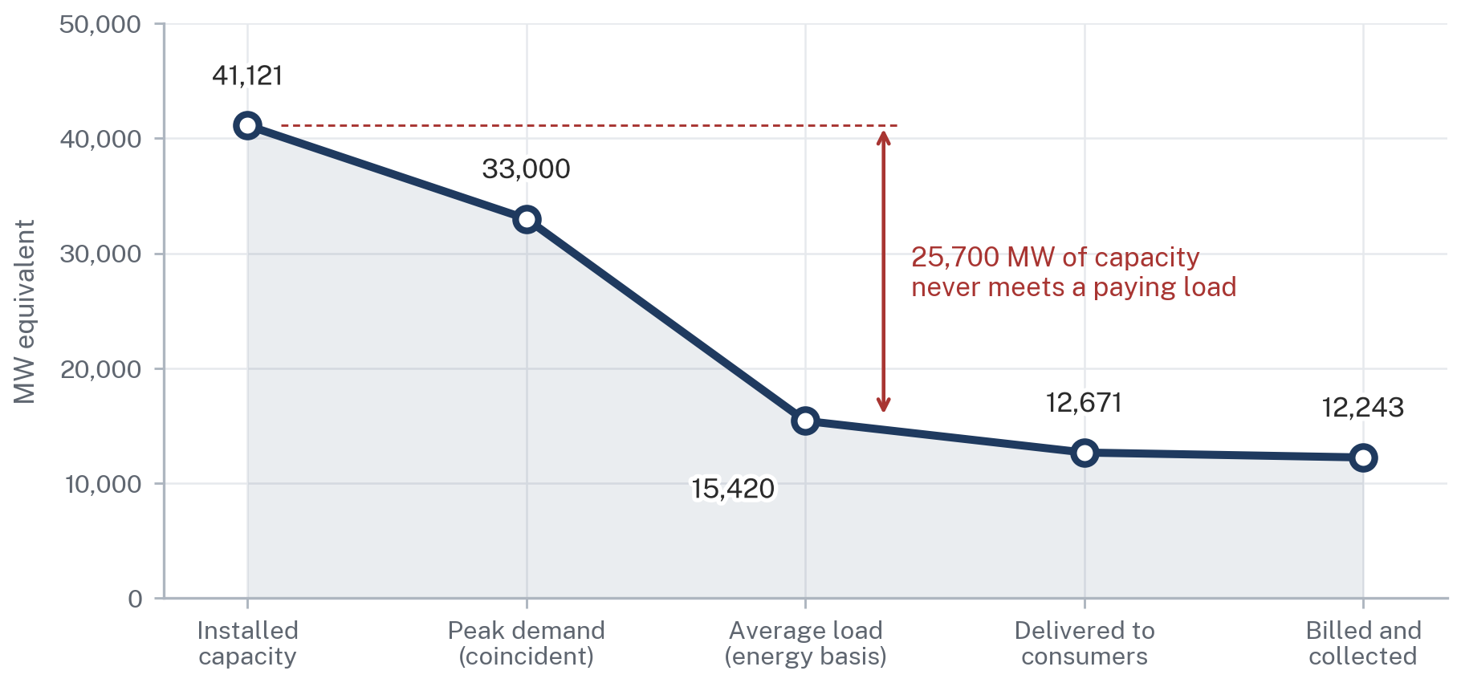
Source: NEPRA, State of Industry Report 2025; Renewables First, Pakistan Electricity Review 2026, for grid sales of 111 TWh. ARS calculation: energy quantities converted to average MW by dividing GWh by 8,760 hours; the collection stage applies NEPRA's reported recovery ratio of 96.62%. Illustrative reconciliation, not a NEPRA energy balance.
Figure 6.

2. The Independent Power Producer Model
2.1 How Pakistan's IPP System Works
Pakistan opened generation to private capital in 1994 and did so on terms designed to overcome a specific problem: a country with no regulatory track record, a history of currency depreciation and a state-owned offtaker of uncertain creditworthiness could not attract long-term foreign investment on ordinary commercial terms. The solution was to remove almost all commercial risk from the generator. Successive policies in 1994, 2002 and 2015 refined the structure without changing its logic.
The structure has three legs. A generator obtains a licence, now under section 14B of the NEPRA Act, to construct, own and operate a generation facility [2]. It signs a long-term power purchase agreement with a single buyer, historically WAPDA and subsequently the Central Power Purchasing Agency (Guarantee) Limited, which holds a market operator licence issued under section 23A and is governed under sections 23A and 23B [32]. The Federal Government provides an implementation agreement and, in most cases, a sovereign guarantee of the offtaker's payment obligations. NEPRA determines the tariff under section 31.
The distribution companies then buy from CPPA-G and sell to consumers. Since the 2018 Amendment Act, a distribution licence under section 20 and a supply licence under sections 23E and 23F are conceptually distinct, with existing distribution licensees deemed to hold supply licences for a transitional period under the proviso to section 23E(1) [2]. The market operator, system operator, trader and supplier categories inserted by that Act are the statutory scaffolding of a competitive market. The scaffolding was erected in 2018. The building has been under construction ever since.
How Money Moves Through Pakistan's Single-Buyer Power Market, and Where It Leaks
Contractual and payment architecture under the NEPRA Act, 1997 as amended; schematic, not to scale
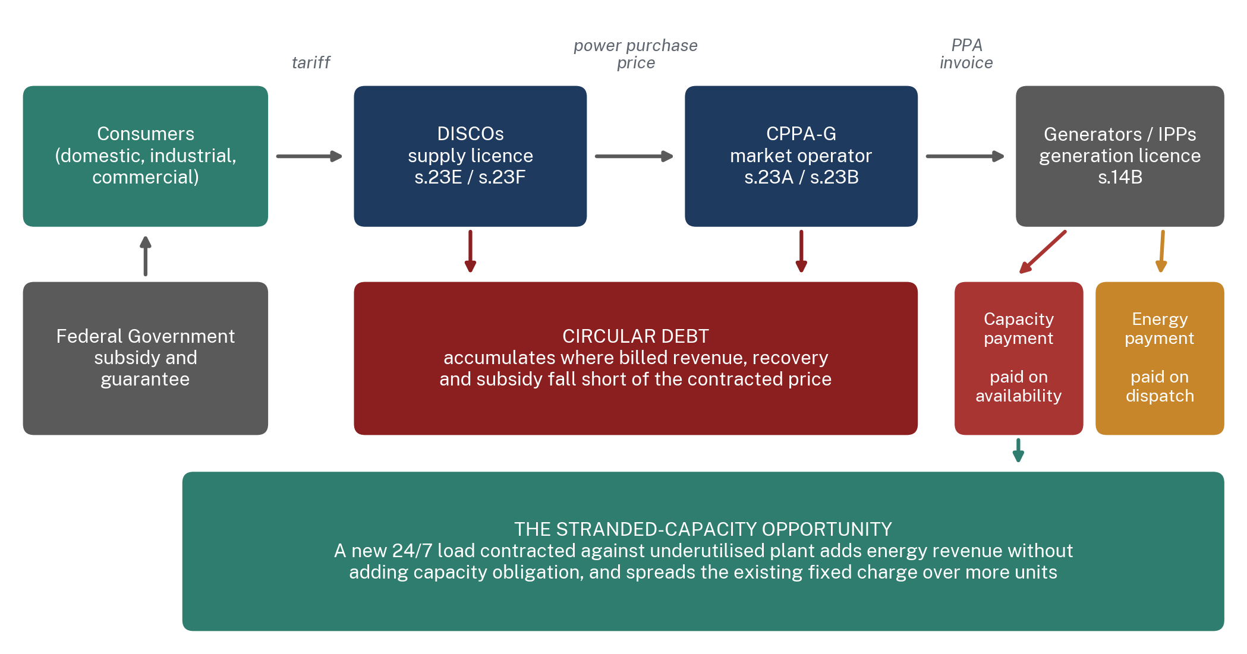
Source: ARS analysis of the Regulation of Generation, Transmission and Distribution of Electric Power Act, 1997 (as amended by Act XII of 2018), and NEPRA licensing and tariff determinations.
Figure 7.
2.2 Power Purchase Agreements and Capacity Payments
A Pakistani power purchase agreement splits the generator's remuneration into two components with entirely different economic logics, and understanding the split is essential to understanding everything that follows.
The Two Halves of an IPP Tariff
Structural comparison of the capacity and energy components under Pakistan's standard PPA architecture
Feature | Capacity payment (capacity purchase price) | Energy payment (energy purchase price)
Trigger | Plant declared available for dispatch | Units actually dispatched and delivered
Recovers | Debt service, return on equity, fixed operation and maintenance, insurance | Fuel cost, variable operation and maintenance
Sensitivity to output | None. Payable at zero dispatch if availability is maintained | Directly proportional to units generated
Currency exposure | Substantially indexed to the US dollar for foreign-financed plant | Indexed to fuel price, itself often dollar-denominated for imported fuel
Effect of adding a new load | Unchanged in total; falls sharply per unit delivered | Rises in proportion to units taken
Who bears the risk of low demand | The consumer, through tariff, and the state, through subsidy and circular debt | Nobody. The cost simply is not incurred
Source: ARS analysis of the standard PPA structure applied under Pakistan's 1994, 2002 and 2015 power policies and NEPRA tariff determinations. Indicative and structural; specific PPAs vary materially by vintage, technology and sponsor.
Table 2.
The consequence is that Pakistan's electricity cost structure is dominated by a charge that is entirely insensitive to how much electricity anyone uses. This is why the tariff cannot be reduced by using less electricity, and why every reduction in demand raises the per-unit cost for those who remain. It is also why a large new base load is worth more to the system than its own consumption would suggest.
2.3 Energy Payments versus Capacity Payments in Practice
At the FY 2025-26 projection, capacity charges of Rs 2.03 trillion to Rs 2.16 trillion translate to between Rs 16.04 and Rs 16.45 per unit against a determined national average tariff of Rs 34 per unit [8][19]. Close to half the headline tariff is the capacity charge alone, before energy, before transmission and distribution, before the distribution margin, before the debt servicing surcharge and before general sales tax.
A hyperscaler evaluating Pakistan will read that as follows. The variable cost of electricity in Pakistan is not internationally uncompetitive. The all-in tariff is. The gap between the two is a fixed charge levied to recover the cost of plant that exists because of a demand forecast that failed. Whether any portion of that gap can be lawfully and durably excluded from the price offered to a new large load is, in the end, the single commercial question on which this entire proposition turns. It is a question of regulatory design and statutory authority, not of engineering, and Section 10 of this report answers it.
2.4 Take-or-Pay: What It Actually Means
The phrase take-or-pay is used loosely in Pakistani public debate and the looseness obscures the legal position. In the standard Pakistani structure, the offtaker's obligation is not to take a specified volume of energy. It is to pay the capacity charge in respect of capacity that the generator has declared and made available, whether or not the system operator calls upon that capacity. The generator's obligation is availability, not output. Where the plant is unavailable, liquidated damages apply and the capacity payment is reduced or forfeited in accordance with the agreed availability mechanics.
This distinction has practical consequences. It means the offtaker cannot escape the charge by declining to dispatch, but it also means the generator earns nothing extra by being dispatched more, beyond recovery of its variable costs. Neither party has a contractual interest in higher utilisation. The generator is indifferent. The offtaker prefers lower utilisation, because dispatch adds fuel cost. Only the consumer and the state, who bear the fixed charge, have an interest in the plant running more. Neither of them is a party to the agreement.
That misalignment is the contractual root of the stranded-capacity problem, and it explains why the problem has proved so durable. It also explains why the government's route out has been renegotiation and termination rather than utilisation. In FY 2024-25 contracts covering 2,829 MW were terminated, with NEPRA estimating potential savings above Rs 900 billion, and the Power Division has stated that negotiations with independent power producers produced terminations or revisions across several contracts, with roughly Rs 260 billion of the circular debt reduction attributed to renegotiated IPP contracts and around 8,000 MW of expensive future projects removed from the plan [3][35].
2.5 Dispatch and Merit Order
Dispatch in Pakistan is not a matter of contract but of statute and system operation. Section 14B(4) of the NEPRA Act requires a generation licensee connected to the national grid to make the facility available to the national grid company for safe, reliable, non-discriminatory and economic dispatch, subject to compensation fixed by the Authority for voltage support and uneconomic dispatch. Section 14D(2) imposes a materially identical duty by reference to the system operator [2]. Section 23G, in force following the 2018 Amendment Act, establishes the system operator licence and lists generation scheduling, commitment and dispatch, transmission congestion management and procurement of ancillary services among its functions.
Economic dispatch means merit order: the system operator calls plant in ascending order of variable cost, subject to must-run obligations, network constraints and technical minimums. The critical implication for this report is that a data centre cannot, merely by contracting with a particular generator, cause that generator to be dispatched. Dispatch is a system function. A bilateral contract between a generator and a consumer is, in a wheeling or bilateral-contract market, a financial and commercial arrangement settled against physical flows that the system operator determines. Confusing the contract with the physics is one of the most common errors in this debate, and it has direct consequences for how a curtailment clause must be drafted.
2.6 Why Plants Are Paid When They Are Not Fully Dispatched
Several mechanisms operate simultaneously and it is worth separating them, because they attract different remedies.
Why Payment and Output Diverge
Mechanisms by which Pakistani generators receive payment without corresponding dispatch
Mechanism | What happens | Character of the remedy
Capacity payment on available but undispatched plant | The plant declares availability, is not called, and is paid the full capacity charge | Contractual. Requires renegotiation or new load
Part Load Adjustment Charges | A plant is dispatched below efficient output and compensated for the efficiency penalty. Rs 46.59 bn in FY 2022-23 | Operational. Better load management and time-of-use tariffs
Non-project missed volume | Plant available but not dispatched for reasons outside the generator's control, including network constraint | Network. Requires transmission investment
Must-run status | Nuclear, certain hydro and some contracted plant dispatched ahead of merit order | Structural. Reflects technology and contract, not inefficiency
Transmission constraint | Cheap southern generation cannot reach northern load; costlier northern plant runs instead | Network. Requires corridor reinforcement
Source: ARS analysis of NEPRA State of Industry Reports 2023, 2024 and 2025, and the NEPRA Act, 1997 as amended. PLAC figure is for FY 2022-23, the most recent year for which a discrete published figure was located.
Table 3.
The last of these is the one most often overlooked and it is the one most relevant to siting. Pakistan's cheapest thermal generation is concentrated in the south and its largest hydro in the north, while load is distributed across both. The north-south corridor is the constraint. The Matiari to Lahore HVDC link was designed for 4,000 MW but has been reported operating at around 1,400 MW, roughly 35% of design rating, on account of converter station faults, while three 500 kV HVAC circuits reach a thermal ceiling of approximately 4,500 MW northward, with the result that a reported 1,845 MW of southern generation is constrained off daily [7]. NEPRA's own Performance Evaluation Report for transmission in FY 2024-25 records congestion and overloading of 500 kV and 220 kV grid stations and lines, and attributes delays to right-of-way disputes, land acquisition, foreign exchange constraints, funding shortfalls and security concerns [20].
The North-South Corridor Is Where Cheap Southern Power Stops Being Deliverable
Reported transmission capability on Pakistan's principal evacuation corridor, MW
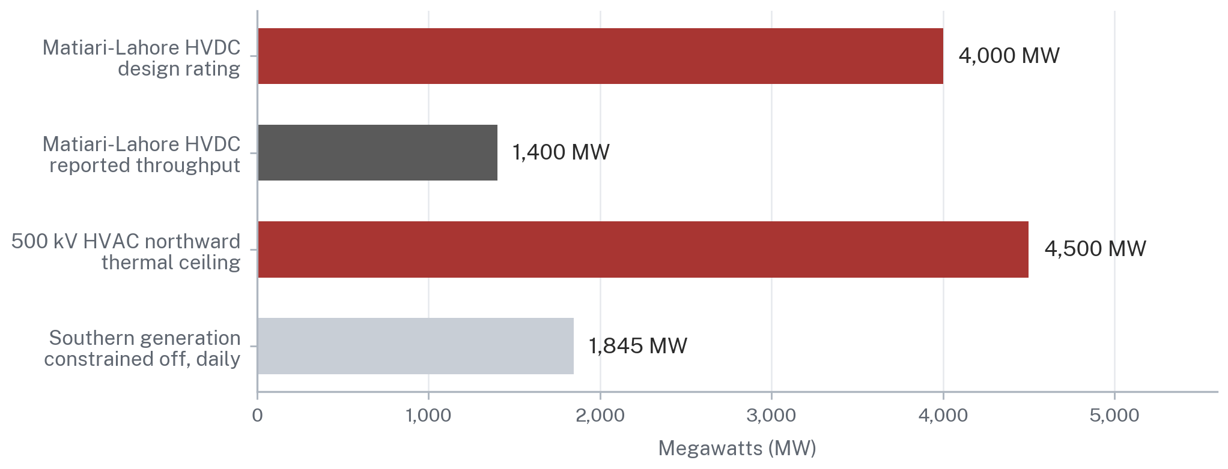
Source: Sustainable Development Policy Institute analysis of the NTDC Transmission System Expansion Plan 2025-35 and NEPRA State of Industry Report 2025, presented at UNESCAP; NEPRA Performance Evaluation Report, Transmission, FY 2024-25. HVDC throughput reflects reported converter station faults and is an operational, not a design, limitation.
Figure 8.
The Asian Development Bank approved a USD 330 million Second Power Transmission Strengthening Project in November 2025, comprising a new 500 kV line of approximately 290 km together with grid upgrades serving Islamabad and Faisalabad, intended to enable evacuation and transfer of up to 3,200 MW of hydropower from northern generation clusters [22]. The World Bank has separately emphasised that unbundling of the National Transmission and Despatch Company, announced by the government in November 2024, is central to establishing a well-governed and creditworthy transmission system operator [23]. NTDC now operates as the National Grid Company. These are the right measures. They are also multi-year measures, and a hyperscaler siting a campus in 2027 cannot underwrite against a corridor that will be reinforced in 2030.
2.7 The Stranded-Capacity Opportunity
With the mechanics established, the opportunity can be stated precisely rather than rhetorically.
A plant carrying a fixed capacity charge delivers energy at a total cost per unit equal to the variable energy cost plus the fixed charge divided by units delivered. The second term is a hyperbola. At low utilisation it dominates completely; at high utilisation it approaches insignificance. On an illustrative basis, using a capacity charge of Rs 2.0 million per MW per month and a variable energy charge of Rs 10 per kWh, a plant running at 12% load factor delivers at roughly Rs 32.8 per unit, while the same plant at 85% load factor delivers at roughly Rs 13.2 per unit. The plant is identical. The contract is identical. Only the utilisation has changed.
Adding Utilisation, Not Adding Plant, Is What Lowers the Cost of Pakistani Electricity
Delivered cost per unit for a plant carrying a fixed capacity charge, by load factor, Rs/kWh
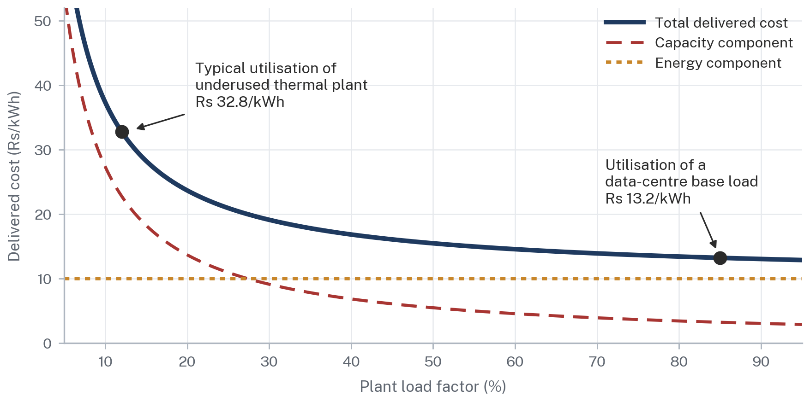
Source: ARS illustrative model, not a plant-specific tariff. Assumes a capacity charge of Rs 2.0 million per MW per month and a variable energy charge of Rs 10 per kWh, both held constant. Real Pakistani tariffs are plant-specific, partly indexed to the US dollar and determined by NEPRA.
Figure 9.
Four conditions must hold for this arithmetic to translate into a real gain, and each of them is a legal or regulatory condition rather than a commercial one.
The first is that the new load must not trigger any new capacity obligation. If serving a 300 MW data centre requires new plant to be contracted, the system has simply repeated its original mistake at a new address. The load must be served from existing available capacity, which means the contracting structure must be capable of identifying and committing that capacity.
The second is that the new load must pay a price that exceeds short-run marginal cost by enough to make a real contribution to the fixed charge. A tariff set at or near marginal cost transfers the benefit entirely to the data centre and leaves the general consumer no better off, which is politically unsustainable and, given NEPRA's obligations under section 31(2) to protect consumers against monopolistic pricing and to eliminate economic distortions, regulatorily contestable.
The third is that the energy must be physically deliverable to the site. Contracting against a southern plant to serve a northern campus across a constrained corridor produces a financial arrangement that the system cannot honour physically, and the resulting curtailment risk sits with somebody.
The fourth is that the arrangement must be durable for the term of the investment. A data centre is a fifteen to twenty-five year asset financed on long-term debt. An arrangement that depends on a tariff concession renewable annually, or on a wheeling charge set by administrative decision, is not an arrangement a lender will underwrite.
WHERE THIS LEAVES THE ARGUMENT
The stranded-capacity opportunity is real, and it is larger than most public discussion recognises. But it is not an opportunity in electricity. It is an opportunity in contract design, and it can only be captured if Pakistani law allows a specific generator and a specific consumer to commit to each other for a specific term at a specific price, across a network at a charge that neither of them controls. Sections 8 and 9 examine whether it does.

PART II
WHO CAN SUPPLY POWER?
3. Captive Power: Can Data Centres Go It Alone?
3.1 What Captive Power Is
The NEPRA Act defines a captive generating plant, at section 2(iia) inserted by the 2018 Amendment Act, as a power plant set up by any person to generate electricity primarily for his own use, including a plant set up by a cooperative society or association of persons for the use of its members [2]. The definitional pivot is the words "primarily for his own use". A captive plant is not a business selling electricity. It is a consumer generating for itself, and the whole regulatory treatment follows from that.
The attraction for a large industrial user has always been the same. Self-generation escapes the tariff, and therefore escapes the cross-subsidies, the capacity charge on plant the user did not commission, the debt servicing surcharge and the general sales tax embedded in the electricity bill. In a country where the national average tariff for FY 2025-26 was determined at Rs 34 per unit, that escape has been worth a great deal, which is precisely why the state has moved to close it.
3.2 Pakistan's Captive Generation Framework
Section 14C is short and unusually important, and it is worth reading closely because it does two different things.
Subsection (1) provides that notwithstanding anything contained in the Act, a person may construct, maintain or operate a captive generating plant and dedicated transmission lines, with a proviso that supply from the captive plant through the grid is regulated in the same manner as the generating facility of a generating company. The effect is that behind-the-meter self-generation sits largely outside the licensing regime, but the moment the plant exports through the public network it is regulated as an ordinary generator.
Subsection (2) is the provision that matters commercially. Every person who has constructed and operates a captive generating plant "shall have the right to open access for the purposes of carrying electricity from his captive generating plant to the destination of his use". This is drafted as a right, in mandatory language, which is materially stronger than the permissive drafting of section 22. But it is immediately qualified. The right is subject to availability of adequate transmission facility, and that availability "shall be determined by the national grid company or the provincial grid company, as the case may be". Any dispute regarding availability is to be adjudicated by the Authority [2].
For a project lawyer this is the crux. Section 14C(2) creates a statutory right whose exercise is conditioned on a determination made by the very entity whose network is being accessed, with recourse only to a regulator whose determination is then appealable under section 12G to the Appellate Tribunal and thereafter to the High Court. The right exists. The timeline for vindicating it does not. A data centre developer holding a construction programme cannot wait out a determination, an appeal to the Appellate Tribunal within its three-month statutory window under section 12G(1), and a further appeal to the High Court under section 12G(6). Section 10.1 proposes a specific remedy directed at this precise sequencing problem.
3.3 Industrial Self-Generation and the New Fiscal Position
Captive generation in Pakistan has historically been gas-fired, concentrated in textiles and heavy manufacturing, and supplied through SNGPL and SSGCL. That position has been changed by statute rather than by regulation, and the change is recent, deliberate and escalating.
The Off the Grid (Captive Power Plants) Levy Ordinance, 2025 was promulgated on 30 January 2025 and re-promulgated in March 2025, and was replaced by the Off the Grid (Captive Power Plants) Levy Act, 2025 (Act XIV of 2025), notified in the Gazette on 10 June 2025 [12][13]. Section 2(e) defines the levy as an off-the-grid charge on natural gas or RLNG-based captive power plants. Section 3 requires every captive power plant to pay the levy to the Federal Government on consumption of natural gas or RLNG, over and above the sale price notified under sections 8 and 43B of the Oil and Gas Regulatory Authority Ordinance, 2002.
Section 4 is the operative pricing provision and it is unusually explicit about intent. Before notifying the levy, the relevant Divisions are to calculate the rate by taking into account the difference between the industrial B3 power tariff notified by NEPRA and the self-generation cost of the captive plant at OGRA-notified gas tariffs. In other words, the levy is calibrated by statute to close the arbitrage between self-generation and grid supply. The rate steps up by 5% immediately, 10% from July 2025, 15% from February 2026 and 20% from August 2026 [13]. Section 5 directs the proceeds to reducing generation tariffs for consumer categories, with an annual report to both Houses three months after the close of each financial year, and section 6 makes unpaid levy recoverable under the Public Finance Management Act, 2019.
Parliament Has Legislated Gas-Fired Captive Generation Into Retreat
Notified off-the-grid levy on natural gas and RLNG consumed by captive power plants, Rs per MMBtu
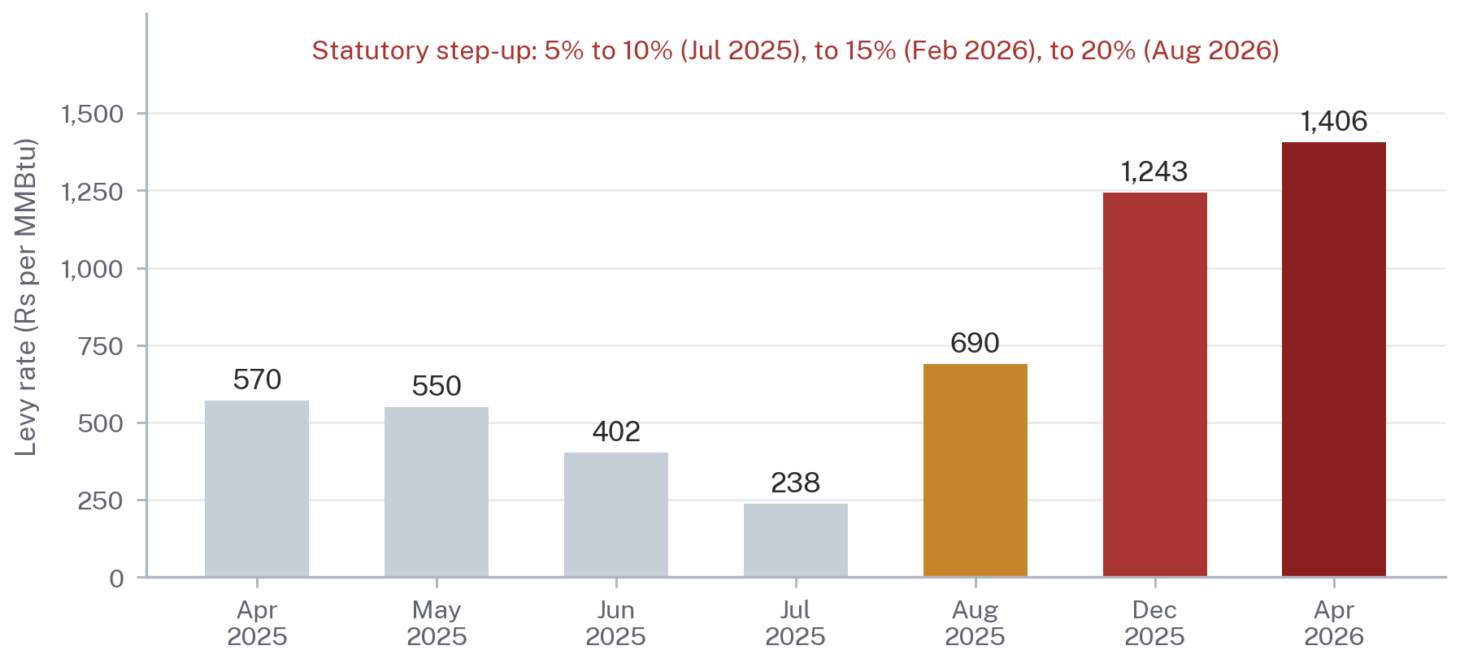
Source: Off the Grid (Captive Power Plants) Levy Act, 2025 (Act XIV of 2025), sections 3 and 4; Petroleum Division notifications. The Act sets the levy by reference to the gap between NEPRA's B3 industrial tariff and the captive plant's own generation cost at OGRA-notified gas prices, stepping up to 20% from August 2026.
Figure 10.
The notified rates trace the escalation. Rs 238 per MMBtu was notified in July 2025 in fulfilment of an International Monetary Fund structural benchmark, rising to Rs 690 in August 2025, Rs 1,243 for December 2025, and Rs 1,406 by April 2026 following a Rs 163 increase [12][14][24]. In January 2026 the levy was extended to third-party gas suppliers after consultation with the Ministry of Law and Justice, closing the route by which a captive plant could source gas outside the SNGPL and SSGCL networks [13].
THE LEGAL POINT, STATED PRECISELY
Gas-fired captive generation for a data centre in Pakistan is lawful. Sections 2(iia) and 14C of the NEPRA Act permit it and no licence is required for behind-the-meter operation. But Parliament has enacted a levy whose stated statutory formula is the gap between grid and self-generation cost, and which steps up to 20% from August 2026. The commercial case is being legislated away by design, not by accident. Any financial model that projects gas-fired captive economics across a fifteen-year data-centre life is modelling against a declared legislative trajectory.

3.4 Solar, Gas, Storage and Hybrid Generation
The non-gas captive routes are worth assessing on their own terms rather than by analogy to rooftop solar.
Solar photovoltaic generation is now genuinely cheap in Pakistan and the deployment figures prove that the market works. Cumulative net-metered capacity reached approximately 5.3 GW by April 2025 and a projected 6.3 GW by the close of FY 2024-25 [6]. But net metering is a settlement arrangement for a consumer whose consumption and generation both sit behind a distribution meter, and the regime has been shifting toward net billing, under which exports are compensated at a materially lower rate than imports. That shift changes the economics of oversizing an array, and it is not a framework designed for a 300 MW industrial load.
The physical requirement is the point most often understated. A solar array sized to serve a 100 MW continuous IT load must be sized not for 100 MW but for the load divided by its capacity factor, which in most of Pakistan means an array in the region of 400 MW to 500 MW of direct-current capacity, occupying something on the order of 1,200 to 2,000 acres depending on technology and layout, together with battery storage sufficient to carry the load through the night and through consecutive low-irradiance days. The storage requirement, not the array, is what breaks the budget. A 100 MW load requires on the order of 1,400 MWh of usable storage to cover a fourteen-hour non-generating period at full load, before any allowance for degradation, round-trip losses or reserve.
This is not an argument against solar. It is an argument that solar plus storage is a firming technology and a cost-reduction technology within a hybrid architecture, and not a standalone supply solution for a hyperscale campus at Pakistani capital costs. The same conclusion holds in most jurisdictions. It holds more strongly in Pakistan because of the cost of capital.
3.5 Captive versus Grid Procurement: A Structured Comparison
The following assessment scores four routes on six dimensions a hyperscaler's investment committee would apply. The scoring is an ARS analytical judgement applied consistently across routes on a common one-to-five scale. It is not a measurement, and the report states the criteria so the reader can disagree with a specific score rather than with the exercise.
Price certainty asks whether the developer can know the cost per unit for the term of its investment. Delivery reliability asks whether the route can meet a contracted availability above 99.9% at the meter. Legal certainty asks whether the right to procure rests on statute, on subordinate regulation, or on the exercise of administrative discretion. Scalability asks whether the route extends from 100 MW to 300 MW and beyond without a change of legal basis. Speed to implement asks how long from decision to energisation. Lender bankability asks whether an international project finance lender would accept the arrangement as security without a sovereign wrap.
No Single Procurement Route Scores Well on Every Dimension a Hyperscaler Tests
ARS assessment of four routes to power a large load in Pakistan, scored 1 (weak) to 5 (strong)
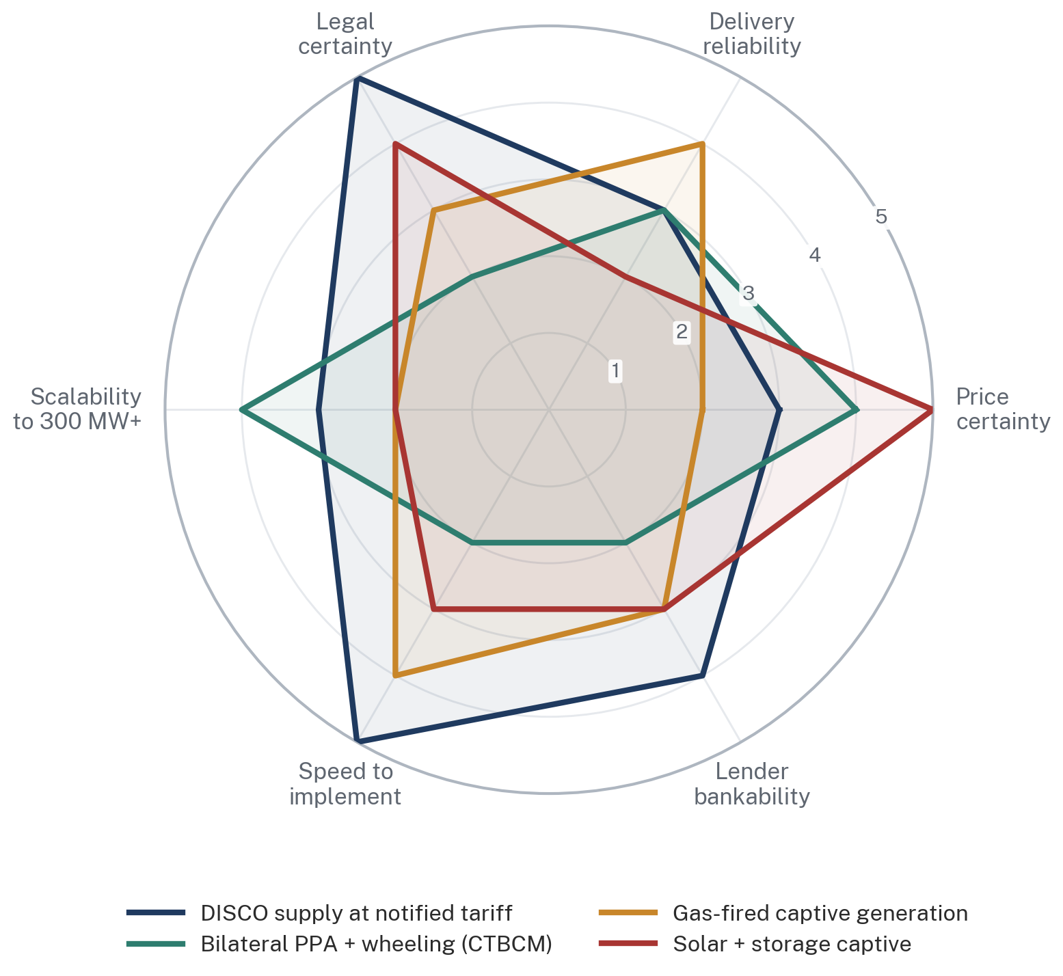
Source: ARS assessment. Scores are analytical judgements applied consistently across routes on a common 1-5 scale, not measured values. Legal certainty reflects whether the right rests on statute, on regulation, or on regulatory discretion. The methodology is set out in Section 3.5.
Figure 11.
Power Procurement Routes for a Large Load in Pakistan
Legal basis, commercial character and principal constraint of each available route
Route | Principal legal basis | What it delivers today | Binding constraint
DISCO or supplier at notified tariff | ss. 20, 23E, 23F; s. 31 tariff determination | Immediate, legally uncomplicated supply at the regulated industrial tariff | Price. Carries the full capacity charge, cross-subsidy and surcharges
Direct sale to a bulk power consumer | s. 22, read with the proviso to s. 21(2)(a) | A statutory pathway for generator-to-consumer sale above 1 MW | Section 22 says the Authority "may permit". It is a discretion, not a right
Bilateral contract with wheeling | Wheeling Regulations, 2016 (SRO 549(I)/2016); CTBCM market rules | Competitive energy pricing from a chosen generator, wheeled to site | Use-of-system charges set administratively; capacity allocation and curtailment risk unresolved
Supply via a licensed electric power trader | ss. 23C and 23D | A licensed intermediary able to contract bilaterally and hold wheeling agreements | Thin market. s. 23D(2)(d) requires agreements with transmission and distribution licensees
Captive generation on site | ss. 2(iia) and 14C | Full control of the asset and escape from the tariff stack | Gas route penalised by Act XIV of 2025; solar route constrained by land and storage cost
Hybrid of contracted, grid and on-site supply | All of the above simultaneously | The only configuration meeting both price and reliability tests | Requires every one of the above legal bases to work at once
Source: ARS analysis of the NEPRA Act, 1997 as amended, the NEPRA (Wheeling of Electric Power) Regulations, 2016, and the CTBCM design as approved by NEPRA. Assessment of bankability is an ARS judgement, not a measurement.
Table 4.
3.6 Advantages and Limitations for a Data Centre Specifically
Three characteristics of data-centre load distinguish it from ordinary industrial load and change the captive calculus.
The first is that the reliability requirement is extreme and asymmetric. An industrial plant that loses power loses a shift. A data centre that loses power loses customer trust, contractual service credits and, in the case of AI training workloads, potentially weeks of computation. Design availability is typically expressed in the region of 99.98% or higher at the point of delivery, which is a permitted outage measured in tens of minutes per year. No single supply route in Pakistan meets that standard on its own. Redundancy is not optional and it is expensive.
The second is that the load is constant, which is unusual and valuable. It means the campus is a perfect base-load customer, but it also means there is no operational flexibility to offer the system in exchange for a better price, at least for training and inference workloads under service-level commitments. Demand response, which is often the currency in which large loads buy favourable terms elsewhere, is largely unavailable here.
The third is that a hyperscale operator does not want to be a power company. Building and operating 400 MW of captive generation is a separate business with separate skills, separate regulatory exposure and separate capital. The commercial preference, everywhere in the world, is to contract for power rather than to build it. Pakistan will not attract hyperscale investment by offering an investor the opportunity to become a Pakistani independent power producer. It will attract it by offering a contract.
3.7 The Case for a Hybrid Architecture
The conclusion of this section is that no single route works and the correct configuration is a hybrid in which each leg carries the risk it is best placed to carry.
Contracted generation, whether hydro or efficient thermal, provides the bulk of the energy at a negotiated price under a long-term bilateral agreement. Grid supply from a licensed supplier or distribution company provides firming, backup and the balancing service that makes the contracted leg deliverable at constant load. On-site solar with storage reduces the average cost, provides ride-through for short interruptions and improves the emissions profile that a hyperscaler's own procurement policy will require. On-site backup generation and uninterruptible power supply provide the final layer of protection at the campus boundary.
A Hybrid Architecture Is the Only Configuration That Meets Both the Price and the Reliability Test
Indicative supply architecture for a 100 MW-plus campus in Pakistan; schematic, not an engineering design
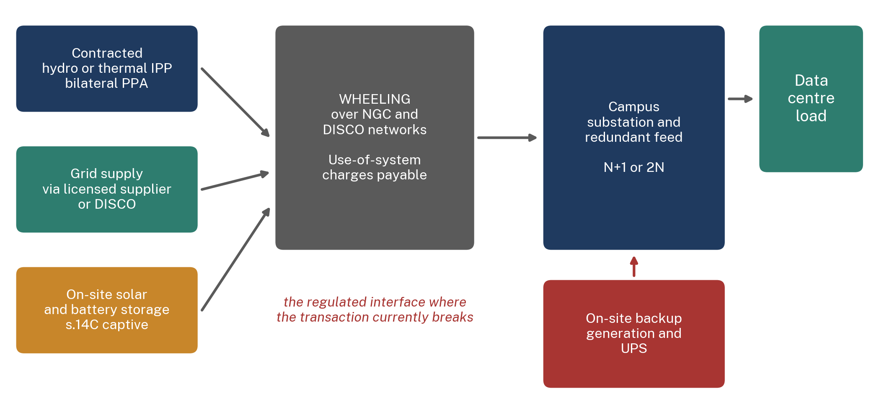
Source: ARS analysis. Each leg rests on a different legal instrument: the bilateral PPA on sections 14D and 23C to 23F of the NEPRA Act, wheeling on the NEPRA (Wheeling of Electric Power) Regulations, 2016, and on-site generation on section 14C.
Figure 12.
Each leg of that architecture rests on a different legal instrument, and this is the substantive difficulty. The bilateral leg depends on sections 14D and 23C to 23F and on the wheeling regulations. The firming leg depends on a supply licensee's willingness to contract for standby at a defined charge. The on-site leg depends on section 14C. The interface between them, and specifically the point at which wheeled power crosses onto the National Grid Company and distribution networks, is where the transaction currently breaks. That interface is the subject of Part IV.

4. Hydropower: Pakistan's Natural Advantage, Correctly Stated
4.1 The Endowment
Pakistan's hydropower endowment is genuine, large and geographically concentrated. The Indus and its western tributaries fall from the Karakoram, Himalaya and Hindu Kush across some of the steepest exploitable gradients in Asia. Installed hydel capacity stood at approximately 11,500 MW at 30 June 2025, roughly 28% of the national fleet, and rose during FY 2024-25 with new plant additions even as thermal capacity fell by 19.5% [5]. NEPRA's own assessment of hydel potential records the resource as heavily concentrated in Khyber Pakhtunkhwa, Azad Jammu and Kashmir, Gilgit-Baltistan and northern Punjab [26].
The strategic attraction is straightforward. Hydro generation has no fuel cost, is not exposed to imported fuel prices, and is not exposed to the exchange-rate risk that runs through the fuel component of Pakistan's thermal tariff. In a country whose electricity cost problem is substantially a foreign-currency problem, that matters.
4.2 Existing Projects
Principal Hydropower Assets and the Construction Pipeline
Installed and under-construction capacity, by owner category and location
Project | Capacity (MW) | Location | Type | Status
Tarbela (Units 1-14) | 3,478 | KP / Punjab | Storage | Operating since 1976 onward
Ghazi Barotha | 1,450 | Punjab | Run-of-river | Operating
Tarbela 4th Extension | 1,410 | KP | Storage | Operating
Mangla | 1,000 | AJK | Storage | Operating; refurbishment adding 310 MW
Neelum-Jhelum | 969 | AJK | Run-of-river | Shut since 2 April 2024; restoration targeted March 2028
Suki Kinari | 884 | KP | Run-of-river | Operating since September 2024; CPEC IPP
Karot | 720 | Punjab | Run-of-river | Operating since June 2022; CPEC IPP
Warsak | 243 | KP | Run-of-river | Operating
Chashma | 184 | Punjab | Canal / low head | Operating
Diamer Basha | 4,500 | KP / GB | Storage | Under construction; target February 2029
Dasu Stage-I | 2,160 | KP | Run-of-river | Under construction; target December 2027
Tarbela 5th Extension | 1,530 | KP | Storage | Under construction; target December 2026
Mohmand | 800 | KP | Storage | Under construction; target 2027
Source: Sources: WAPDA project and generation reporting for calendar year 2025; NEPRA hydel potential assessment; Senate Standing Committee on Water Resources briefing of 10 July 2026 for Neelum-Jhelum. Target dates are as stated by the executing agency. Neelum-Jhelum is a restoration of existing capacity, not a net addition.
Table 5.
4.3 Run-of-River versus Storage
The distinction determines whether a hydro plant can sell firm power, and it is routinely elided in Pakistani policy discussion.
A storage plant impounds water behind a dam and can therefore shift generation across days, weeks or seasons. Tarbela and Mangla are storage plants, although both are operated primarily as irrigation reservoirs, which means their generation follows the irrigation release schedule set by the Indus River System Authority rather than the merit order. Their operator does not fully control their output.
A run-of-river plant generates from the flow available at the moment. It has limited or no meaningful storage and its output tracks the hydrograph. Karot, Suki Kinari and Neelum-Jhelum are run-of-river schemes, as is Dasu Stage-I. Their annual energy is substantial and their winter output is not. A run-of-river plant cannot contract to deliver a flat 100 MW in January because in January the river does not carry the water.
For a data-centre power contract this is decisive. Annual energy is not what a hyperscaler buys. It buys availability at every hour. A generator can sell that only if it can either store water or buy firming from elsewhere, and the cost of that firming, not the cost of the hydro energy, sets the price of the delivered product.
4.4 Hydropower Economics
WAPDA generated 33.12 billion units of hydel electricity in calendar year 2025, at an average cost stated by the authority at Rs 3.83 per unit [15]. Tarbela contributed 14.3 billion units, Ghazi Barotha 6.5 billion, Tarbela 4th Extension 5.6 billion, Mangla 3.6 billion, Chashma 0.79 billion, Warsak 0.77 billion, with the balance of 1.56 billion units from high-head, Jinnah and small stations.
Two Stations on the Indus Produce Well Over Half of WAPDA's Hydel Output
WAPDA hydel electricity generation by station, calendar year 2025, billion units (TWh)
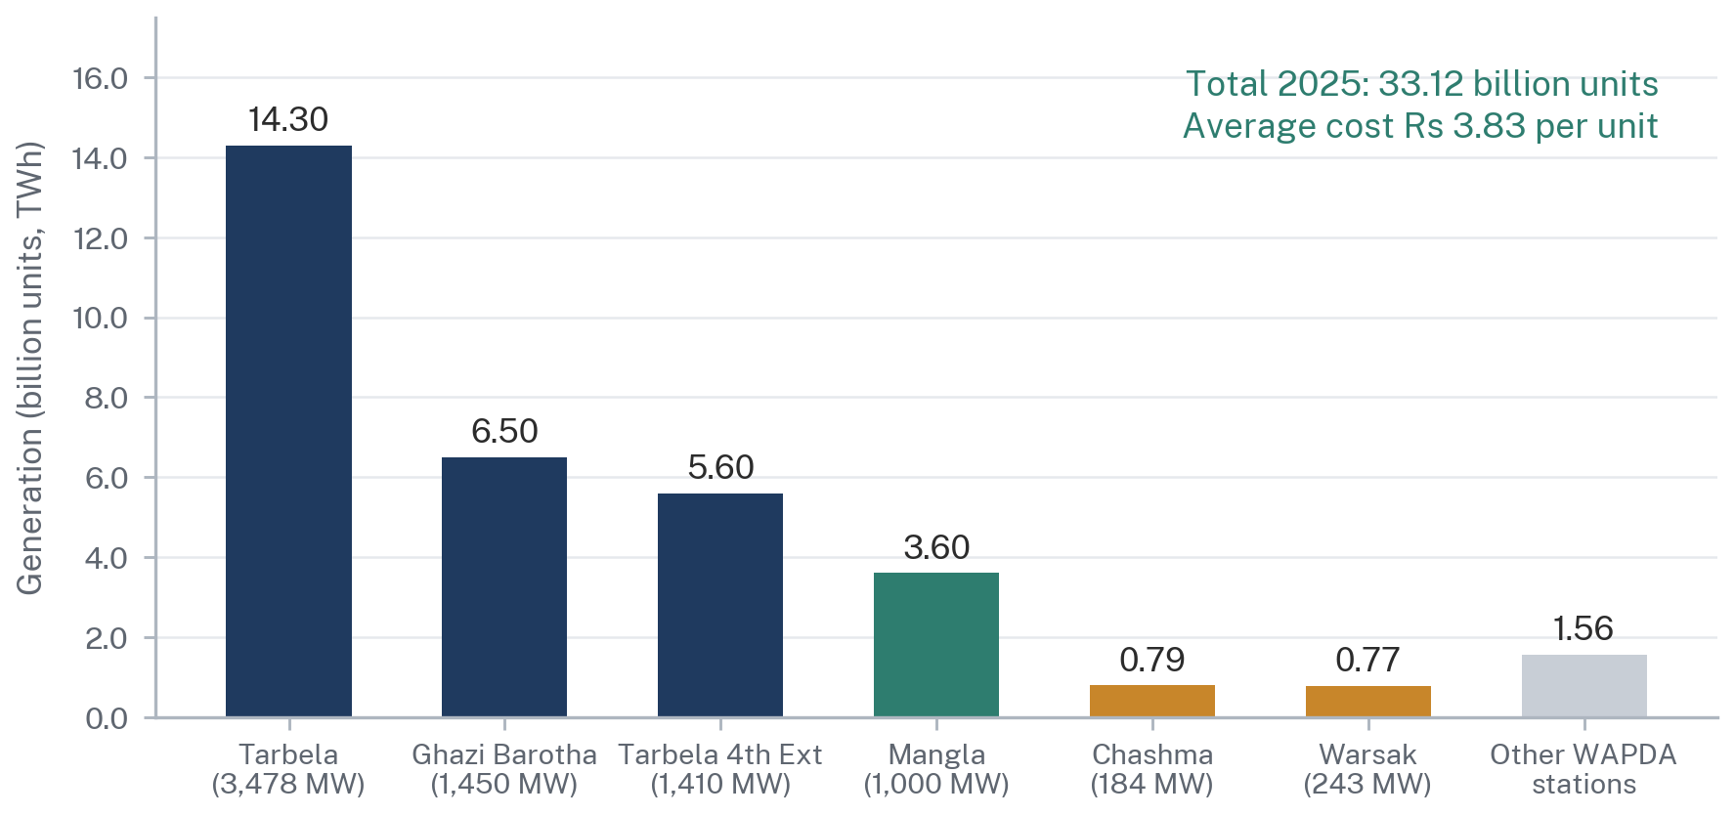
Source: Water and Power Development Authority (WAPDA), generation statement for calendar year 2025. Excludes hydropower owned by independent producers and provincial utilities.
Figure 13.
Two cautions attach to the Rs 3.83 per unit figure and both matter to any investor reading it. First, it is WAPDA's cost of generation on legacy public assets whose capital cost was largely written off decades ago. It is not a market price and it is not available to a private buyer as a purchase price. Second, it is not the price of new hydro. Karot and Suki Kinari are privately financed independent power producers with dollar-linked tariffs determined by NEPRA on the same capacity-and-energy architecture as thermal IPPs, and Neelum-Jhelum's first unit was commissioned in 2018 at a levelised tariff of Rs 13.50 per unit. New Pakistani hydro is cheap in fuel and expensive in capital, and the capital is priced in dollars.
The capital cost record reinforces the point. The Auditor-General's report on Neelum-Jhelum records that the fourth revised PC-I was approved at Rs 506.808 billion against an original 1989 approval of Rs 15.012 billion, a cost overrun of Rs 334.952 billion against the first revised PC-I and a delay of almost eight years [27]. That is not a marginal variance. It is a category of execution risk that any lender will price.
4.5 Seasonal Water Flows and the Firm-Power Problem
This is the section where the hydro case must be stated honestly, because the temptation to overstate it is considerable and an investor will discover the truth in the first week of diligence.
ARS has calculated annual capacity factors for the major WAPDA stations by dividing calendar year 2025 generation by installed capacity multiplied by 8,760 hours. Ghazi Barotha achieved 51.2%, Chashma 49.0%, Tarbela 46.9%, Tarbela 4th Extension 45.3%, Mangla 41.1% and Warsak 36.2%. These figures reflect hydrology, planned outages, irrigation operation and system dispatch together, and they are not a judgement on plant condition. But they are the numbers.
Pakistan's Best Hydro Assets Run Below Half the Year, and Cannot Be Sold as Firm Power
Annual capacity factor of major WAPDA hydel stations, calendar year 2025, per cent
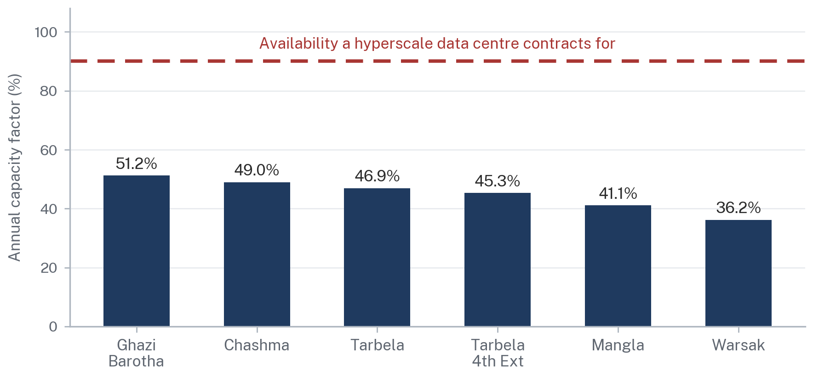
Source: ARS calculation from the WAPDA 2025 generation statement and the installed capacity of each station: annual generation divided by installed capacity multiplied by 8,760 hours. Capacity factors reflect hydrology, planned outages and system dispatch, and are not a measure of plant condition. The 90% reference line is the contracted availability typical of hyperscale supply agreements.
Figure 14.
A hyperscale data centre contracts for availability above 90%. Pakistan's best-performing large hydro station delivers, on an annual average basis, a little over half that. The gap between the two lines on the preceding chart is the entire commercial problem with a hydro-anchored data-centre proposition, and no amount of enthusiasm about the Indus closes it.
The seasonal shape compounds the annual average. Indus basin flows are driven by snowmelt from spring and by the summer monsoon, peaking between June and August and falling to their minimum between December and February. The binding constraint is therefore not annual energy, which is ample, but winter availability, which is when a run-of-river plant produces least and when a data centre's load is unchanged.
Hydro Gives Pakistan Cheap Energy in Summer and a Firming Bill in Winter
Schematic seasonal profile of run-of-river hydro output against a constant compute load, per cent of installed capacity
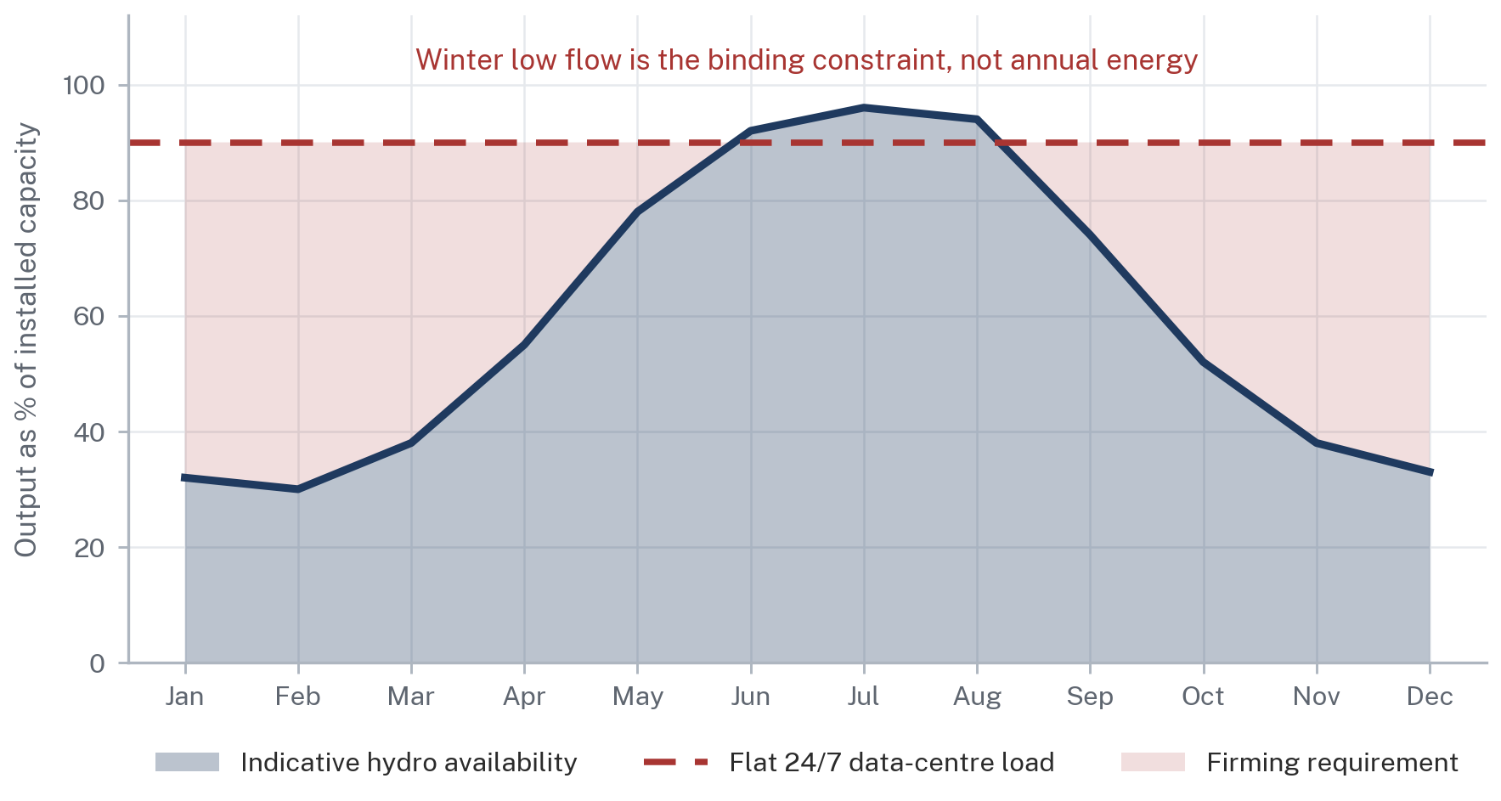
Source: ARS schematic, illustrative only. The monthly shape reflects the well-documented Indus basin snowmelt and monsoon cycle and is not a measured generation series for any named station. It is drawn to show the shape of the firming problem, not to quantify it.
Figure 15.
The Neelum-Jhelum experience makes the availability point more sharply than any hydrological analysis. The 969 MW plant has been out of service since a tunnel collapse on 2 April 2024. WAPDA's chairman told the Senate Standing Committee on Water Resources on 10 July 2026 that restoration work was under way and that the authority hoped to resume generation by March 2028, nearly four years after closure, and the committee pressed for a transparent and independent inquiry into the causes of the collapse and the cost escalations [16][17]. This followed an earlier tailrace tunnel failure whose repair cost approximately Rs 6 billion together with roughly Rs 37 billion in lost energy over twenty months. A single-tunnel run-of-river scheme in a seismic zone is a concentrated engineering risk, and the record shows what happens when that risk materialises.
4.6 Hydro Plus Thermal Firming
The workable configuration is hydro for energy and thermal or storage for firm capacity, which is precisely the configuration Pakistan's existing fleet is already capable of providing. The country's underutilised thermal plant is, in this framing, not a liability to be retired but a firming resource to be contracted.
That reframing has a specific contractual implication. A hydro-anchored supply arrangement for a data centre requires at least two agreements running in parallel: an energy contract with the hydro generator, priced per unit and seasonal in volume, and a capacity or standby contract with a firming provider, priced per MW of committed availability and drawn upon when the hydro leg falls short. The second contract is the expensive one and it is the one Pakistani market design has not yet standardised. Replacement power obligations, the mechanism by which a supplier undertakes to source alternative energy when its contracted generator underdelivers, do not currently exist as a standard product in the Pakistani market. Section 11 sets out what such a product would need to contain.
4.7 Northern Pakistan as a Compute Geography
The northern hydro corridor has real advantages for compute siting. Ambient temperatures across Khyber Pakhtunkhwa's northern districts, Azad Jammu and Kashmir and Gilgit-Baltistan permit free cooling for a substantially larger share of the year than Karachi or Lahore, which reduces power usage effectiveness and therefore the total electricity bill for a given IT load. Proximity to generation reduces transmission losses and reduces exposure to the north-south corridor constraint discussed in Section 2.6. Land is available and comparatively inexpensive.
Four constraints qualify the advantage and each will appear in an investor's risk register.
Fibre is the first. Compute capacity is worthless without low-latency, diverse, high-capacity connectivity to the customers who buy it. Pakistan's international capacity improved materially with the landing of the Africa-2 cable, a 45,000 km system connecting 33 countries through 46 landing stations [18], but international capacity lands on the coast. The domestic backhaul from Karachi to a northern campus, and the requirement for genuinely diverse routing rather than nominally diverse routing sharing a common duct, is an unresolved question that Section 5.6 examines in detail.
Seismicity is the second. The northern corridor sits across the collision zone between the Indian and Eurasian plates. Reports highlighting Neelum-Jhelum's location in a seismic zone existed before the project was launched [17]. Data centres can be engineered for seismic risk, and are, in Japan and California. Doing so costs money and it changes the insurance position.
Constitutional and jurisdictional status is the third, and it is the one most often overlooked by promoters. Azad Jammu and Kashmir and Gilgit-Baltistan are not provinces of Pakistan within the meaning of Article 1(2) of the Constitution and are governed under their own distinct constitutional instruments. That affects which legislature may enact what, which courts have jurisdiction over a dispute, how land is acquired, how a security interest is perfected and registered, and whether a foreign investor's protections operate identically to those available in Punjab or Sindh. This is not an insuperable obstacle. It is a diligence question with a real answer, and the answer must be worked out before a site is selected rather than after.
Transmission is the fourth. The ADB's Second Power Transmission Strengthening Project is intended to enable evacuation of up to 3,200 MW from northern generation clusters, which is an acknowledgement that the corridor cannot presently carry what the north can generate [22]. A campus sited in the north to be close to hydro is well placed if it consumes locally and poorly placed if it must draw firming power from the south.
4.8 Water versus Electricity: Two Different Resource Questions
Data centres consume water for evaporative cooling, and the volumes are not trivial. Locating a large campus in the Indus basin therefore raises a water question that is entirely separate from the electricity question, and which in Pakistan carries a political charge that electricity does not.
Water allocation between provinces operates under the 1991 Water Apportionment Accord and is administered by the Indus River System Authority. Any material industrial abstraction in a basin already under stress, in a country where inter-provincial water allocation is among the most sensitive subjects in federal politics, will attract scrutiny that a purely electrical project would not. The technical answer is closed-loop or air-cooled design, which raises capital cost and worsens power usage effectiveness but largely removes the water question. That trade-off should be made deliberately and disclosed early, not discovered during permitting.
There is also a treaty dimension that any foreign investor's country-risk assessment will identify. India placed the Indus Waters Treaty in abeyance on 23 April 2025 following the Pahalgam attack and has reaffirmed that position since, including at the United Nations in March 2026 and again in July 2026 [28][29]. The Permanent Court of Arbitration issued a binding award on general interpretation of the treaty on 8 August 2025 and a supplemental award concerning maximum pondage on 15 May 2026, both of which India rejected as null and void on the basis that the court is not properly constituted [28][30]. Pakistan's position is that the treaty remains valid and operational.
ARS takes no position on the merits of that dispute, which is a matter of international law between two states. The relevant observation for this report is narrower and unavoidable: an investor being asked to place a multi-billion-dollar asset whose power supply is anchored to Indus basin hydrology will read that the treaty governing the upstream regulation of those rivers is currently contested, that one party denies the jurisdiction of the tribunal seized of it, and that hydrological data sharing has been affected. That is a country-risk factor and it should be addressed in the offer document rather than left for the investor to find.
4.9 What Hydropower Can and Cannot Do
Hydropower Against the Requirements of a Hyperscale Load
An honest assessment of fit, requirement by requirement
Requirement | What hydro delivers | Verdict | What closes the gap
Low energy cost | Genuinely low variable cost; no fuel exposure | Meets the requirement | Nothing required
Foreign-currency resilience | No imported fuel; but new hydro carries dollar-linked capital charges | Partially meets | Local-currency financing; longer tenors
Availability above 90% | Annual capacity factors of 36% to 51% on major stations | Does not meet | Thermal or storage firming under a separate contract
Winter firmness | Run-of-river output falls to its minimum December to February | Does not meet | Storage hydro, thermal firming, or a seasonal contract structure
Scalability to 300 MW+ | Ample installed and pipeline capacity in aggregate | Meets in principle | Transmission corridor reinforcement
Delivery certainty | Neelum-Jhelum out of service since April 2024 | Materially qualified | N-1 contracting across multiple generators, not a single asset
Low-carbon profile | Strong, and increasingly a procurement requirement for hyperscalers | Meets the requirement | Certification and tracking mechanism
Source: ARS assessment, drawing on WAPDA generation reporting for calendar year 2025 and the capacity-factor calculation set out in Section 4.5.
Table 6.
The Hydro Pipeline Is Real but Arrives After the Window in Which Compute Capacity Is Being Sited
Major hydropower capacity under construction or restoration, with stated target dates, MW
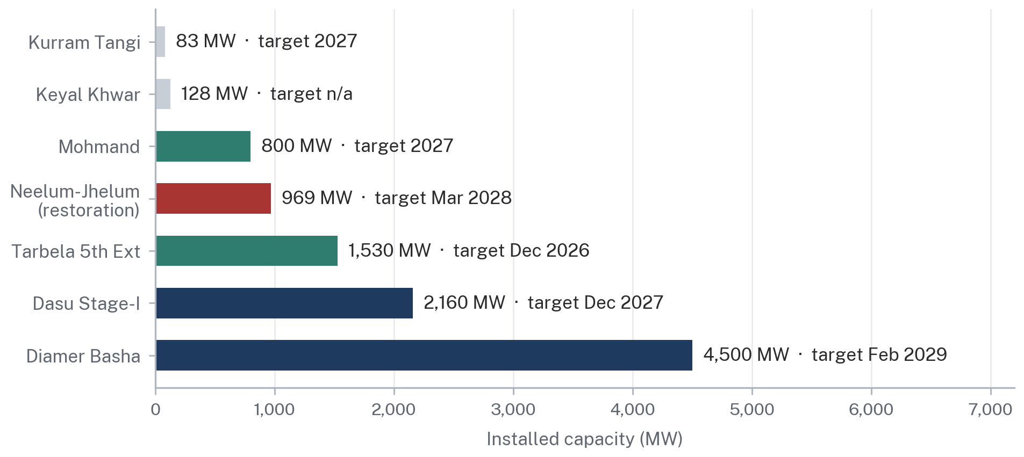
Source: WAPDA project reporting for calendar year 2025; Senate Standing Committee on Water Resources briefing, 10 July 2026, for Neelum-Jhelum restoration to March 2028. Target dates are as stated by the executing agency and have historically slipped. Neelum-Jhelum is a restoration of existing capacity shut since the tunnel collapse of 2 April 2024, not a net addition.
Figure 16.
The pipeline chart states the timing problem plainly. Diamer Basha at 4,500 MW is targeted for February 2029, Dasu Stage-I at 2,160 MW for December 2027, Tarbela 5th Extension at 1,530 MW for December 2026 and Mohmand at 800 MW for 2027. These are meaningful additions. They also arrive after the period in which global compute capacity is being sited, and Pakistani hydro target dates have historically slipped by years rather than months. A strategy that requires Diamer Basha to be commissioned on schedule is not a strategy. It is a hope.
4.10 The Correct Statement of the Hydro Case
Hydropower gives Pakistan a durable structural advantage in the cost of energy and a durable structural disadvantage in the firmness of supply. Both statements are true simultaneously, and a serious offer to an international investor must make both.
The correct proposition is not that Pakistan can power data centres with cheap hydroelectricity. It is that Pakistan can offer a blended product in which hydro supplies the energy at low variable cost, existing underutilised thermal capacity supplies the firmness that hydro cannot, and the combination is delivered under a single contract at a single blended price with a single counterparty answerable for delivery. That product does not currently exist in Pakistani law or in Pakistani market practice. Constructing it is the subject of Parts IV and V.

PART III
THE DATA-CENTRE OPPORTUNITY
5. Why Data Centres Change the Equation
5.1 Artificial Intelligence Has Made Electricity a Strategic Input
For most of the internet era, the location of computing capacity was determined by proximity to users and by the cost of bandwidth. Electricity was a line item. Since 2023 that has changed. Training and serving large models requires accelerator hardware with power densities several times those of conventional server racks, and the binding constraint on new capacity in most developed markets is now the availability of grid connections rather than the availability of capital, land or chips.
The International Energy Agency puts global data-centre electricity consumption at 415 TWh in 2024, approximately 1.5% of world electricity demand, rising to around 945 TWh by 2030 under its Base Case [33]. Its updated assessment records consumption of 485 TWh in 2025, growth of 17% against overall global electricity demand growth of 3%, and projects roughly 950 TWh by 2030 and 1,200 TWh by 2035, with global data-centre capacity approaching 100 GW [34]. The increment between 2024 and 2030 alone is more than four times Pakistan's entire annual generation.
Global Data Centres Will Add Roughly Four Times Pakistan's Total Generation by 2030
World data-centre electricity consumption, IEA Base Case, TWh per year
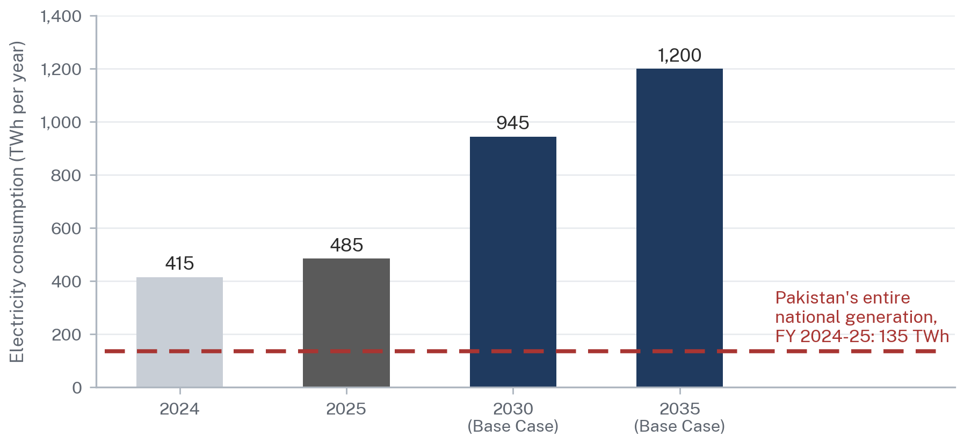
Source: International Energy Agency, Energy and AI, for 2024 and 2030; IEA, Key Questions on Energy and AI, for the 2025 estimate. The Pakistan comparison is from NEPRA State of Industry Report 2025. The 2035 figure is the IEA Base Case, not a forecast.
Figure 17.
That growth has to be sited somewhere, and the queue for grid connections in Northern Virginia, Ireland, the Netherlands, Singapore and parts of the United States is now measured in years. This is the window Pakistan is being invited to enter. It is also a window that closes: capacity sited elsewhere between 2026 and 2030 does not come back.
5.2 Hyperscale versus Conventional Data Centres
The distinction matters because the two categories buy electricity in entirely different ways. A conventional enterprise or colocation facility in Pakistan today draws a few megawatts on an ordinary commercial connection and treats power as an operating cost. Transworld Associates, the landing partner for several of Pakistan's submarine cables, has been developing a Tier III certified facility in Karachi connected directly to the subsea systems [36]. Facilities of that class are valuable and they do not require a change in the law.
A hyperscale campus is a different proposition. It draws between 100 MW and 1,000 MW, is built in phases over several years, is financed on long-term project debt or corporate balance sheet against a fifteen to twenty-five year asset life, and negotiates its power supply directly rather than accepting a published tariff. It is the second category that requires legal reform, and it is the second category that would make a material difference to Pakistan's electricity economics and to its export earnings.
5.3 What 100 MW, 300 MW, 500 MW and 1 GW Actually Mean
These figures are quoted loosely and it is worth fixing what they represent. The number normally refers to critical IT load, the power delivered to the servers themselves. Total facility load is higher because cooling, power conversion and lighting consume additional energy. The ratio is power usage effectiveness. A well-designed modern facility in a temperate climate achieves a PUE around 1.15 to 1.25; a facility in a hot climate using conventional mechanical cooling will be higher. This report uses 1.30 throughout as a conservative planning assumption for Pakistani conditions and states it wherever it is applied.
A Single Gigawatt Campus Would Consume More Than Eight Per Cent of Pakistan's Electricity
Annual electricity consumption by campus size, at an assumed power usage effectiveness of 1.30
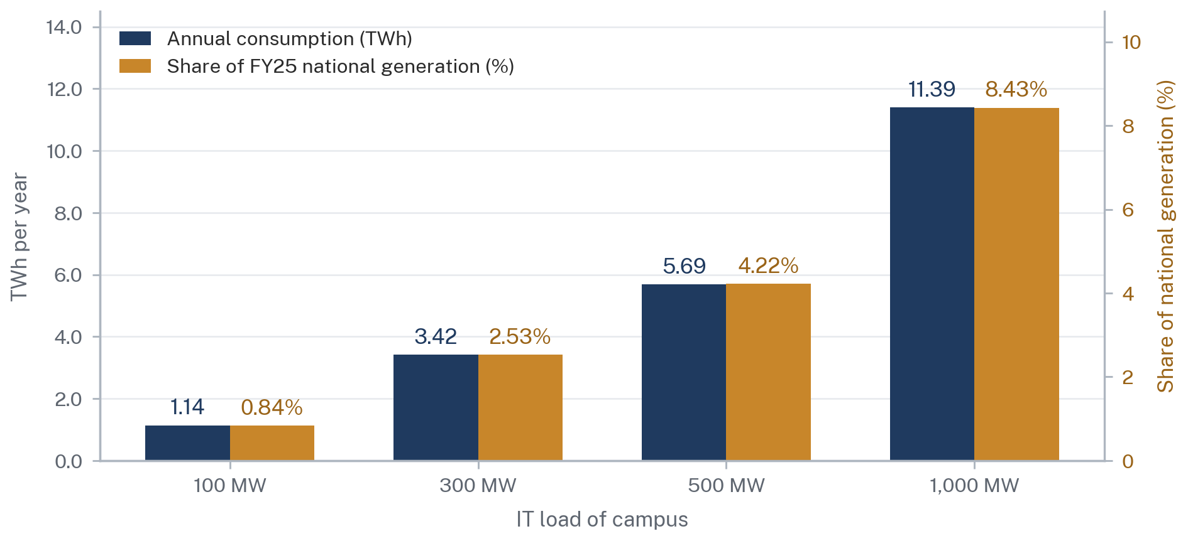
Source: ARS calculation. Total facility load equals IT load multiplied by a PUE of 1.30; annual energy equals facility load multiplied by 8,760 hours at 100% utilisation. The share is measured against NEPRA's reported FY 2024-25 net generation of 135,078 GWh. Illustrative, not a forecast.
Figure 18.
What Each Campus Size Means in Pakistani Terms
Facility load, annual consumption and system significance, at PUE 1.30 and continuous operation
IT load | Facility load | Annual energy | Share of national generation | Share of average national load | Annual electricity purchase at Rs 25/kWh
100 MW | 130 MW | 1.14 TWh | 0.84% | 0.84% | Rs 28 billion
300 MW | 390 MW | 3.42 TWh | 2.53% | 2.53% | Rs 85 billion
500 MW | 650 MW | 5.69 TWh | 4.22% | 4.22% | Rs 142 billion
1,000 MW | 1,300 MW | 11.39 TWh | 8.43% | 8.43% | Rs 285 billion
2,000 MW (the allocation announced in 2025) | 2,600 MW | 22.78 TWh | 16.86% | 16.86% | Rs 570 billion
Source: ARS calculation. Facility load equals IT load multiplied by 1.30. Annual energy equals facility load multiplied by 8,760 hours. National comparison uses NEPRA's reported FY 2024-25 net generation of 135,078 GWh and average load of approximately 15,420 MW. Rupee value assumes a delivered price of Rs 25 per kWh and is illustrative.
Table 7.
The last row deserves attention because it is the government's own stated figure. An allocation of 2,000 MW, if it were fully built and fully utilised, would consume close to 17% of Pakistan's current annual generation and would generate electricity purchases on the order of Rs 570 billion a year at an assumed delivered price of Rs 25 per unit. Set against a projected capacity charge of Rs 2.03 trillion to Rs 2.16 trillion, that is a contribution of real significance to the fixed-cost recovery problem described in Part I. It is also, on any realistic assessment, a decade of construction rather than a single announcement.
5.4 Reliability Requirements
Reliability is where the Pakistani proposition is weakest and where the conversation with an investor will begin. The Uptime Institute tier classification is the industry reference: Tier III facilities are concurrently maintainable and Tier IV are fault tolerant, with corresponding design availability targets that translate into permitted annual downtime measured in hours for Tier III and in minutes for Tier IV. A hyperscale operator building at 300 MW will typically design to Tier III equivalence with N+1 or 2N redundancy in the power train, and will contract for an availability standard at the point of delivery that Pakistan's distribution network does not currently meet at any voltage level.
The practical consequence is that the campus must be designed as though the grid will fail, with on-site uninterruptible power supply and generation capable of carrying the full load. That is normal practice everywhere. What is not normal is designing for the frequency of interruption that Pakistani distribution feeders experience, and the additional redundancy required is a cost that must be counted against whatever electricity price advantage Pakistan offers.
5.5 Cooling, Water and Site Conditions
Cooling is the second largest electrical load after the servers themselves and its cost is driven by ambient conditions. Karachi's coastal humidity, Lahore's summer dry-bulb temperatures and the northern corridor's cooler climate produce materially different PUE outcomes for the same equipment. The northern hydro corridor's advantage on this dimension is real and is one of the few unambiguous Pakistani advantages identified in this report.
The cooling technology choice is also a water choice. Evaporative cooling reduces electricity consumption and consumes water. Closed-loop and air-cooled designs consume little or no water and raise electricity consumption. In the Indus basin, where inter-provincial allocation under the 1991 Water Apportionment Accord is administered by the Indus River System Authority and is among the most politically sensitive subjects in Pakistani federalism, this trade-off should be resolved in favour of low water consumption and disclosed at the outset. Section 14 returns to this in the site analysis.
5.6 Fibre and Network Requirements
Compute capacity is worthless without connectivity to the customers who buy it, and Pakistan's position here has improved sharply and remains structurally limited.
Pakistan is served by submarine systems including SMW-4, SMW-5, IMEWE, AAE-1, TW-1 and PEACE, which together provided approximately 13 Tbps of international bandwidth before recent additions [37]. Africa-1 landed at Karachi in early 2025. The 2Africa system, extending 45,000 km across 46 landing stations in 33 countries with a design capacity of up to 180 Tbps, lands at Karachi through Transworld Associates as part of the 2Africa Pearls branch [38]. SEA-ME-WE 6 was connected in November 2025, with the landing partner initially providing 4 Tbps of additional capacity, an increase of nearly 40% on the then-current national total [37]. Three international systems were added within a single year.
Two qualifications limit what this means for a hyperscale campus. First, all of it lands at Karachi. There is no diversity of landing geography, and a campus sited in the north depends entirely on domestic backhaul from the coast. Second, the requirement for a hyperscaler is not headline capacity but genuinely diverse routing: two paths that do not share a duct, a bridge crossing or a single point of failure. Whether Pakistan can offer that between Karachi and an inland site is an engineering question that has not been publicly answered, and it is one of the first questions a network architect will ask.
5.7 Site Selection Criteria
Bringing these together, a hyperscale site selection team applies a standard filter in roughly this order: is there deliverable power at the required scale, is the price predictable for the contract term, is there diverse fibre, is the climate suitable, is water available or avoidable, is the land acquirable with clear title, is the seismic and flood risk manageable, is the jurisdiction one in which the investment can be financed and insured, and can permits be obtained on a known timetable. Pakistan currently produces a defensible answer to the first, a weak answer to the second and no settled answer to the last. Section 14 scores six candidate locations against these criteria.

6. What Would Pakistan Actually Be Selling?
6.1 Electricity Is the Input, Not the Export
The most common analytical error in this debate is to treat the proposition as electricity export. It is not. Pakistan cannot export electrons to a customer in Frankfurt. What it can do is convert electricity into a service that is delivered over fibre and billed in foreign currency, which is a fundamentally different transaction with different economics and a different legal architecture.
What Pakistan Would Actually Be Selling Is Compute Time, Not Kilowatt-Hours
The conversion chain from idle generation to foreign-exchange earnings
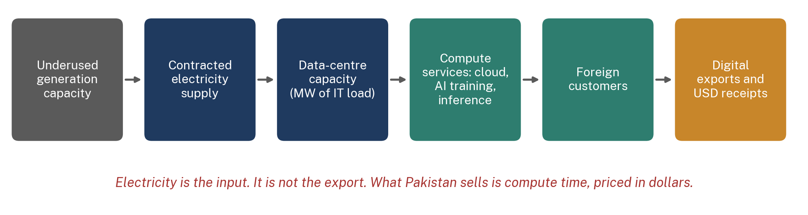
Source: ARS analysis. Each link in the chain requires a distinct legal instrument, from the power purchase agreement at the left to the data-transfer and tax framework at the right.
Figure 19.
The distinction has three practical consequences. First, the value captured depends on where in the chain Pakistan participates: leasing space and power to a foreign operator captures far less than operating the compute service, which in turn captures less than owning the models or the platform. Second, the foreign-exchange benefit accrues only if the revenue is billed abroad and repatriated, which is a State Bank and tax question rather than an energy question. Third, the electricity itself is sold domestically in rupees at a domestic tariff, which means the electricity transaction and the export transaction are legally and commercially separate even though they are physically the same activity.
6.2 The Layers of the Offer
What Pakistan Could Sell, and What Each Layer Is Worth
Ascending order of value capture and of institutional difficulty
Layer | What is sold | Value capture | Difficulty | Foreign-exchange effect
Wholesale capacity | Powered shell and MW of IT capacity leased to a foreign operator | Lowest | Lowest | Indirect; rent received in USD
Colocation | Rack space, power and cooling to enterprise customers | Low | Low | Partial; mixed domestic and foreign customers
Enterprise hosting | Managed hosting and disaster recovery for regional customers | Moderate | Moderate | Direct where customers are foreign
Cloud services | Compute, storage and networking sold as a regional cloud region | High | High | Direct and recurring
AI inference | Serving trained models to customers by the token or the request | High | High | Direct; latency-sensitive, favours regional demand
AI training | Large-scale training runs sold as reserved capacity | Highest | Highest | Direct; latency-insensitive, favours cheap power
Source: ARS analysis. Value capture and difficulty are relative rankings, not measured values. Foreign-exchange treatment reflects whether revenue is ordinarily billed to a foreign customer and repatriated.
Table 8.
The bottom two rows deserve emphasis because they point in different directions. Inference is latency-sensitive and therefore wants to be near its users, which favours Pakistan serving Pakistani and regional demand. Training is largely latency-insensitive and cares almost entirely about the cost of power and the availability of capacity, which is exactly the arbitrage Pakistan is positioned to offer. A realistic Pakistani proposition is training and batch workloads first, inference for the domestic and regional market second, and full cloud region status only once the first two are established.
6.3 Digital Services Exports and Foreign Exchange
Pakistan already exports digital services at scale and the trajectory is strong. IT and telecom export remittances reached a record USD 4.6 billion in FY 2025-26, up 20.6% from USD 3.814 billion in FY 2024-25, having grown from USD 2.108 billion in FY 2020-21 [39]. The Ministry of Information Technology and Telecommunication has set a target of USD 25.1 billion by 2030 [40].
Pakistan's Digital Exports Are Growing Fast and Are Nowhere Near the Official Target
IT and telecom export remittances, FY 2020-21 to FY 2025-26, USD billion
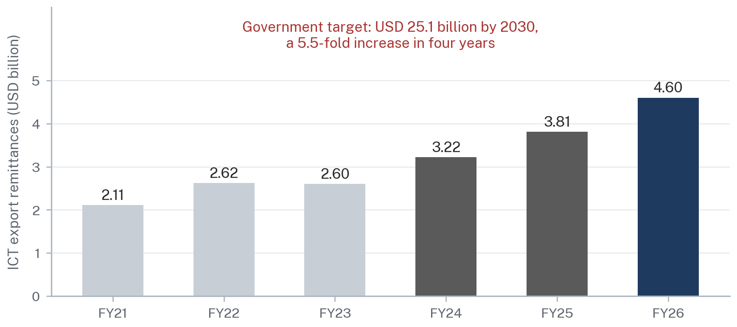
Source: State Bank of Pakistan export remittance data as reported; the official target is as stated by the Ministry of Information Technology and Telecommunication. The target lies above the plotted range and is shown as an annotation only.
Figure 20.
That target is a 5.5-fold increase in four years and it will not be reached by extending the current model, which is dominated by services delivered by people rather than by machines. Freelancing and software services scale with the number of trained workers. Data-centre capacity scales with megawatts and capital. The strategic case for compute infrastructure is precisely that it is the only element of Pakistan's digital export mix whose growth is not constrained by the rate at which the country can train software engineers.
STATING THE SCENARIO HONESTLY
ARS does not forecast what data-centre exports would be worth to Pakistan, and this report contains no such forecast. The arithmetic that can be stated is narrower and is set out in Section 15: what a campus of a given size consumes, what it costs to build, and what it would pay for electricity. Revenue depends on commercial terms with customers who do not yet exist, and any figure attached to it would be a construction rather than an estimate.

7. What Would a Pakistani Data-Centre Power Deal Look Like?
Five structures are available in principle under existing Pakistani law. Only one of them is in routine commercial use. This section sets each out, identifies its legal basis, and assesses it against the criteria a project-finance lender applies.
Five Ways to Get Electricity to a Pakistani Data Centre, and Only One of Them Is Currently Routine
Transaction architecture of each procurement model
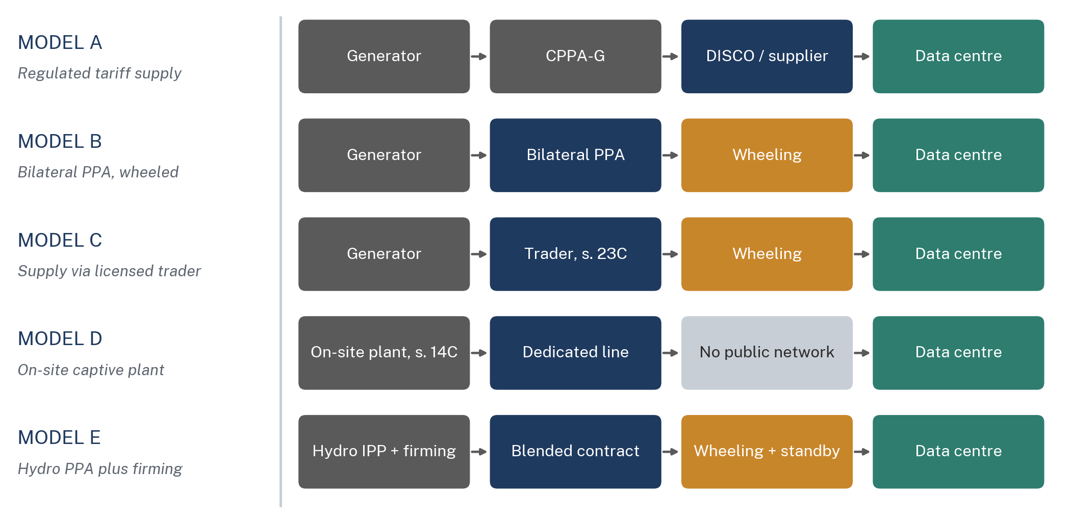
Source: ARS analysis of the NEPRA Act, 1997 as amended, and the NEPRA (Wheeling of Electric Power) Regulations, 2016. Model A is the only route in routine commercial use today. Models B, C and E depend on the wheeling and bilateral-contract framework; Model D depends on section 14C.
Figure 21.
7.1 Model A: Supply from a DISCO or Licensed Supplier at the Notified Tariff
The investor takes a connection from the distribution company in whose service territory the site sits and pays the tariff determined by NEPRA under section 31, as notified by the Federal Government. The legal basis is settled: a distribution licence under section 20 and a supply licence under sections 23E and 23F, with existing distribution licensees deemed to hold supply licences under the proviso to section 23E(1) [2].
This route works today and requires no reform. Its defect is price. The consumer pays the full capacity charge, the cross-subsidy, the debt servicing surcharge and general sales tax, which is the Rs 34 per unit national average tariff described in Part I. At a delivered price around 12 US cents per kWh, a 300 MW campus would face an annual electricity bill of roughly USD 410 million, against roughly USD 205 million at 6 cents. On a fifteen-year view that difference is larger than the entire construction cost of the facility.
Price, Not Availability, Is the Variable a Hyperscaler Optimises
Annual electricity cost by campus size and delivered tariff, USD million
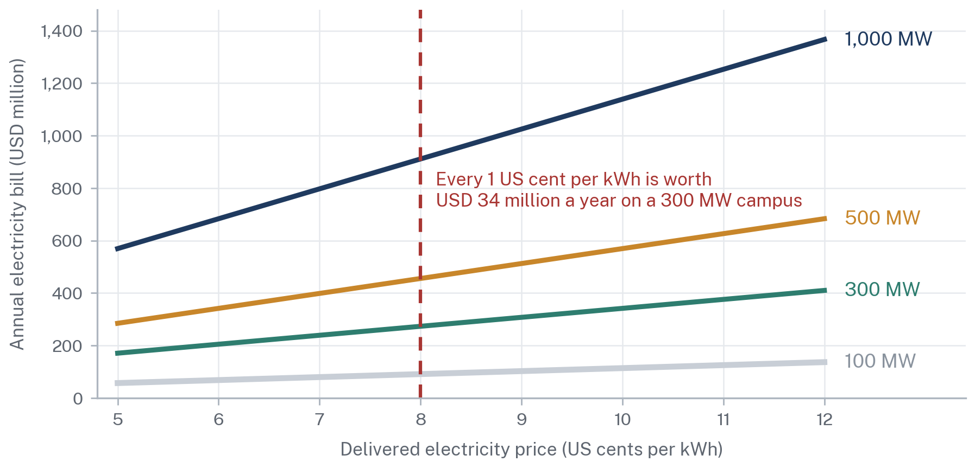
Source: ARS calculation on the same PUE 1.30 and 8,760-hour basis as Figure 18. Delivered price is the all-in price at the campus meter including energy, capacity, use-of-system charges and taxes. Illustrative sensitivity, not a price quotation.
Figure 22.
7.2 Model B: Generator, Bilateral PPA, Wheeling, Data Centre
The investor contracts directly with a chosen generator and pays the network owners to transport the energy. The legal basis is section 14D(3), under which a generation company may supply electric power to any consumer subject to section 23E, read with the proviso to section 21(2)(a) preserving sales to bulk power consumers, section 22 permitting such sales, and the NEPRA (Wheeling of Electric Power) Regulations, 2016, notified vide SRO 549(I)/2016, which allow a licensed generator to sell to a consumer of 1 MW or more anywhere in Pakistan [2][21].
This is the structure the whole proposition depends on and it is the structure with the greatest legal uncertainty. Section 22 provides that the Authority "may permit" the sale. Wheeling charges are set administratively and have moved from above Rs 22 per unit to below Rs 9 per unit [11]. The Framework Guidelines for Wheeling Auctions 2025 introduced a competitive allocation of a defined wheeling quantum, with NEPRA determining uniform wheeling charges and the market operator running the auction, and approximately 800 MW to be allocated [25]. Competitive allocation is an improvement on discretionary allocation. It is not the same as a right, and an auction that allocates a fixed quantum is by definition a rationing mechanism.
7.3 Model C: Generator, Licensed Trader, Data Centre
An electric power trader licensed under section 23C intermediates between generators and the consumer, aggregating supply and managing balancing. Section 23D(2) sets out the trader's obligations, including at subsection (2)(d) the requirement to enter into agreements with transmission and distribution licensees for use of their systems [2].
The advantage of this model is that the trader, not the data centre, carries the burden of managing multiple generators and the network relationships, which is exactly the specialisation a hyperscaler wants. The obstacle is that the Pakistani trading market is thin, and a trader's ability to offer a firm fifteen-year price depends on its own upstream contracts and its own balance sheet. A hyperscaler will look through the trader to the underlying credit.
7.4 Model D: Captive Generation
The investor builds its own generation on or adjacent to the site under sections 2(iia) and 14C. Section 3 of this report set out why this route cannot carry a hyperscale campus alone: the Off the Grid (Captive Power Plants) Levy Act, 2025 has removed the commercial basis for the gas-fired version, and the solar-plus-storage version requires land and storage at a scale that does not clear the capital cost test at Pakistani financing rates [12][13].
7.5 Model E: Hydro PPA plus Grid plus Thermal Firming plus Backup
This is the configuration ARS regards as the only one that satisfies both the price test and the reliability test, and it is the configuration this report recommends. Hydro or efficient thermal generation supplies the bulk of the energy under a long-term bilateral agreement. Grid supply from a licensed supplier provides firming and balancing. On-site solar with storage reduces average cost and provides ride-through. On-site backup generation provides the final layer.
Its difficulty is that it requires every one of the preceding legal bases to work simultaneously, and it requires one instrument that does not exist in Pakistan at all: a replacement power obligation under which the supplier undertakes to source alternative energy when the contracted generator underdelivers, at a defined price and with a defined remedy. Section 11 sets out what that instrument would need to contain.
The Five Models Compared Against the Criteria a Lender Applies
Legal basis, commercial character, and readiness of each structure
Model | Legal basis | Indicative delivered price | Reliability | Scalability to 300 MW+ | Regulatory complexity | Bankable today
A. DISCO or supplier | ss. 20, 23E, 23F, 31 | Highest; full tariff stack | Grid-dependent | Constrained by feeder capacity | Low | Yes, but uneconomic
B. Bilateral PPA with wheeling | s. 14D(3), s. 22, Wheeling Regs 2016 | Lower; energy plus use-of-system | Depends on curtailment terms | Good, subject to corridor | High | No
C. Licensed trader | ss. 23C, 23D | Lower; trader margin applies | Depends on trader's portfolio | Good in principle | High | No
D. Captive generation | ss. 2(iia), 14C | Gas route penalised; solar high capex | High, self-controlled | Poor at hyperscale | Moderate | Partially
E. Hydro PPA plus firming | All of the above combined | Lowest achievable blended price | Highest, if firming contracted | Best | Highest | No
Source: ARS analysis of the NEPRA Act, 1997 as amended, the NEPRA (Wheeling of Electric Power) Regulations, 2016, the Framework Guidelines for Wheeling Auctions 2025 and the Off the Grid (Captive Power Plants) Levy Act, 2025. Price bands are illustrative planning ranges, not quotations. Bankability is an ARS judgement.
Table 9.
The table states the central finding of Part III. The model that works commercially is the model that is least ready legally, and the model that is ready legally is the model that does not work commercially. Closing that gap is the subject of the remainder of this report.

PART IV
WHAT CAN THE LAW DO TODAY?
8. Pakistan's Current Electricity-Law Framework
This section takes the relevant provisions in turn. For each it states what the law says, what it means in practice, what a data centre can do today on the strength of it, and what remains uncertain. It is important to be precise about a point made in Part I: Pakistan does not have a legal vacuum in electricity. It has a reasonably complete legal architecture that was designed for a transition it has not yet completed.
A Bankable Power Contract Requires Every Tier of This Stack to Be Aligned
Hierarchy of legal instruments governing a Pakistani electricity transaction
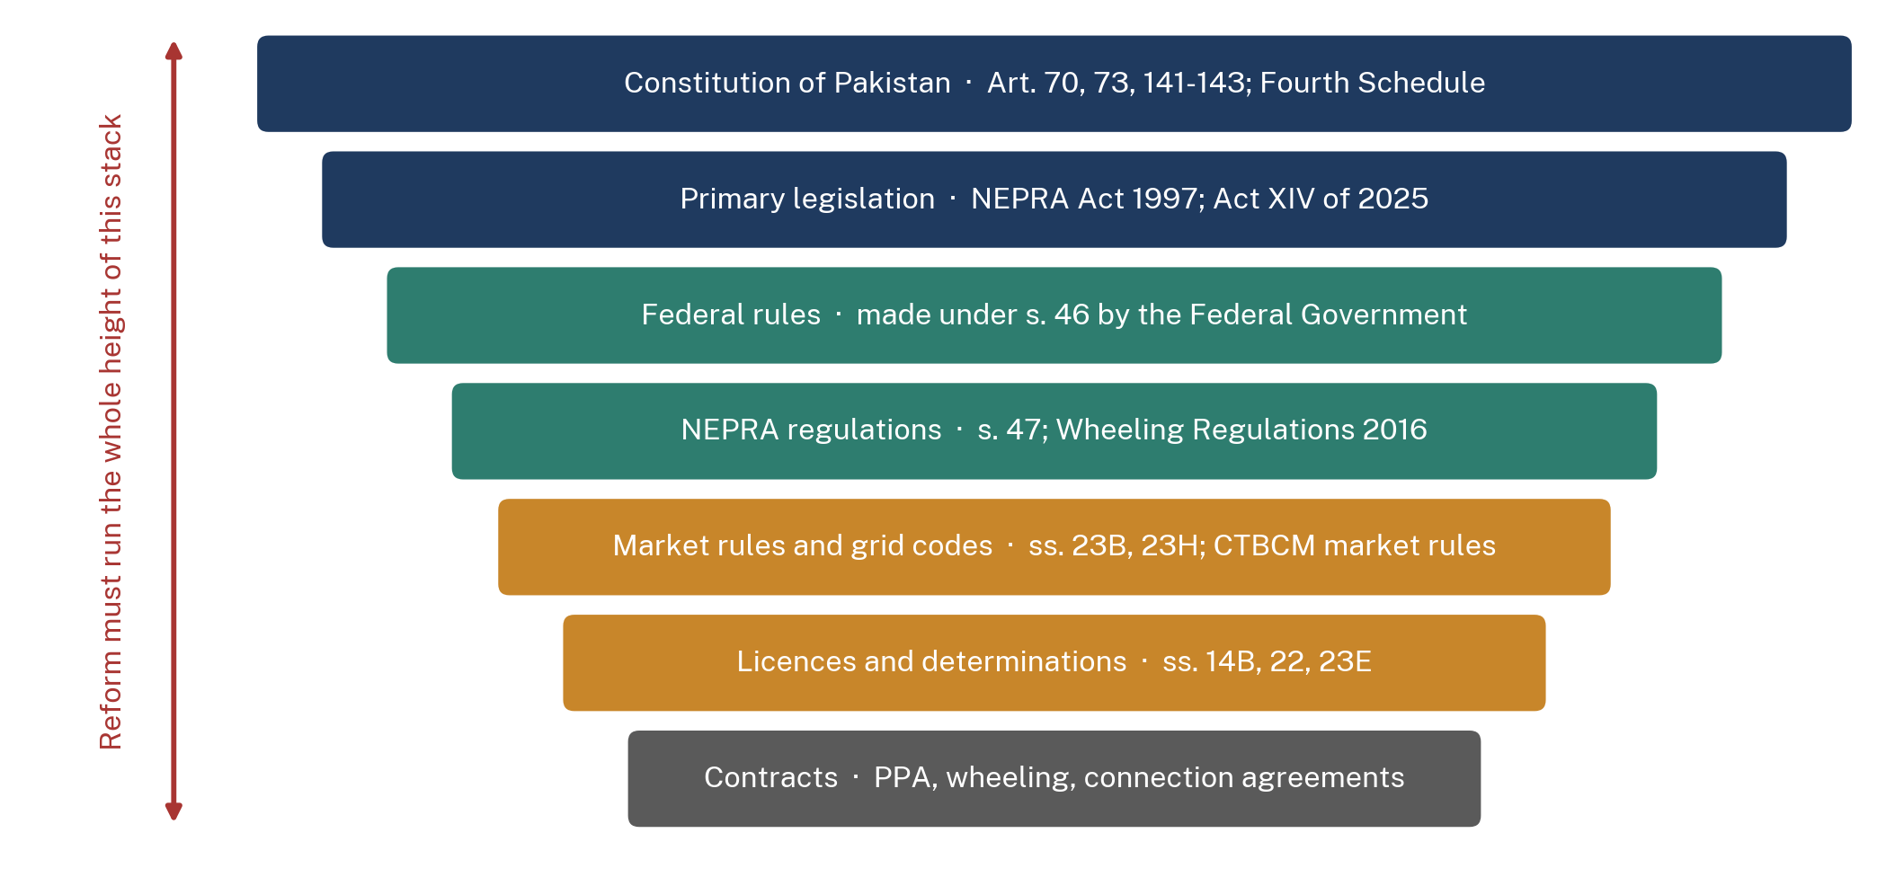
Source: ARS analysis. A change at one tier that is not carried through the tiers below it does not change what an investor can actually contract for.
Figure 23.
8.1 The NEPRA Act, 1997 and Its 2018 Amendment
The governing statute is the Regulation of Generation, Transmission and Distribution of Electric Power Act, 1997 (Act XL of 1997), substantially amended by Act XII of 2018 [2]. The 1997 Act established NEPRA as an independent regulator with exclusive responsibility for licensing and tariff determination. The 2018 Amendment inserted the architecture of a competitive market: captive generation and open access at section 14C, the market operator at sections 23A and 23B, the electric power trader at sections 23C and 23D, the electric power supplier at sections 23E and 23F, and the system operator at sections 23G and 23H.
Section 45 gives the Act overriding effect over inconsistent laws. Section 46 empowers the Federal Government to make rules and section 47 empowers the Authority to make regulations. Section 12G provides an appeal to the Appellate Tribunal within three months, with a further appeal to the High Court. Section 7(4) preserves a Province's power to construct power houses and grid stations and to determine tariff for distribution within the Province, a provision whose significance for provincially sponsored compute zones has not been tested.
8.2 Bulk-Power Consumers and Section 22
Section 2(ii) defines a bulk-power consumer as a consumer who purchases or receives electric power at one premises in an amount of one megawatt or more, or such other amount as the Authority may determine. Any data centre in the scope of this report clears that threshold many times over. The definition confers no procurement right by itself; it identifies a class.
Section 22 is the provision that matters and its drafting is decisive. It provides that the Authority "may permit" the sale of electric power to bulk power consumers located within the service territory of a distribution or supply licensee, with subsection (2) requiring one year's notice before a consumer exits an existing supply arrangement. The verb is permissive. There is no statutory criterion the Authority must apply, no timeline within which it must decide, and no deemed approval if it does not. An investor cannot tell from the face of the statute whether its application will succeed, how long it will take, or on what basis a refusal could be challenged beyond ordinary administrative-law grounds.
8.3 Sections 23C to 23H: Traders, Suppliers, Market and System Operators
Sections 23C and 23D create the electric power trader. Section 23D(2) sets out the trader's obligations, including at subsection (2)(d) the requirement to enter into agreements with transmission and distribution licensees for the use of their systems. A trader is therefore only as capable as the network agreements it can obtain.
Sections 23E and 23F create the electric power supplier. The proviso to section 23E(1) deems existing distribution licensees to hold supply licences for a transitional period, which was intended to allow continuity while competition developed. A supplier may decline to serve a consumer who has contracted elsewhere, which is the counterpart of the consumer's freedom to choose and is a provision a data centre relying on grid firming must read carefully.
Sections 23A and 23B create the market operator and sections 23G and 23H the system operator. The system operator's functions include generation scheduling, commitment and dispatch, transmission congestion management and the procurement of ancillary services. NEPRA has supported the transfer of the market operator and system operator functions into an Independent System and Market Operator [32]. The significance for this report is that congestion management and curtailment ranking, which determine who loses power first when the network is constrained, are functions of the system operator and are governed by market rules rather than by contract. A data centre cannot negotiate its own curtailment position bilaterally; it can only be protected by the rules.
8.4 Captive Generation and Open Access: Section 14C
Section 14C(1) permits any person to construct, maintain or operate a captive generating plant and dedicated transmission lines, with a proviso that supply through the grid is regulated as though the plant were that of a generating company. Section 14C(2) provides that every person who has constructed and operates a captive generating plant "shall have the right to open access" for carrying electricity to the destination of his use, subject to availability of adequate transmission facility as determined by the national grid company or the provincial grid company, with disputes adjudicated by the Authority.
This is the only place in the Act where a procurement-related entitlement is drafted as a right rather than a permission, and the drafting is therefore instructive for the reform proposed in Section 11. Its weakness is the condition. The determination of transmission availability is made by the entity whose network is being accessed, on criteria the Act does not specify, within no stated period, and the only remedy is adjudication by NEPRA followed by appeal. A right whose exercise depends on an unreviewable-in-practice determination by the counterparty is a right in form.
8.5 Wheeling and the 2016 Regulations
The NEPRA (Wheeling of Electric Power) Regulations, 2016, notified vide SRO 549(I)/2016, provide the operative framework under which a licensed generator may sell to a bulk power consumer anywhere in Pakistan using the transmission and distribution networks of others [21]. The regulations establish the requirement for a wheeling agreement and for the payment of use-of-system charges.
Three features limit their usefulness for a hyperscale transaction. The use-of-system charge is determined administratively and has been revised materially, falling from above Rs 22 per unit to below Rs 9 per unit [11]. There is no published methodology binding the charge for the term of a long-term contract. And there is no NEPRA-approved standard wheeling agreement, which means every transaction is negotiated from first principles with counterparties who have no commercial incentive to conclude it quickly.
8.6 CTBCM and the State of the Market in 2026
The Competitive Trading Bilateral Contract Market is the market design NEPRA approved to move Pakistan from a single-buyer model to bilateral contracting. It was formally launched in January 2026, with an initial trading tranche and a first competitive auction of approximately 800 MW scheduled for September 2026 [11][31]. The Framework Guidelines for Wheeling Auctions 2025 were approved in December 2025, with NEPRA to determine uniform wheeling charges and the market operator to conduct the auction [25].
This is genuine progress and the report should say so plainly. Pakistan is further along than most commentary allows. But an auction that allocates a fixed quantum of wheeling capacity is a rationing instrument, and a hyperscaler cannot build a fifteen-year investment case on winning successive auctions. The distinction between a market that allocates scarcity and a market that confers rights is the distinction on which this entire report turns.
8.7 The Legal Matrix
Provision by Provision: What the Law Permits and What Must Change
The principal analytical table of this report
Provision | What the law says | What a data centre can do today | Limitation | Required change | Instrument
s. 2(ii) | Bulk-power consumer means 1 MW or more at one premises | Qualify automatically as a bulk-power consumer | Status confers no entitlement to procure | Create a defined class of strategic large load with objective criteria | Primary legislation
s. 2(iia) | Captive plant means one set up primarily for own use | Build behind-the-meter generation without a licence | "Primarily" undefined; multi-tenant campus status unclear | Define permitted self-use share and treatment of co-located tenants | NEPRA regulation
s. 7(4) | A Province may build power houses and set intra-provincial distribution tariff | Explore a provincially sponsored zone supply arrangement | Untested for large industrial loads; interaction with federal market unclear | Clarify the interface between provincial supply and the national market | Rules under s. 46
s. 14B(4) | Generator must be available for non-discriminatory economic dispatch | Understand that dispatch is a system function | A bilateral contract cannot compel dispatch of the chosen plant | Define financial settlement against system dispatch in the market rules | ISMO market rules
s. 14C(1) | Any person may build a captive plant and dedicated lines | Build on-site generation | Grid export is regulated as ordinary generation | No change required | None
s. 14C(2) | Right of open access, subject to availability determined by the grid company | Apply for open access from a captive plant | Determination by the counterparty; no timeline; no deemed approval | Statutory time limit with deemed approval and published capacity register | Primary legislation
s. 14D(3) | Generator may supply any licensee and, subject to s. 23E, any consumer | Contract bilaterally with a generator in principle | Cross-reference to s. 23E imports the supply licensing regime | Clarify that a qualifying large load may contract without a supply licence | Primary legislation
s. 21(2)(a) proviso | Preserves generation company sales to bulk-power consumers | Rely on it as a supporting basis | Operates subject to s. 22 | Align with the new statutory right | Primary legislation
s. 22 | The Authority may permit sale to bulk power consumers; one year's notice to exit | Apply for permission | Discretionary. No criteria, no timeline, no deemed approval | Convert to a right for qualifying loads with objective eligibility | Primary legislation
ss. 23A-23B | Market operator licence and commercial code | Transact through CPPA-G | Transition to ISMO incomplete | Complete the licence transfer and publish the market code | Notification and licence
ss. 23C-23D | Electric power trader; must hold network agreements | Contract through a licensed trader | Thin market; trader depends on network agreements it may not obtain | Standard network access agreement available to all traders on equal terms | NEPRA regulation
ss. 23E-23F | Electric power supplier; may decline a consumer contracted elsewhere | Buy firming from a supplier | No standby or replacement power product exists | Create a licensed standby and replacement power product with a determined tariff | NEPRA regulation
ss. 23G-23H | System operator; congestion management and ancillary services | Nothing directly | Curtailment ranking unpublished; no compensation regime | Publish curtailment ranking and a compensation mechanism | ISMO market rules
s. 27 | No assignment or transfer of a licence without the Authority's approval | Nothing directly | Blocks pre-agreed lender step-in; approval is case by case | Pre-approved assignment and step-in for registered strategic projects | Primary legislation
s. 31 | Tariff determination; s. 31(3)(f) prefers competition to regulation | Rely on the stated policy preference | No long-term tariff methodology for a 15-year bilateral contract | Publish a binding long-term tariff and use-of-system methodology | NEPRA regulation
s. 45 | The Act overrides inconsistent laws | Rely on federal primacy in electricity | Does not resolve conflicts with provincial land, water and environmental law | Inter-governmental coordination protocol for designated zones | Administrative
Wheeling Regs 2016 | Licensed generator may sell to a 1 MW+ consumer anywhere in Pakistan | Wheel energy from a chosen generator | Charges set administratively; no standard agreement | Published methodology, term certainty and a standard wheeling agreement | NEPRA regulation
Act XIV of 2025 | Levy on gas and RLNG used by captive plants, rising to 20% from Aug 2026 | Nothing helpful | Removes the commercial basis for gas-fired self-generation | Exempt or carve out generation dedicated to a designated compute zone | Primary legislation
Source: Regulation of Generation, Transmission and Distribution of Electric Power Act, 1997 (Act XL of 1997) as amended by Act XII of 2018; NEPRA (Wheeling of Electric Power) Regulations, 2016 (SRO 549(I)/2016); Off the Grid (Captive Power Plants) Levy Act, 2025 (Act XIV of 2025); Framework Guidelines for Wheeling Auctions 2025. Columns four to six are ARS analysis and constitute a policy proposal, not a legal opinion.
Table 10.

9. Where the Existing Legal Framework Falls Short
Section 8 established that Pakistan has most of the legal components. This section identifies why they do not yet assemble into a financeable transaction. Throughout, the report distinguishes three categories of obstacle that are routinely conflated: legal restrictions, which arise from what the statute or regulation says; engineering restrictions, which arise from the physical network; and administrative restrictions, which arise from how institutions behave within a framework that would otherwise permit the transaction. The remedies are different in each case, and proposing a legislative amendment to solve an engineering problem wastes the amendment.
Every Question a Project-Finance Lawyer Asks Is Currently Answered by Discretion or Not at All
ARS assessment of the legal readiness of each element of a hyperscale power transaction in Pakistan
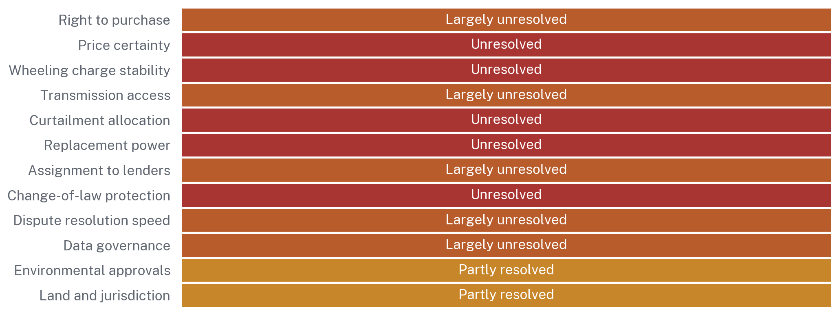
Source: ARS assessment on a five-point scale from resolved to unresolved, applied consistently across dimensions. Resolved means the answer is fixed in statute or standard contract and is not subject to unilateral administrative change. This is an analytical judgement, not a measurement.
Figure 24.
9.1 A Right to Buy or a Permission to Buy?
This is the foundational defect and everything else follows from it. Section 22 says the Authority "may permit". Section 14C(2) says a captive generator "shall have the right", then conditions that right on a determination by the network owner. Neither provision gives an investor an entitlement it can plead, price and finance.
The comparator is instructive. India's Electricity Act, 2003 provides for open access at section 42, historically with a 1 MW threshold. The Electricity (Promoting Renewable Energy Through Green Energy Open Access) Rules, 2022, notified on 6 June 2022 under section 176, reduced that threshold to 100 kW for green energy, established a central nodal agency operating a single-window national portal, and, critically, prescribed a fifteen-day timeline for approval of each application failing which the application is deemed approved subject to technical requirements [41][42]. Indian implementation is uneven and the Karnataka High Court has held that regulating open access falls within the exclusive domain of the State Electricity Regulatory Commissions under sections 42(2) and 181 [43]. But the central design point stands: India converted open access from a discretion into a time-bound, deemed-approval procedure. Pakistan has not.
9.2 Statutory versus Regulatory Certainty
An entitlement created by regulation can be withdrawn by regulation. NEPRA may make regulations under section 47 and the Federal Government may make rules under section 46, and neither process requires the deliberation that primary legislation attracts. A wheeling charge that fell from Rs 22 to Rs 9 by administrative decision can rise by the same route without any change in the underlying statute.
This is not an argument that regulation is illegitimate. It is an argument about where a fifteen-year commitment must sit. The elements a lender requires to be immovable are the right to procure, the eligibility criteria, the methodology by which network charges are set, and the assignability of the contract. Those four belong in the Act. The detailed rates, procedures and technical standards belong in regulation, where they should be capable of adjustment.
9.3 Open-Access Eligibility and Transmission Capacity
Eligibility is unclear because it is decided case by case rather than by published criterion, and capacity is unclear because there is no public register of available transmission capacity at each node. An investor evaluating a site cannot determine, before committing to land, whether the network can carry the load it intends to connect. In every mature market that information is published. Its absence in Pakistan is an administrative failure rather than a legal one, and it can therefore be remedied quickly and cheaply.
The underlying engineering constraint is real and was set out in Section 2.6: the Matiari to Lahore HVDC link operating well below its 4,000 MW design rating, a northward HVAC thermal ceiling of approximately 4,500 MW, and a reported 1,845 MW of southern generation constrained off daily [7]. NEPRA's own transmission performance evaluation records congestion and overloading of 500 kV and 220 kV assets [20]. No statutory amendment relieves a thermal limit. This is the clearest example in the report of a constraint that must be solved with conductor and steel rather than with drafting.
9.4 Curtailment, Grid Reliability and Replacement Power
Three connected gaps sit here and together they are the single largest obstacle to bankability after the right to procure itself.
Curtailment allocation is unpublished. When the network is constrained, the system operator reduces load or generation according to criteria that are not available to an investor in advance. A data centre cannot price a risk whose incidence it cannot observe.
Grid reliability at the point of delivery is not contractually guaranteed at a standard a hyperscale facility requires, and there is no mechanism by which a consumer can purchase a higher standard at a determined price.
Replacement power does not exist as a product. If a contracted generator fails to deliver, there is no supplier obligation to source alternative energy at a defined price. The consumer falls back to the grid at whatever the applicable tariff is, which converts a fixed-price contract into a variable-price exposure precisely at the moment the investor most needs certainty. This is a regulatory gap and it can be closed by NEPRA regulation without amending the Act.
9.5 Supplier Default, Change in Law and Contract Enforcement
Pakistani commercial contract enforcement is slow and both foreign investors and their insurers price that fact. The relevant question for this report is narrower: whether a dispute about network access, wheeling charges or curtailment can be resolved on a commercial timescale. Under the current framework such a dispute goes to NEPRA under section 14C(2) or the general dispute provisions, then on appeal to the Appellate Tribunal under section 12G within three months, then to the High Court. That sequence is measured in years.
Change in law is a specific and acute concern in Pakistan given the recent record. The Off the Grid (Captive Power Plants) Levy Act, 2025 imposed a new fiscal burden on an existing category of investment with a legislated escalation schedule [12][13]. IPP contracts covering 2,829 MW were terminated or renegotiated in FY 2024-25, with roughly Rs 260 billion of circular debt reduction attributed to renegotiation [3][35]. Both measures may be defensible on their merits. Their combined effect on an investor's assessment of contractual durability is nonetheless significant and cannot be argued away. It must be answered with an express change-of-law provision.
9.6 Assignment and Financing
Section 27 prohibits the surrender, assignment or transfer of a licence without the prior approval of the Authority. Project finance depends on the lender's ability to take security over the project's revenue contracts and, in a default, to step into the borrower's position and continue operating. If that step-in requires a discretionary regulatory approval obtained after the default has occurred, the security is substantially less valuable and the debt is priced accordingly or not offered at all. This is a legal restriction with a legal remedy: a pre-approval mechanism for registered projects, granted at financial close rather than at enforcement.
9.7 Data Governance
A data centre is a data facility and the legal regime governing the data it holds is part of the investment decision. Pakistan does not yet have an enacted comprehensive personal data protection statute. The Personal Data Protection Bill, prepared by the Ministry of Information Technology and Telecommunication and approved by the Federal Cabinet in its updated form, has not completed passage through both Houses [44][45]. In the meantime the applicable criminal provisions sit in the Prevention of Electronic Crimes Act, 2016, which is not a general processing framework.
Policy has moved faster than legislation. The Digital Nation Pakistan Act, 2025 established the Pakistan Digital Authority, and the National AI Policy was adopted in 2025 [45]. The Ministry released the draft National Data Governance Policy 2026 for consultation in late June 2026, closing on 10 July 2026, declaring government data a strategic national asset, asserting that government data must remain under Pakistan's lawful authority and effective control, and introducing rules on cross-border transfer, privacy impact assessments and AI explainability. The draft states that it will be updated once a comprehensive personal data protection law is enacted [46][47].
For a hyperscaler two questions follow. The first is whether it can lawfully serve foreign customers from Pakistani infrastructure without triggering localisation or transfer restrictions, which depends on the final form of the data protection statute rather than on the policy. The second is whether Pakistani and regional customers can lawfully place regulated data in a Pakistani facility, which is the demand-side question and which an adequacy-grade statute would answer positively. The absence of the statute is currently a deterrent in both directions, and enacting it is the single cheapest thing Pakistan could do to improve the proposition.
9.8 Environmental Law, Water and Land
Environmental approval is a provincial competence following the Eighteenth Amendment, exercised through the provincial environmental protection agencies under provincial environmental protection legislation. A campus spanning power generation, high-voltage connection and large-scale construction will require an initial environmental examination or environmental impact assessment with public hearing. The timeline is not fixed by statute in a way an investor can rely upon.
Water abstraction, discussed in Section 5.5, engages provincial irrigation departments and, for basin water, the Indus River System Authority under the 1991 Water Apportionment Accord. Land acquisition engages provincial land revenue administration, and title verification in Pakistan is a recognised diligence burden.
Jurisdictional status is the sharpest version of this problem. Azad Jammu and Kashmir and Gilgit-Baltistan are not provinces of Pakistan within the meaning of Article 1(2) of the Constitution and are governed under separate constitutional instruments. For a northern hydro-linked site, that affects which legislature may enact the applicable law, which courts have jurisdiction, how land is acquired, how a security interest is registered and perfected, and whether investor protections operate identically. These are answerable questions. They are not currently answered in any published form, and an investor will not do that work speculatively.
Where the Transaction Breaks
Current-state process map for a bilateral power arrangement serving a large load; schematic
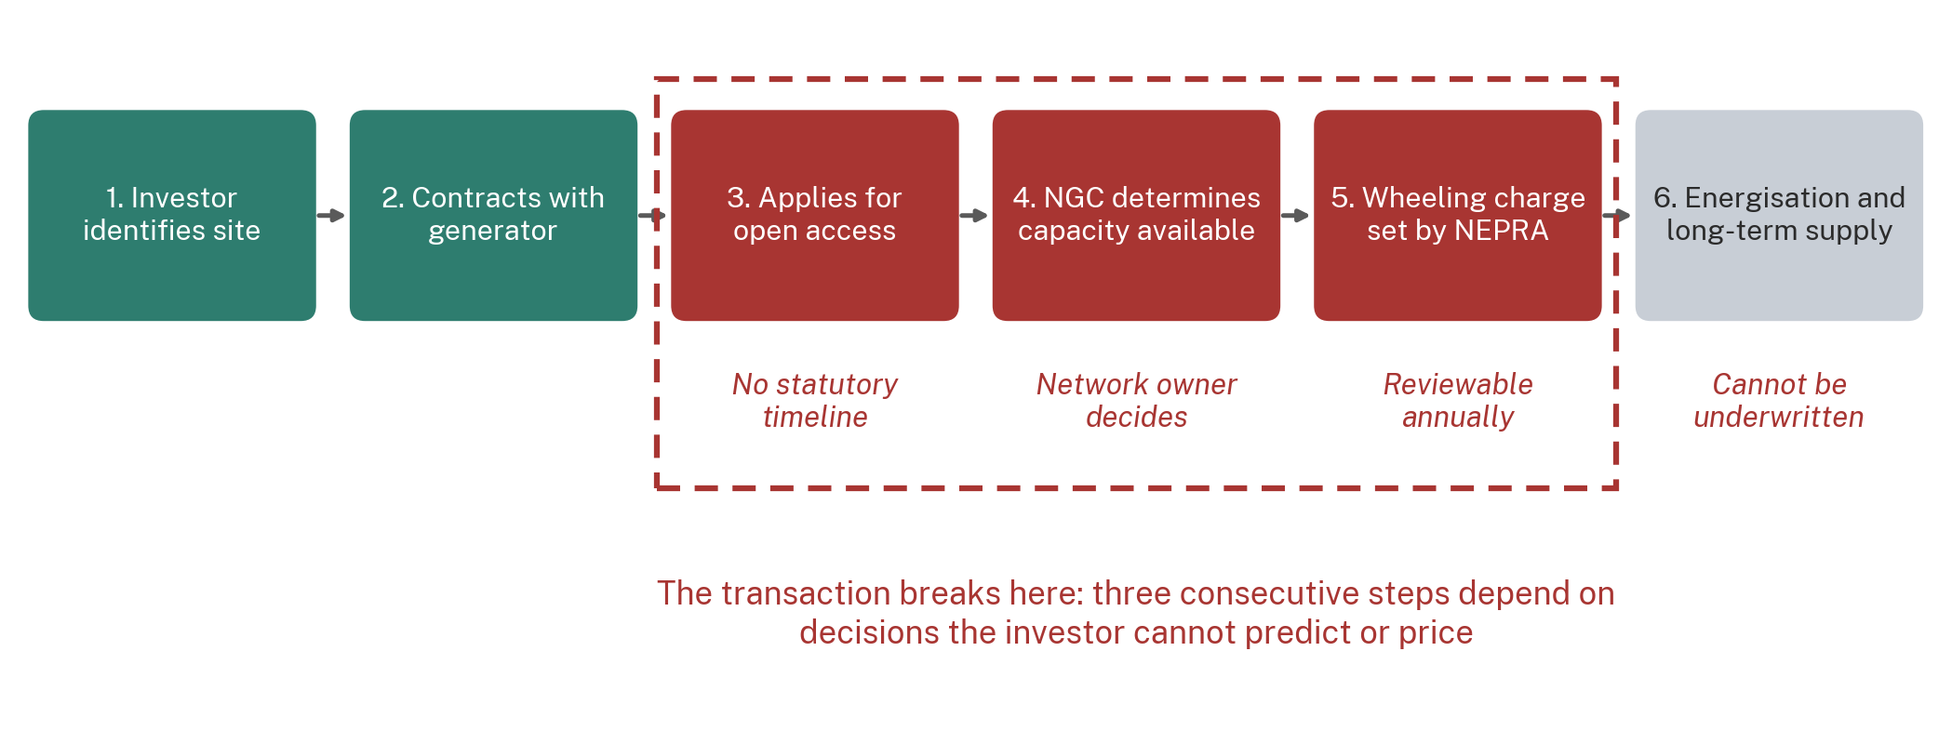
Source: ARS analysis of section 14C(2) and section 22 of the NEPRA Act, 1997, the NEPRA (Wheeling of Electric Power) Regulations, 2016, and the Framework Guidelines for Wheeling Auctions 2025.
Figure 25.
THE FINDING OF PART IV
Of the fifteen questions a project-finance lender asks, Pakistan today answers none of them in a form the lender would accept without a sovereign guarantee. That is not because the law forbids the transaction. It is because the law permits it without committing to it, and a permission that can be withdrawn is not an asset a lender can take security over.

PART V
WHAT HAS TO CHANGE?
10. The Legal Reform Package
This is the operative section of the report. It identifies what must change, who must change it, and by which instrument. The distinction between instruments is not procedural pedantry. A reform placed in the wrong instrument either fails to bind or fails to be adjustable, and both failures are expensive.
STATUS OF THE DRAFTING IN THIS SECTION
The illustrative statutory language set out below is an ARS policy drafting proposal. It is not enacted legislation, it is not a bill before either House, and it is not a legal opinion. It is offered to demonstrate that the reform is capable of being expressed in ordinary statutory form, and to give Parliament, the Power Division and NEPRA a concrete starting point rather than a statement of principle.

10.1 What Parliament Must Change
Four amendments to the NEPRA Act, 1997 are required. Each addresses a defect identified in Section 9, and each must sit in primary legislation because each is a commitment a lender needs to be immovable.
The first converts section 22 from a permission into a right for a defined class. The current provision states that the Authority may permit sale to bulk power consumers. The legal problem is that a discretion cannot be underwritten. The proposed amendment inserts a new section 22A creating a right to procure electric power from any licensed generator, trader or supplier, exercisable by a consumer meeting published objective criteria, subject only to payment of determined use-of-system charges and to technical compliance. The expected effect is that eligibility becomes a question of fact rather than of favour.
ARS POLICY DRAFTING PROPOSAL: SECTION 22A
22A. Right of strategic large loads to competitive procurement. (1) Notwithstanding section 22, a consumer registered under subsection (3) shall have the right to purchase electric power from any generation, transmission, trading or supply licensee of its choice, and to have such power transported over the transmission and distribution systems of any licensee, on payment of the use-of-system charges determined under section 31 and subject to compliance with the applicable grid and distribution codes. (2) The right conferred by subsection (1) shall not be refused, suspended or made conditional except on grounds of technical infeasibility recorded in writing with reasons and supported by the capacity register maintained under section 23I. (3) The Authority shall by regulation prescribe objective criteria for registration as a strategic large load, which shall include a minimum contracted demand, a minimum contract term and a demonstrated capability to be metered and settled on an interval basis, and shall register any applicant meeting those criteria within sixty days. (4) Where the Authority does not decide an application under subsection (3) within sixty days, the applicant shall be deemed to be registered. Note: ARS policy drafting proposal. Not enacted legislation and not a legal opinion.

The second addresses the conditionality in section 14C(2). The current provision subjects the right of open access to a determination of transmission availability by the network owner, with no timeline and no default outcome. The proposed amendment imposes a statutory period within which the determination must be made, provides for deemed availability if it is not, and requires the grid company to maintain and publish a capacity register at each node. The model is the fifteen-day deemed-approval mechanism in India's Green Energy Open Access Rules, 2022 [41][42], adapted to a longer period appropriate to the scale of connection contemplated here.
The third addresses section 27. The current prohibition on assignment without prior approval defeats lender step-in. The proposed amendment permits the Authority, at the time it registers a strategic large load or issues a related licence, to grant a conditional pre-approval of assignment to identified financing parties, exercisable on a defined default event with notice to the Authority. The expected effect is that the security package becomes enforceable on the timetable a lender requires.
The fourth addresses the captive levy. The Off the Grid (Captive Power Plants) Levy Act, 2025 is sound policy in its own context, which is the recovery of industrial load to the grid. Applied to generation dedicated to a designated compute zone, it penalises exactly the investment the state says it wants. The proposed amendment inserts an exemption in section 3 of Act XIV of 2025 for generation dedicated to a load registered under the new section 22A, conditioned on that load also taking a minimum contracted quantity from the grid, so that the exemption cannot be used to exit the system entirely.
10.2 What NEPRA Must Change
Six regulatory instruments are required and none of them requires parliamentary time. This is the fastest-moving part of the reform and it should begin immediately.
Eligibility regulations under the proposed section 22A(3), prescribing the objective criteria and the registration procedure. A long-term tariff and use-of-system methodology, published and binding, under which the wheeling charge applicable to a registered load is fixed or indexed to a published formula for the term of the contract rather than revised at each determination. Amended wheeling regulations replacing the 2016 instrument, incorporating the standard wheeling agreement, interval metering and settlement requirements, and defined connection timelines. A standby and replacement power product, licensed and tariffed, so that supplier default has a priced remedy. Standard forms of power purchase agreement, wheeling agreement and connection agreement approved by the Authority. And a determination on how the benefit of improved fleet utilisation is shared between the new load and the general consumer body, which is the distributional question flagged in Section 2.7 and which NEPRA must answer under its section 31(2) obligations rather than leave to negotiation.
10.3 What the Market and System Operator Must Change
The Independent System and Market Operator, once the licences under sections 23A, 23B, 23G and 23H are consolidated [32], must publish four things a hyperscaler will demand before it commits: a market access procedure with defined timelines for registration as a market participant; a transmission capacity register showing available capacity at each node and the queue of applications against it; a curtailment ranking specifying the order in which load and generation are constrained, together with the compensation payable; and scheduling and settlement rules capable of handling a flat 24/7 load contracted against a seasonal generator, which is a settlement problem Pakistani market design has not yet had to solve.
10.4 What the Grid Must Provide
The network requirements are engineering requirements and they cannot be legislated away. Restoration of the Matiari to Lahore HVDC link to a throughput approaching its 4,000 MW design rating is the single highest-value intervention available, because it directly relieves the constraint that strands southern generation [7]. The Asian Development Bank's USD 330 million Second Power Transmission Strengthening Project, comprising a 500 kV line of approximately 290 km and grid upgrades serving Islamabad and Faisalabad to enable evacuation of up to 3,200 MW from northern generation clusters, is the corresponding northern measure [22]. Beyond these, a hyperscale campus requires a dedicated substation with N+1 transformation, two independent feeds from separate grid stations, and a connection timeline the grid company is contractually bound to meet.
10.5 What Government Must Provide
Five things, none of which sits with NEPRA. Designation of strategic compute zones with pre-cleared land, pre-completed environmental assessment and a single-window permitting authority, whether under the Special Technology Zones Authority framework or a purpose-built instrument. Enactment of the Personal Data Protection legislation, which Section 9.7 identifies as the cheapest available improvement to the proposition. A published position on cross-border data transfer sufficient for a foreign operator to serve foreign customers from Pakistani infrastructure. A State Bank framework confirming the repatriation treatment of service revenue and of investment returns. And an inter-governmental protocol resolving the interaction between federal electricity law under section 45 and provincial land, water and environmental competence, including an express answer on the position in Azad Jammu and Kashmir and Gilgit-Baltistan.
Who Must Change What
The master reform matrix: institution, instrument, action and sequencing
Institution | Instrument | Action required | Timing | Dependency
Parliament | Amendment to Act XL of 1997 | Insert s. 22A conferring a right to procure on registered strategic large loads | 0-9 months | None. This is the critical path
Parliament | Amendment to Act XL of 1997 | Amend s. 14C(2): statutory determination period with deemed availability | 0-9 months | None
Parliament | Amendment to Act XL of 1997 | Amend s. 27: conditional pre-approval of assignment to financing parties | 0-9 months | None
Parliament | Amendment to Act XIV of 2025 | Exempt generation dedicated to a registered strategic large load | 0-9 months | Coordinate with IMF programme commitments
Parliament | Personal Data Protection legislation | Complete passage of the pending Bill through both Houses | 0-18 months | Independent; can proceed in parallel
NEPRA | Regulations under s. 47 | Eligibility criteria and registration procedure for strategic large loads | 6-12 months | Requires s. 22A
NEPRA | Regulations under s. 47 | Published, binding long-term tariff and use-of-system methodology | 6-15 months | None. Can begin immediately
NEPRA | Amended wheeling regulations | Replace SRO 549(I)/2016; standard agreement, metering, settlement, timelines | 6-15 months | None. Can begin immediately
NEPRA | Regulations and determination | Create a licensed standby and replacement power product with a set tariff | 9-18 months | Requires supplier engagement
NEPRA | Standard contract approval | Approve standard PPA, wheeling and connection agreements | 9-20 months | Requires the wheeling regulations
ISMO | Market rules | Market access, capacity register, curtailment ranking, settlement rules | 9-18 months | Requires licence consolidation
National Grid Co. | Investment and code | HVDC restoration, northern evacuation, node capacity publication | 6-36 months | Financing secured for ADB tranche
Federal Government | Notification | Designate strategic compute zones with single-window permitting | 3-12 months | Requires provincial concurrence
State Bank | Circular | Confirm repatriation treatment for compute service revenue | 3-9 months | None
Federal and provincial | Inter-governmental protocol | Resolve land, water, environmental and AJK/GB jurisdictional questions | 6-24 months | Council of Common Interests engagement
Source: ARS policy proposal. Not enacted legislation and not a legal opinion. Timing is indicative and measured in months from commencement of the programme.
Table 11.

11. The ARS Proposed Legal Model
Taken together, the measures in Section 10 amount to a single structural change: the replacement of a permission architecture with a rights architecture. This section states the model as thirteen propositions and shows the shift in a single diagram.
From a Permission Architecture to a Rights Architecture
The six changes that convert a discretionary transaction into a bankable one
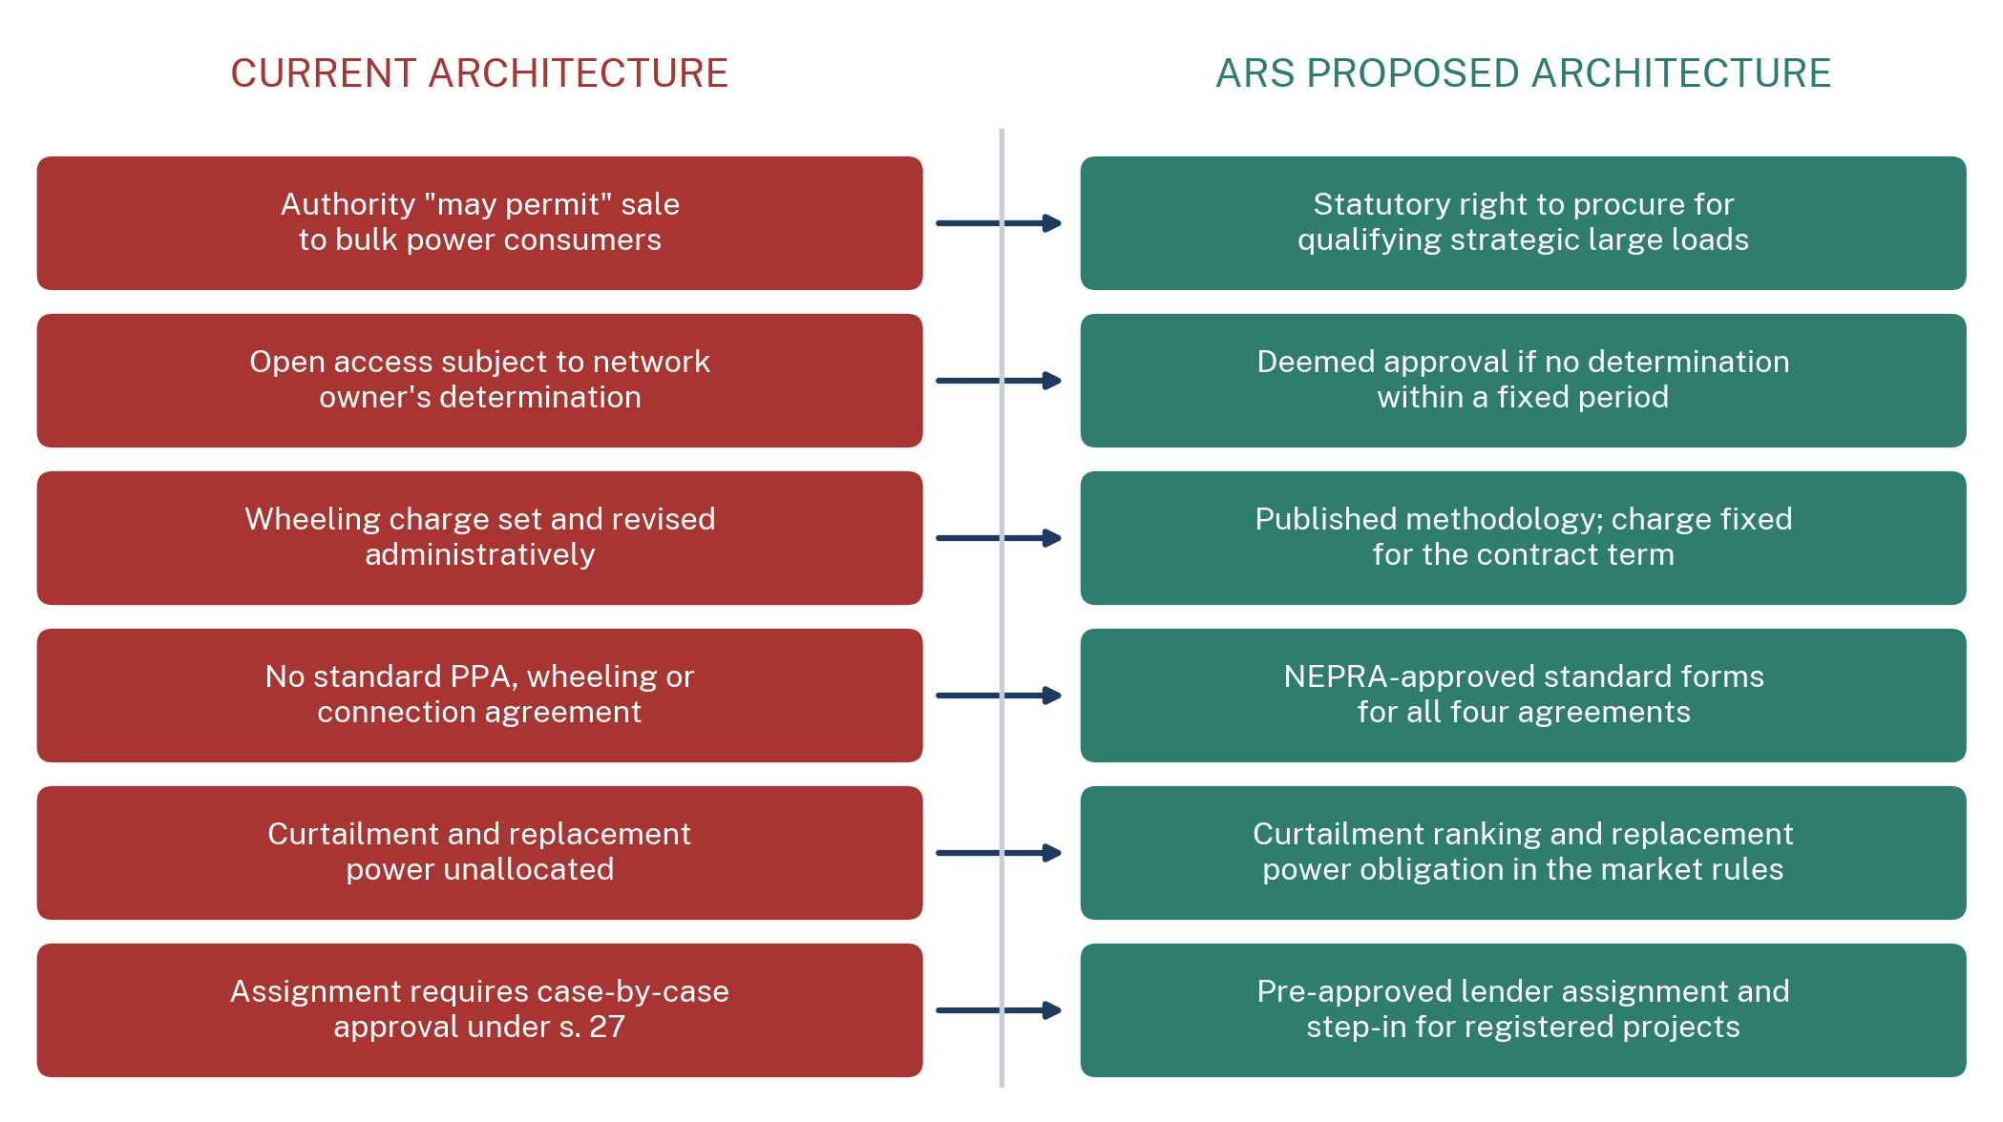
Source: ARS policy drafting proposal. Not enacted legislation and not a legal opinion. Each right-hand item requires a specific instrument identified in Sections 10 and 11 of this report.
Figure 26.
11.1 The Thirteen Elements
A statutory right to competitive power procurement, conferred by the proposed section 22A on any consumer meeting published criteria, replacing a discretion exercised case by case. Objective eligibility for strategic large loads, defined by minimum contracted demand, minimum contract term and interval metering capability, so that eligibility is a matter of fact. Non-discriminatory open access with a statutory determination period and deemed availability where the network owner does not respond, supported by a published capacity register.
Transparent wheeling, with the use-of-system charge determined under a published methodology and fixed or formula-indexed for the term of the registered contract, so that the single largest variable in the delivered price ceases to be a policy variable. A long-term tariff methodology under section 31, giving a fifteen to twenty-five year contract a determinable price path. A standard power purchase agreement, a standard wheeling agreement and a standard connection agreement, each approved by the Authority, so that negotiation is confined to price and volume rather than to the allocation of every risk from first principles.
A curtailment and replacement power regime, in which the ranking is published, compensation is defined, and a licensed supplier is obliged to provide replacement energy at a determined price when a contracted generator underdelivers. Change-of-law protection, expressly provided in the standard contracts, allocating the economic effect of a discriminatory change in law to the party best able to control it. Assignment and financing provisions permitting pre-approved lender step-in under the amended section 27.
Dispute resolution on a commercial timescale, with a fast-track determination procedure before the Authority for network access and wheeling disputes, subject to a fixed period, before the ordinary appellate route under section 12G applies. And investor protection, comprising the repatriation confirmation, the data governance framework and the single-window permitting described in Section 10.5.
11.2 Why This Combination and Not a Smaller One
It is reasonable to ask whether a lighter package would suffice, and the answer is no, for a structural reason. A project-finance lender does not apply a weighted average across risks. It identifies the weakest link and prices the transaction against that. A statutory right to procure that is delivered over a network whose curtailment ranking is unpublished is worth very little; so is a published curtailment ranking attached to a right that can be withdrawn. The elements are complements rather than substitutes, which is why Section 12 scores them as a set.

12. The Bankability Test
This section applies the questions a hyperscaler's investment committee and its lenders' counsel would actually ask. The methodology is stated in full so that a reader who disagrees with a score can identify precisely which judgement is in dispute.
SCORECARD METHODOLOGY
Each of fifteen questions is scored on a five-point scale. A score of 1 means there is no answer a project-finance lender would accept. A score of 2 means an answer exists in principle but rests entirely on administrative discretion with no criteria or timeline. A score of 3 means an answer exists in subordinate regulation and is subject to unilateral change. A score of 4 means the answer is fixed in regulation or in an approved standard contract and cannot be changed without process. A score of 5 means the answer is fixed in primary legislation or in a NEPRA-approved standard contract and cannot be changed unilaterally. Scores are analytical judgements applied consistently, not measurements. The reformed-state column assumes the full package in Section 10 is implemented.

Pakistan Scores 24 Out of 75 on the Questions a Hyperscaler's Lenders Actually Ask
ARS Hyperscaler Bankability Scorecard, current state against the reformed state proposed in Section 11
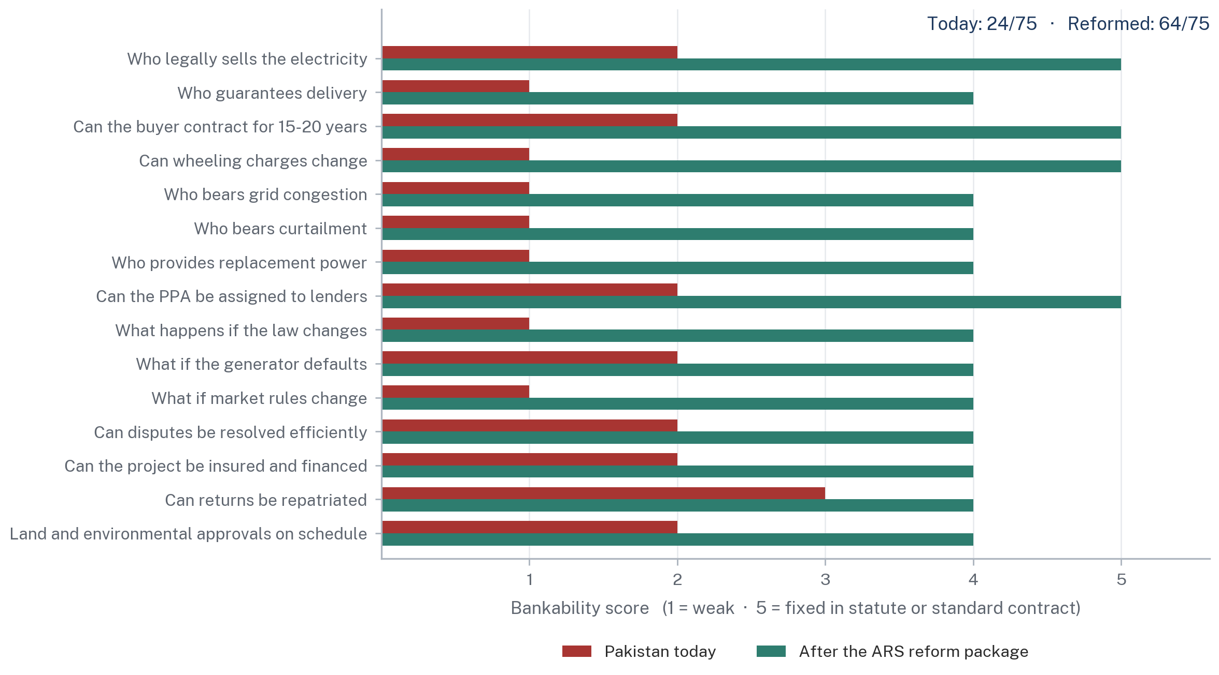
Source: ARS assessment. Each of the 15 questions is scored 1 to 5, where 1 means there is no answer a project-finance lender would accept, 3 means an answer exists but rests on administrative discretion, and 5 means the answer is fixed in primary legislation or in a NEPRA-approved standard contract and cannot be changed unilaterally. Scores are analytical judgements applied consistently, not measurements.
Figure 27.
Pakistan scores 24 out of a possible 75 today. Under the reform package proposed in Section 10, the same fifteen questions score 64. The gap between those two numbers is the entire content of this report, and it is worth noting what the gap is not made of. It is not made of generation capacity, which Pakistan has in surplus. It is not made of hydrological resource, which Pakistan has in abundance. It is not made of demand, which exists globally in quantities that dwarf anything Pakistan could supply. It is made of legal instruments that cost nothing to draft and require political decision rather than capital.
The Hyperscaler Bankability Scorecard
Fifteen questions, the current Pakistani answer, and the answer after the ARS reform package
Question | The Pakistani answer today | Today | Reformed | Instrument that closes the gap
Who legally sells the electricity? | A generator may, if the Authority permits under s. 22 | 2 | 5 | New s. 22A
Who guarantees delivery? | Nobody. Dispatch is a system function under s. 14B(4) | 1 | 4 | ISMO market rules; standard PPA
Can the buyer contract for 15 to 20 years? | Nothing prevents it; nothing supports the price path | 2 | 5 | Long-term tariff methodology
Can wheeling charges change? | Yes, by administrative determination, without limit | 1 | 5 | Published binding methodology
Who bears grid congestion? | Undefined. The corridor is constrained and unallocated | 1 | 4 | Capacity register; curtailment ranking
Who bears curtailment? | Undefined. Ranking unpublished, no compensation regime | 1 | 4 | ISMO market rules
Who provides replacement power? | No such product exists in the Pakistani market | 1 | 4 | New licensed standby product
Can the PPA be assigned to lenders? | Only with the Authority's approval under s. 27, case by case | 2 | 5 | Amended s. 27 pre-approval
What happens if the law changes? | No express protection. Recent record is adverse | 1 | 4 | Change-of-law clause in standard contracts
What if the generator defaults? | Fall back to grid tariff; no priced remedy | 2 | 4 | Replacement power obligation
What if market rules change? | No grandfathering of registered transactions | 1 | 4 | Transitional protection in market rules
Can disputes be resolved efficiently? | NEPRA, then Appellate Tribunal, then High Court. Years | 2 | 4 | Fast-track network access procedure
Can the project be insured and financed? | Possible with sovereign or political risk cover at a cost | 2 | 4 | The package as a whole
Can returns be repatriated? | Yes under the existing regime, but not confirmed for this case | 3 | 4 | State Bank circular
Land and environmental approvals on schedule? | No statutory timeline; provincial competence; AJK/GB unclear | 2 | 4 | Zone designation and single window
TOTAL |  | 24 / 75 | 64 / 75
Source: ARS assessment applying the methodology stated above. Not a measurement and not investment advice. The reformed column assumes full implementation of the package in Section 10.
Table 12.
Reform Would Move Pakistan Past the Regional Benchmark on Legal Right and Lender Security
ARS composite bankability assessment, scored 1 to 5
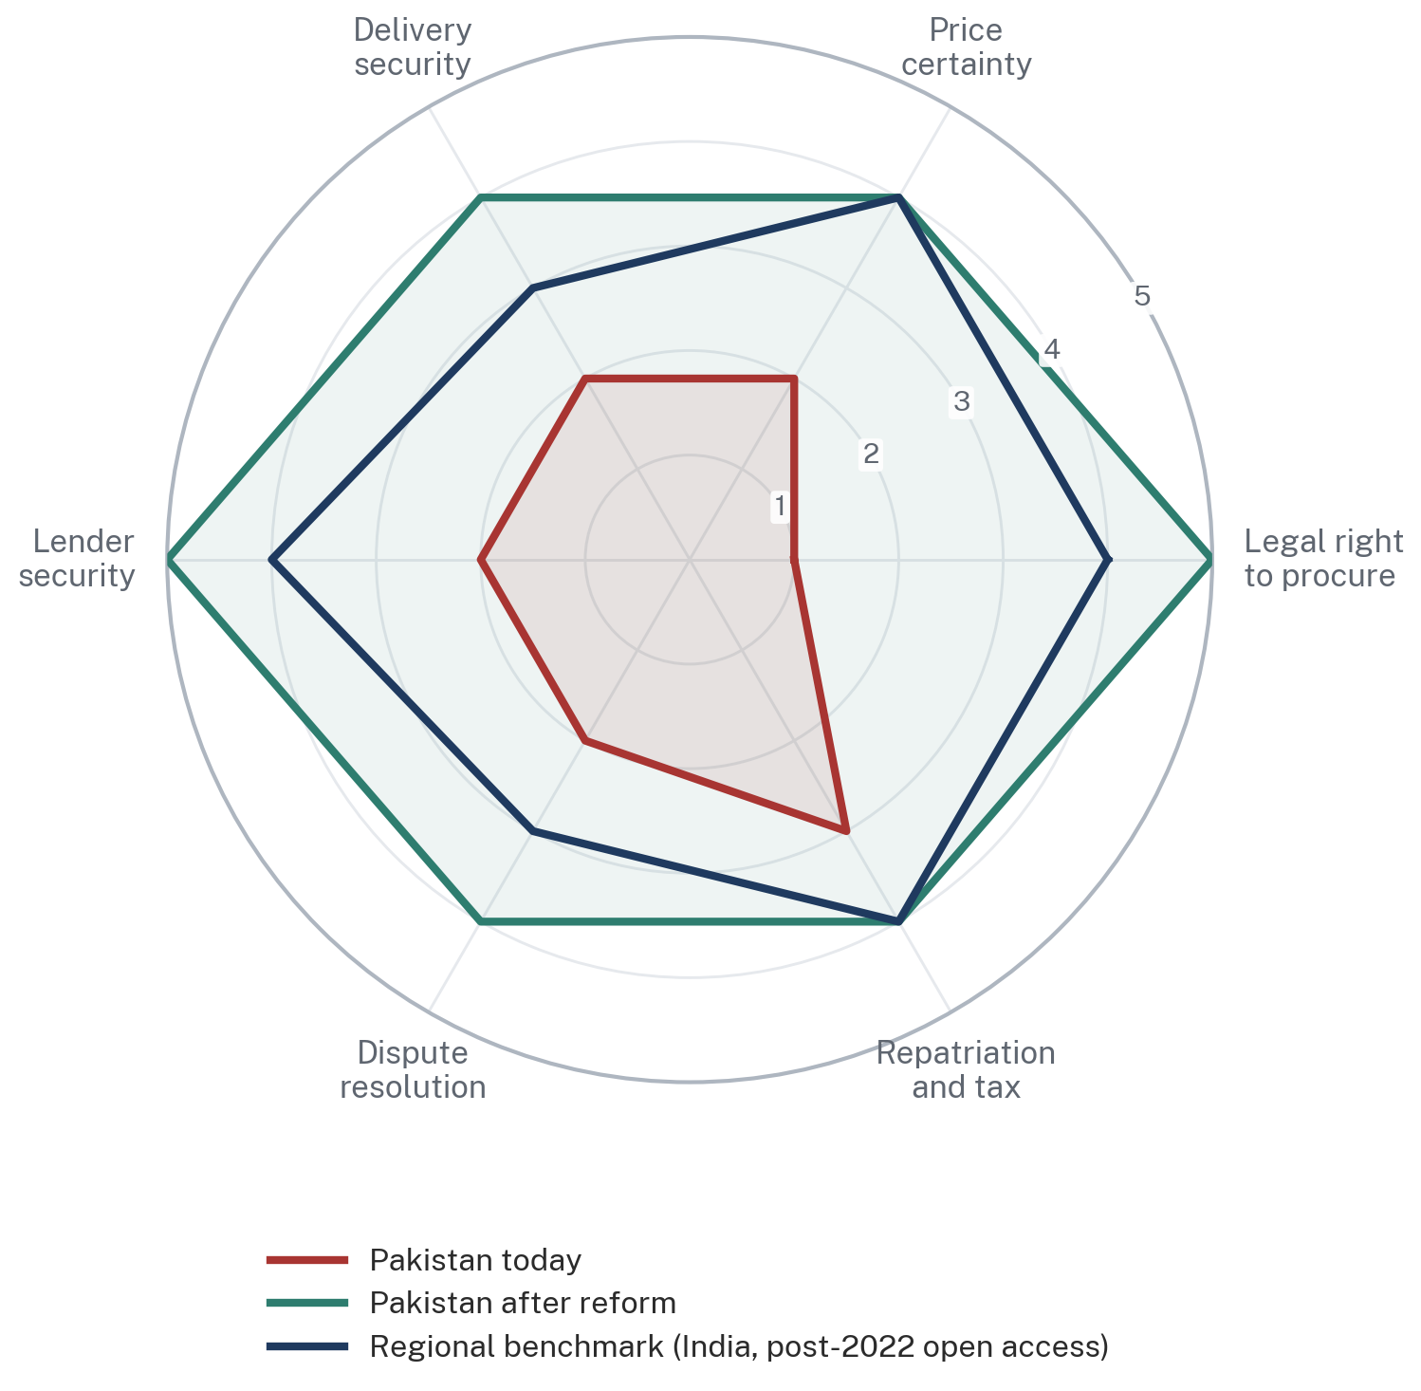
Source: ARS assessment. The India benchmark reflects the Electricity Act, 2003 section 42 open-access regime as amended by the Green Energy Open Access Rules, 2022, including the 15-day deemed-approval mechanism, and does not imply that Indian implementation is uniform across states.
Figure 28.
The regional comparison in the preceding figure should be read carefully. It does not assert that India is easy. Indian open access varies materially between states, several states have declined to adopt the central 100 kW threshold, distribution companies have resisted the fifteen-day timeline, and additional state-level charges have been imposed [43]. What the comparison establishes is that a neighbouring jurisdiction with a comparable institutional inheritance made the structural move from discretion to time-bound entitlement, and that the move is therefore neither unprecedented nor beyond the administrative capacity of a South Asian electricity regulator.

13. Contracts That Make the Model Bankable
Statute confers the right. Regulation sets the terms. Contracts allocate the risk, and it is the contracts that a lender actually reads. Six agreements must interlock.
Six Agreements Must Interlock Before a Single Rack Is Installed
Contract architecture for a hyperscale data centre in Pakistan
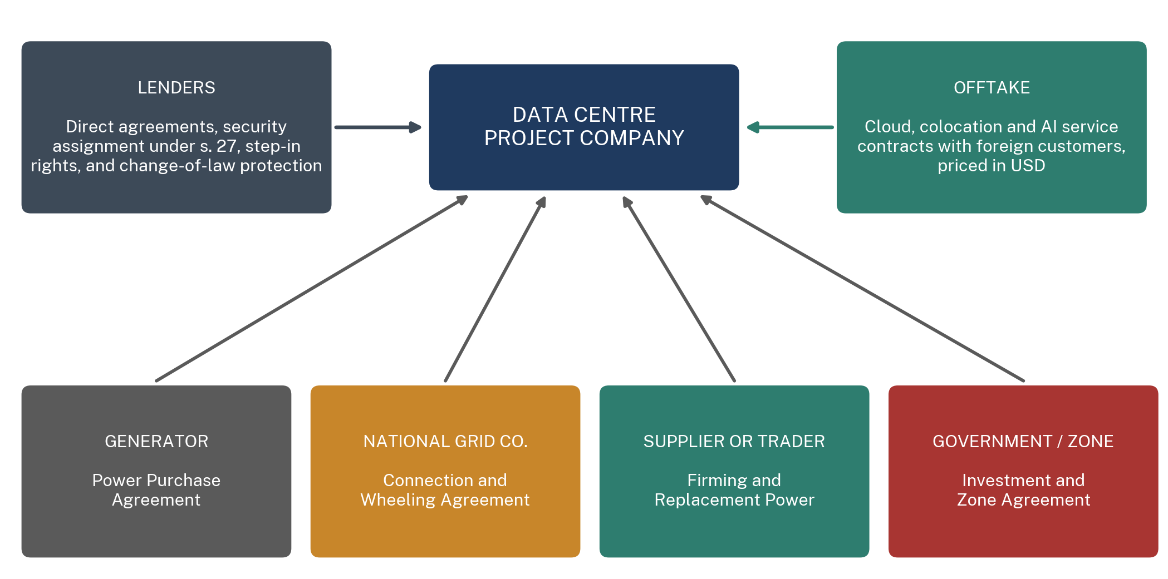
Source: ARS analysis. None of the four upper agreements currently exists in Pakistan as a NEPRA-approved standard form. Section 13 of this report sets out the clauses each would need to contain.
Figure 29.
Required Contractual Architecture and the Clauses Each Agreement Must Contain
Six agreements, their parties, and the provisions without which the transaction is not financeable
Agreement | Parties | Essential clauses | Status in Pakistan today
Power Purchase Agreement | Generator and project company | Term of 15-25 years; price and indexation formula; availability guarantee with liquidated damages; scheduled and unscheduled outage regime; change-of-law; assignment to lenders; termination and buyout | No approved standard form for bilateral consumer sale
Wheeling Agreement | Project company and network licensees | Use-of-system charge fixed or formula-indexed for the term; capacity reservation; curtailment ranking and compensation; metering and settlement on interval basis; force majeure; dispute fast-track | No approved standard form; charges administratively revisable
Connection Agreement | Project company and National Grid Company | Connection date with liquidated damages for delay; two independent feeds from separate grid stations; N+1 transformation; voltage and frequency standards; maintenance coordination; security of supply standard | No approved standard form; no binding connection timeline
Supply or Trading Agreement | Project company and licensed supplier or trader | Standby capacity commitment; replacement power obligation at a determined price; balancing and imbalance settlement; credit support; step-down on generator default | Product does not exist; requires the new NEPRA instrument
Government or Zone Agreement | Project company and Federal Government or zone authority | Land tenure and access; single-window permitting with timelines; environmental clearance; fiscal treatment; repatriation confirmation; stabilisation of the applicable regime; jurisdiction and governing law | No standard instrument for compute-specific investment
Backup and Firming Agreement | Project company and firming provider | Committed firm capacity in MW; response time; seasonal profile matched to the hydro contract; availability payment structure; testing regime | Does not exist as a market product
Source: ARS analysis. Not a legal opinion and not a substitute for transaction counsel. None of the four network-facing agreements currently exists in Pakistan as a NEPRA-approved standard form.
Table 13.
13.1 The Risk Allocation That Makes It Work
Underlying the six agreements is a single allocation principle: each risk should sit with the party best able to control it, and where no party can control it, it should be priced explicitly rather than left to fall where it lands. Hydrological risk sits with the generator, which selects and operates the plant. Network availability and congestion risk sit with the network company, which builds and operates the network. Demand risk sits with the data centre, which sells the compute. Change-of-law risk sits with the state, which makes the law. Fuel and commodity price risk sits with the generator, subject to indexation. Currency risk on the electricity leg sits with the consumer, whose revenues are in dollars and whose costs are in rupees, which is one of the few places where Pakistan's position is structurally favourable.
That last point is worth drawing out because it is a genuine and underappreciated advantage. A hyperscale data centre in Pakistan earns dollars and pays a substantial part of its costs in rupees. Rupee depreciation, which damages almost every other participant in the Pakistani power sector, improves this project's economics. In a country whose electricity problem is at root a foreign-currency problem, an investor whose revenue is denominated in foreign currency is not simply another consumer. It is a source of the currency the system needs.

PART VI
MAKING THE DATA CENTRES A REALITY
14. Where Should Pakistan Build?
Siting is where the energy analysis, the network analysis and the legal analysis converge, and where the trade-offs become concrete. This section scores six candidate locations against ten criteria.
No Pakistani Site Scores Well on Both Power and Connectivity, Which Is the Central Siting Trade-Off
ARS site-selection scorecard, each criterion scored 1 (weak) to 5 (strong), with the total out of 50
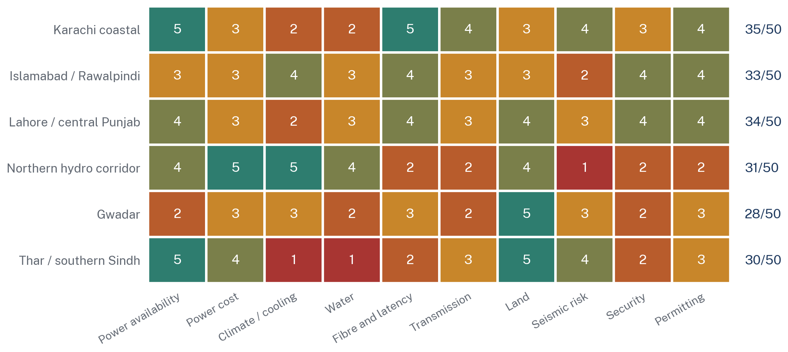
Source: ARS assessment. Scores are analytical judgements applied consistently across sites on a common scale, not measurements. Power cost reflects proximity to low-marginal-cost generation; transmission reflects the capability of the evacuation corridor serving the site; permitting reflects the clarity of the applicable land, environmental and jurisdictional regime.
Figure 30.
14.1 The Central Trade-Off
The scorecard states the problem in one line: no Pakistani location scores well on both power and connectivity. Every submarine cable lands at Karachi. Every large hydro asset sits in the north. The cheap thermal generation sits in the south but cannot be evacuated northward at scale because of the corridor constraint described in Section 2.6. A site optimised for power cost is badly placed for latency and backhaul diversity; a site optimised for connectivity pays the full grid tariff and sits in the country's hottest, most humid cooling environment.
14.2 The Northern Hydro-Linked Corridor
Highest score on power cost and climate, lowest on fibre, transmission, seismic risk, security and permitting. Free cooling for a substantially larger part of the year materially reduces PUE and therefore the electricity bill for a given IT load. Proximity to generation avoids the north-south corridor. Land is inexpensive.
Against that: no diverse fibre without a major backhaul investment from Karachi; the collision zone between the Indian and Eurasian plates; the constitutional position of Azad Jammu and Kashmir and Gilgit-Baltistan described in Section 9.8; and the hydro firmness problem set out in Section 4. The northern corridor is where Pakistan should build in the 2030s, and it is not where Pakistan should build first.
14.3 Karachi
Highest score on fibre and power availability, weakest on cooling and water. Every international system lands here, K-Electric operates a separate and comparatively better-performing distribution network, industrial land and skilled labour are available, and the Transworld Tier III facility already demonstrates that the basic proposition works at small scale [36]. Coastal humidity raises cooling load and therefore PUE, and water for evaporative cooling is scarce in a city with a chronic municipal supply problem, which pushes the design toward closed-loop or air-cooled systems and raises electricity consumption further.
14.4 Islamabad and Rawalpindi
The balanced option and, on the ARS assessment, the right location for a first demonstration project. Adequate fibre, adequate power, a moderate climate by Pakistani standards, proximity to the federal institutions whose cooperation the project requires, an existing technology-sector presence, and a jurisdictional position that raises none of the questions the northern corridor raises. It scores highest on nothing and lowest on nothing, which for a first project of this kind is the correct profile.
14.5 Lahore, Gwadar and Southern Sindh
Lahore offers good connectivity and a large customer base but sits at the receiving end of the constrained corridor and has severe summer conditions. Gwadar has land and strategic attention but the weakest power and transmission position of the six, and its security profile is a material constraint on foreign investment of this class. Southern Sindh scores highest on raw power availability, sitting adjacent to the Thar coal complex and the southern wind corridor, and lowest on climate, water and fibre. It is a candidate for a power-anchored campus if, and only if, the fibre backhaul is solved.
14.6 The ARS Siting Recommendation
Build the first demonstration project at 50 MW to 100 MW in the Islamabad and Rawalpindi corridor, where every constraint is moderate and none is disqualifying, and use it to test the legal instruments proposed in Section 11 in a real transaction with a real lender. Develop Karachi in parallel as the connectivity-anchored location for latency-sensitive workloads, taking advantage of the three cable systems added since early 2025. Treat the northern hydro corridor as the target for the 2030s, conditional on the ADB-financed northern evacuation reinforcement [22], on resolution of the jurisdictional questions, and on a serious answer to fibre diversity. Do not begin in the north because the electricity is cheap there. The electricity is cheap there because nothing else is.

15. What Could the Opportunity Be Worth?
This section sets out scenario arithmetic. It is not a forecast and it should not be quoted as one. Every figure below is derived from stated assumptions that are themselves stated, and a reader who disagrees with an assumption can recompute the result.
A 300 MW Campus Implies Roughly USD 3 Billion of Construction and USD 273 Million a Year of Electricity Purchases
Illustrative capital and electricity scenarios by campus size, USD billion
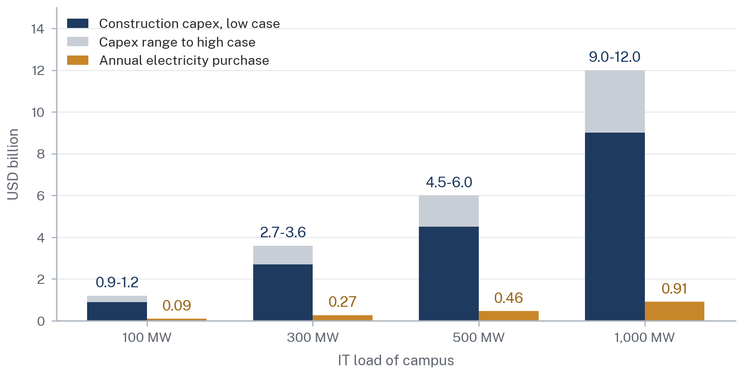
Source: ARS illustrative scenario, not a forecast. Capex assumes USD 9 million to USD 12 million per MW of IT capacity, a planning band ARS applies for greenfield hyperscale build; actual costs vary widely with design, cooling technology and site. Annual electricity purchase assumes PUE 1.30, 8,760 hours and a delivered price of 8 US cents per kWh.
Figure 31.
Scenario Arithmetic by Campus Size
Observed data, ARS-derived calculations and illustrative scenarios, distinguished by column
IT load | Annual energy | Share of FY25 generation | Construction capex (illustrative) | Annual electricity purchase | Direct jobs (order of magnitude)
100 MW | 1.14 TWh | 0.84% | USD 0.9-1.2 bn | USD 91 m (Rs 25 bn) | Low hundreds
300 MW | 3.42 TWh | 2.53% | USD 2.7-3.6 bn | USD 273 m (Rs 76 bn) | Several hundred
500 MW | 5.69 TWh | 4.22% | USD 4.5-6.0 bn | USD 455 m (Rs 127 bn) | Under one thousand
1,000 MW | 11.39 TWh | 8.43% | USD 9.0-12.0 bn | USD 911 m (Rs 255 bn) | Around one thousand
2,000 MW | 22.78 TWh | 16.86% | USD 18.0-24.0 bn | USD 1.82 bn (Rs 510 bn) | Low thousands
Source: ARS calculation and illustrative scenario. Facility load at PUE 1.30; annual energy at 8,760 hours. Capex band of USD 9-12 million per MW of IT capacity is an ARS planning assumption for greenfield hyperscale build, not an observed Pakistani cost. Electricity purchase at 8 US cents per kWh delivered. Rupee conversion at 280 PKR/USD; rupee figures therefore differ from Table 7, which applies a Rs 25 per kWh delivered price. None of these figures is a forecast.
Table 14.
15.1 Power-Cost Sensitivity
The sensitivity shown at Figure 22 is the number that decides the investment. On a 300 MW campus, each additional US cent per kWh in the delivered price costs approximately USD 34 million a year, or roughly USD 510 million over a fifteen-year term. The difference between supply at the notified industrial tariff and supply under a well-structured bilateral contract is plausibly four to six cents. On a 300 MW campus that difference is worth USD 136 million to USD 205 million a year, which exceeds the annual electricity bill of most Pakistani industrial sectors and is larger than the entire capital cost of a 100 MW facility over the term.
This is why the legal reform matters more than any subsidy. The state does not need to pay a hyperscaler to come to Pakistan. It needs to allow a hyperscaler to buy electricity at a price that reflects the cost of producing it, which is a legal question, not a fiscal one.
15.2 What This Is Worth to the Electricity Sector
A 1,000 MW IT load would purchase 11.39 TWh a year. Against FY 2024-25 grid sales of approximately 111 TWh, that is roughly a 10% increase in volume, from a single creditworthy customer paying in a currency the country needs, with a load shape that requires no new peaking capacity.
The effect on the fixed-cost recovery problem is the point. Capacity charges of Rs 2.03 trillion to Rs 2.16 trillion are currently spread across roughly 111 TWh of sales. Spreading the same charge across 122 TWh reduces the capacity component of the average tariff by approximately 9.3% without any reduction in the charge itself and without any subsidy. On a capacity component of Rs 16.04 to Rs 16.45 per unit, that is a reduction of roughly Rs 1.49 to Rs 1.53 per unit available to every other consumer in the country. That, and not the export receipts, is the strongest domestic political argument for this policy.
WHAT ARS DOES NOT CLAIM
This report contains no estimate of digital-service export revenue from data-centre capacity, no multiplier analysis, and no employment forecast beyond an order of magnitude. Revenue depends on commercial terms with customers who do not yet exist and on a global compute market whose pricing is volatile. Data centres are capital-intensive and employment-light; anyone presenting large direct job numbers for a hyperscale campus is describing the construction phase, not the operating phase. The honest case for this policy rests on foreign-exchange earnings and on the fixed-cost recovery arithmetic above, not on employment.

16. A Roadmap from Law to Data Centre
The sequencing matters as much as the content, for one reason: the legal work must be complete before construction begins, not alongside it. An investor will not commit capital against a statutory amendment that is expected. It will commit against one that has been enacted.
The Legal Work Must Finish Before the Concrete Starts, Not Alongside It
ARS implementation roadmap, from legislative amendment to hyperscale operation, months from commencement
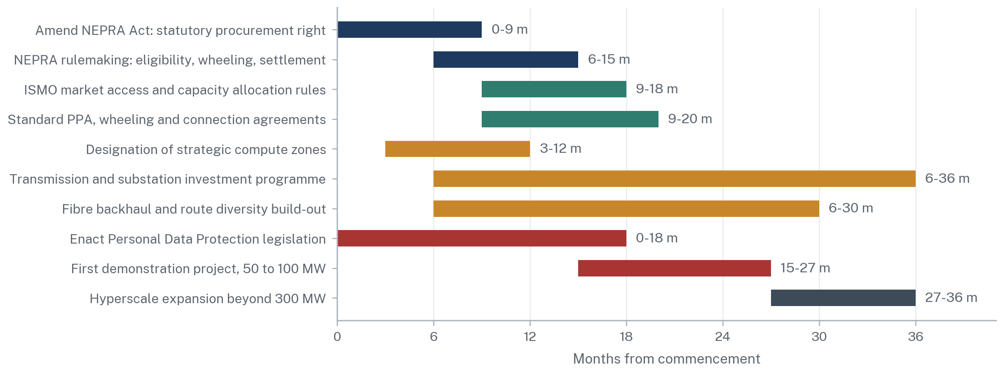
Source: ARS policy proposal. Sequencing is indicative and assumes political commitment at the outset. The critical path runs through the statutory amendment and the standard-contract package; transmission and fibre investment run in parallel but do not gate the first demonstration project.
Figure 32.
16.1 Months 0 to 6
Introduce the amendment bill to the NEPRA Act, 1997 covering the new section 22A, the amendment to section 14C(2) and the amendment to section 27. In parallel, and requiring no legislation, NEPRA begins work on the long-term tariff and use-of-system methodology and on the replacement wheeling regulations. The Federal Government begins the process of designating strategic compute zones and secures provincial concurrence. The State Bank issues the repatriation circular. Consolidation of the market and system operator licences into ISMO proceeds.
16.2 Months 6 to 18
Enactment of the NEPRA Act amendments and of the Personal Data Protection legislation. NEPRA notifies the eligibility regulations, the tariff methodology and the replacement wheeling regulations, and begins consultation on the standby and replacement power product. ISMO publishes the market access procedure, the transmission capacity register and the curtailment ranking. The grid company publishes node capacity and the connection procedure. Zone designation is notified. The inter-governmental protocol on land, water, environment and jurisdiction is agreed through the Council of Common Interests.
16.3 Months 18 to 36
NEPRA approves the standard PPA, wheeling agreement and connection agreement. The first demonstration project, at 50 MW to 100 MW in the Islamabad and Rawalpindi corridor, reaches financial close using those standard instruments and a real project-finance structure, which is the only genuine test of whether the reform worked. Transmission reinforcement continues, including HVDC restoration and the ADB-financed northern evacuation programme. Fibre backhaul diversity is procured. Hyperscale expansion beyond 300 MW begins only once the demonstration project has been financed on the new instruments without a sovereign guarantee.
THE TEST THAT MATTERS
The reform has succeeded when an international lender finances a Pakistani data-centre power contract without a sovereign guarantee. Until that happens, every other indicator, including announcements, memoranda of understanding and allocated megawatts, measures intention rather than achievement.

17. Risks, Limits and the Possibility of New Stranded Assets
The Two Risks That Would Kill the Proposition Are Regulatory Reversal and the Transmission Corridor
ARS risk assessment; bubble area is proportional to likelihood multiplied by impact
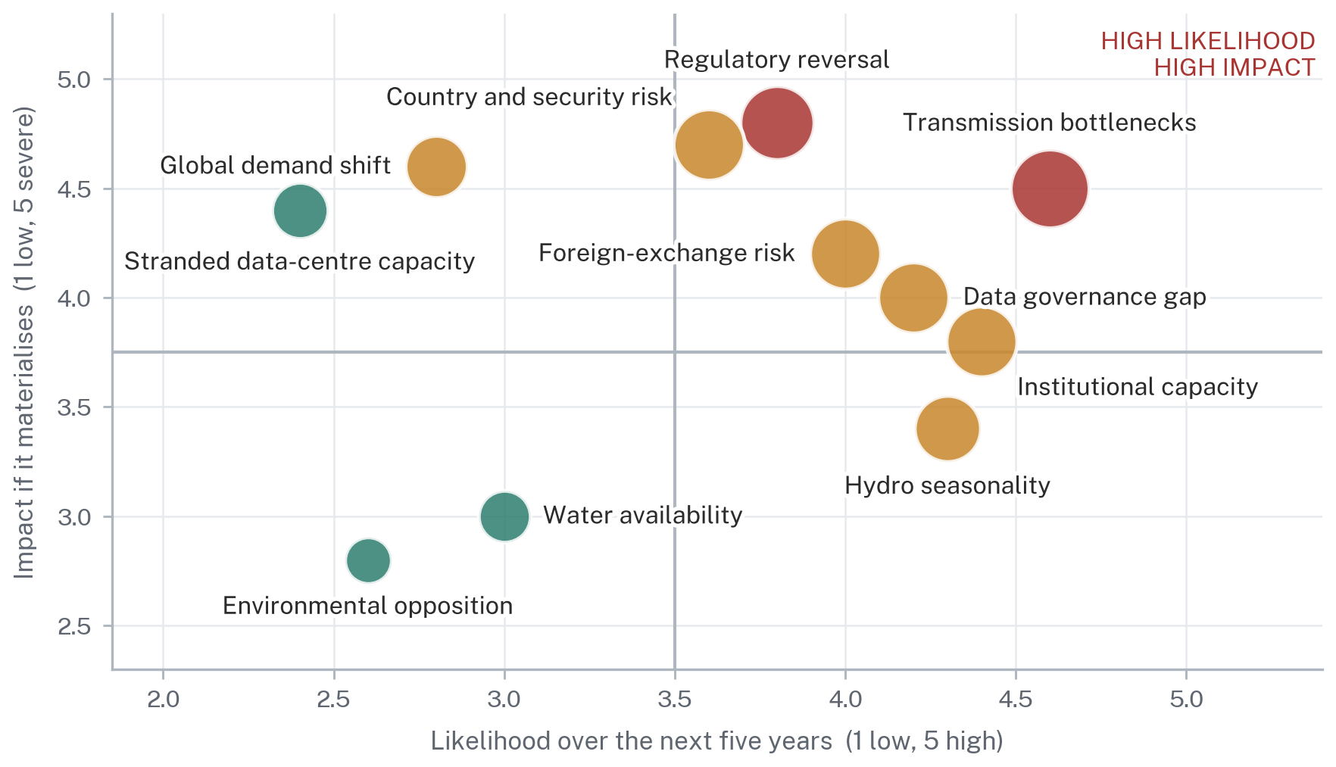
Source: ARS assessment. Likelihood and impact are analytical judgements applied consistently across risks on a common five-point scale, not probabilities. Stranded data-centre capacity is the risk that Pakistan builds compute capacity it cannot sell, replacing one stranded-asset problem with another.
Figure 33.
17.1 The Two Risks That Would Defeat the Proposition
Regulatory reversal ranks highest on impact because the entire proposition is a bet on the durability of a legal commitment. Pakistan's recent record supplies the reason for concern: IPP contracts covering 2,829 MW terminated or renegotiated in a single year, roughly Rs 260 billion of circular debt reduction attributed to renegotiation, and a new statutory levy imposed on an existing category of investment with a legislated escalation to 20% [3][12][35]. Each measure has a defence. Their cumulative signal to a prospective investor is that Pakistani contractual commitments are revisable when fiscal pressure requires it. The only answer is to place the commitments that matter in primary legislation and to accept the constraint that entails.
Transmission bottlenecks rank highest on likelihood because they are already occurring. The HVDC link operating at roughly 35% of design rating, a northward HVAC ceiling of approximately 4,500 MW and 1,845 MW of southern generation constrained off daily are present-tense facts, not projections [7]. No legal instrument relieves them, and the reinforcement programmes are multi-year.
17.2 The Remaining Risks
Risk Register
Category, mechanism, mitigation and the party best placed to bear it
Risk | How it would materialise | Mitigation | Best borne by
Regulatory reversal | Amendment, levy or renegotiation alters the economics after financial close | Primary legislation; change-of-law clauses; stabilisation in the zone agreement | The state
Transmission bottleneck | Contracted energy cannot be delivered to site; curtailment | Site selection near generation; capacity register; corridor reinforcement | Network company
Institutional capacity | NEPRA, ISMO and the grid company cannot execute the programme on schedule | Sequenced roadmap; technical assistance; a single accountable programme office | The state
Hydro seasonality | Winter output falls below contracted volume | Firming and replacement power contracts; hydro as energy not capacity | Generator and firming provider
Foreign-exchange risk | Rupee movement alters the rupee cost of dollar-indexed tariff components | Partly a natural hedge: the investor earns dollars | Shared, and structurally favourable
Country and security risk | Security incident or macroeconomic instability affects operations or insurance | Political risk insurance; site selection; phased commitment | Investor and insurers
Water availability | Cooling water unavailable or politically contested | Closed-loop or air-cooled design; disclose the trade-off early | Investor, by design choice
Environmental opposition | Assessment or public hearing delays or blocks the project | Pre-cleared zones with completed assessment | The state, through zone designation
Data governance gap | No enacted data protection statute deters both operators and customers | Enact the pending Bill; publish a cross-border transfer position | Parliament
Global demand shift | AI compute demand slows or capacity moves to cheaper markets | Phased build; contract capacity before constructing it | Investor
Stranded compute capacity | Pakistan builds capacity it cannot sell | Anchor tenant commitments before construction; build in phases | Investor and the state jointly
Source: ARS assessment. Likelihood and impact ratings correspond to the positions plotted at Figure 33 and are analytical judgements applied on a common scale, not probabilities.
Table 15.
17.3 Could Pakistan Solve One Stranded-Asset Problem Only to Create Another?
This question deserves a direct answer because it is the strongest objection to everything this report proposes, and because Pakistan has made precisely this mistake before.
The parallel is exact enough to be uncomfortable. In the 1990s and 2000s Pakistan built generation capacity against a demand forecast, guaranteed the revenue, and discovered that the demand did not arrive. The result is the capacity charge described in Part I. A state that now guarantees offtake, land, tariff concessions or minimum revenue to data-centre developers against a forecast of global compute demand would be running the same experiment with different equipment.
Three features of the proposal in this report are designed to prevent that, and they should be treated as conditions rather than as commentary.
The first is that the state guarantees nothing. The reform package in Section 10 contains no offtake guarantee, no minimum revenue undertaking, no capacity payment and no sovereign wrap. It confers rights and removes discretion. If the compute market softens, the investor bears the loss, which is the correct allocation because the investor selects the market.
The second is that the load is contracted before the plant is built rather than after. The stranded-capacity problem in Pakistani generation arose because plant was contracted against forecast demand. A data centre that signs anchor tenant commitments before construction is contracting against actual demand. The roadmap in Section 16 places the demonstration project after the legal instruments precisely so that this discipline is tested at small scale.
The third is that the electricity contracts must not create new capacity obligations. This is the condition stated at Section 2.7 and it bears repeating as a risk control: if serving a data centre requires new generation to be contracted on capacity-payment terms, Pakistan has repeated the original error at a new address. The load must be served from existing available capacity, and the reform should be drafted so that a registered strategic large load cannot be used to justify new take-or-pay generation.
Subject to those three conditions, the answer is that the risk is real but is materially lower than in the generation case, because the party bearing it is a private investor selecting into a global market rather than a public utility responding to a national forecast. Without those three conditions, the answer is that Pakistan would be building the same problem again, and this report would not support it.

Conclusion
Pakistan does not need to invent a data-centre electricity market from scratch. It needs to complete, clarify and operationalise the competitive electricity architecture it has already begun to build.
The components are in place and have been for some years. Sections 23A to 23H of the NEPRA Act create market operator, trader, supplier and system operator licences. Section 22 contemplates sale to bulk power consumers. Section 14C confers a right of open access. The Wheeling Regulations of 2016 permit nationwide bilateral sale above 1 MW. The Competitive Trading Bilateral Contract Market was launched in January 2026 and a first competitive auction of approximately 800 MW is scheduled for September 2026. Wheeling charges have fallen from above Rs 22 per unit to below Rs 9 per unit. Installed capacity has been rationalised from 45,888 MW to 41,121 MW. This is a country that has been doing the work.
What it has not done is convert that work into something an international lender can take security over. Section 22 says the Authority may permit. Section 14C(2) says the right exists subject to a determination by the counterparty. The wheeling charge falls and rises administratively. There is no standard contract, no published curtailment ranking, no replacement power product, no long-term tariff methodology and no pre-approved assignment. Pakistan has built a permission architecture where a rights architecture is required, and permissions cannot be financed.
The division of labour that would fix this is straightforward and can be stated in seven lines.
Parliament creates the legal right, through the new section 22A, the amendment to section 14C(2), the amendment to section 27 and the completion of the Personal Data Protection legislation. NEPRA creates the rules, through eligibility regulations, a binding long-term tariff and use-of-system methodology, replacement wheeling regulations, a standby and replacement power product and approved standard contracts. ISMO operates the market, publishing access procedures, a transmission capacity register, a curtailment ranking with defined compensation, and settlement rules capable of matching a flat load to a seasonal generator. The grid makes the right physically deliverable, through HVDC restoration, northern evacuation reinforcement, published node capacity and binding connection timelines. Contracts make it bankable, through six interlocking agreements whose risk allocation places each exposure with the party best able to control it. Government makes the sites investable, through zone designation, single-window permitting, a cross-border data transfer position, a State Bank repatriation confirmation and an inter-governmental protocol resolving land, water, environmental and jurisdictional questions. And data centres turn electricity into digital exports, converting a fixed charge that is currently a pure liability into revenue denominated in the currency the country most needs.
The scale of what is at stake justifies the effort. A 1,000 MW campus would purchase 11.39 TWh a year, roughly a tenth of current grid sales, from a single creditworthy customer paying in dollars, with a load shape requiring no new peaking plant. Spreading the existing capacity charge across that additional volume would reduce the capacity component of the tariff for every other consumer in Pakistan by roughly Rs 1.50 per unit, with no subsidy and no new generation. That is a larger and more durable benefit than anything the retirement of further plant can deliver.
None of this is guaranteed, and this report has been careful not to present it as though it were. The hydro is seasonal and one major station will be out of service until 2028. The corridor is constrained and 1,845 MW of southern generation is presently constrained off daily. Every submarine cable lands at a single city. The data protection statute is not enacted. The recent record on contractual durability is adverse. Any of these could defeat the proposition on its own.
But the binding constraint is none of them. On the ARS bankability assessment, Pakistan scores 24 out of 75 on the questions a hyperscaler's lenders actually ask, and the reform package set out in this report would take it to 64. What separates those two numbers is not generation capacity, hydrology, geography or global demand. It is a set of legal instruments that cost nothing to draft and require a political decision rather than capital. Pakistan is currently paying more than two trillion rupees a year for the availability of plant it does not use, and declining to make the legal changes that would allow someone to use it.
That is the choice, and it is not a technical one.

Annex A: Statutory and Regulatory Provisions Referenced
The consolidated legal matrix appears at Table 10 in Section 8.7 and is not repeated here. This annex records the principal instruments cited in the report, in the form in which they were consulted.
Regulation of Generation, Transmission and Distribution of Electric Power Act, 1997 (Act XL of 1997), as amended, principally by the Regulation of Generation, Transmission and Distribution of Electric Power (Amendment) Act, 2018 (Act XII of 2018). Sections referenced: 2(ii), 2(iia), 7(4), 7(5), 12G, 14B, 14C, 14D, 20, 21(2)(a), 22, 23A to 23H, 27, 31, 32, 45, 46, 47.
NEPRA (Wheeling of Electric Power) Regulations, 2016, notified vide SRO 549(I)/2016. Off the Grid (Captive Power Plants) Levy Act, 2025 (Act XIV of 2025), sections 2(e), 3, 4, 5, 6 and 9. Oil and Gas Regulatory Authority Ordinance, 2002, sections 8 and 43B, as referenced in Act XIV of 2025. Public Finance Management Act, 2019, as referenced in section 6 of Act XIV of 2025. Prevention of Electronic Crimes Act, 2016. Digital Nation Pakistan Act, 2025. Personal Data Protection Bill (pending). Framework Guidelines for Wheeling Auctions 2025. Competitive Trading Bilateral Contract Market design as approved by NEPRA. Water Apportionment Accord, 1991.
Comparator jurisdiction: Electricity Act, 2003 (India), sections 42, 49, 176 and 181; Electricity (Promoting Renewable Energy Through Green Energy Open Access) Rules, 2022 (India), notified 6 June 2022, together with the amendment rules of 2023.
Annex B: Definitions, Units and Conventions
Capacity is a rate, measured in megawatts (MW) or gigawatts (GW). Energy is a quantity, measured in megawatt-hours (MWh), gigawatt-hours (GWh) or terawatt-hours (TWh). One GW sustained for one hour is one GWh. One thousand GWh is one TWh. A billion units, the term used in WAPDA reporting, equals one TWh.
Installed capacity is the aggregate nameplate rating of all connected plant. Available capacity is the portion that can be dispatched at a given moment after outages, fuel constraints and hydrology. Dependable capacity is the capacity that can be relied upon under defined conditions and is generally lower than nameplate. Load factor is average load divided by peak load, or equivalently energy delivered divided by the energy that would be delivered at continuous full output. Capacity factor is the equivalent measure applied to a generating unit. Power usage effectiveness (PUE) is total facility electrical load divided by IT load; water usage effectiveness (WUE) is the corresponding water measure.
Capacity payment remunerates availability. Energy payment remunerates units delivered. Take-or-pay, in Pakistani PPA practice, describes an obligation to pay for declared availability rather than an obligation to take a specified volume. Wheeling is the transport of electricity over a network owned by a third party. Open access is the right to use that network on non-discriminatory terms. Use-of-system charges are the charges levied for that transport. Captive power is generation established primarily for the owner's own use. Trading, under sections 23C and 23D, is the licensed purchase and resale of electric power; supply, under sections 23E and 23F, is the licensed sale of electric power to consumers.
All rupee figures are Pakistani rupees unless otherwise stated. Financial years run from 1 July to 30 June and are stated as, for example, FY 2024-25. WAPDA generation figures are reported on a calendar-year basis and are identified as such. Where a figure is an ARS calculation from published data, the chart or table source note says so. Where a figure is an illustrative scenario, the chart or table source note says so. No figure in this report is presented as an empirical forecast. Where the report proposes statutory language, that language is identified as an ARS policy drafting proposal and is neither enacted legislation nor a legal opinion.
References
[1] NEPRA, State of the Industry Report 2025 (net generation series 2021-22 to 2024-25, as reported). See also "Affordable power", The News, June 2026. https://www.thenews.pk/magazine/money-matters/1421798-affordable-power
[2] Regulation of Generation, Transmission and Distribution of Electric Power Act, 1997 (Act XL of 1997), as amended, principally by Act XII of 2018. Ministry of Energy (Power Division) consolidated text. https://power.gov.pk/siteimage/policy/3-nepraact1997.pdf
[3]"NEPRA releases 2025 State of Industry and 2024-25 Annual Reports for federal review", Profit by Pakistan Today, 16 January 2026 (circular debt stock, recovery ratio, T&D losses). https://profit.pakistantoday.com.pk/2026/01/16/nepra-releases-2025-state-of-industry-and-2024-25-annual-reports-for-federal-review
[4]"Power sector mired in inefficiency: Nepra", The News, January 2026 (installed capacity, peak demand, plant retirements, PLAC, Guddu and Neelum-Jhelum performance). https://www.thenews.pk/print/1393452-power-sector-mired-in-inefficiency-nepra
[5] Renewables First, Pakistan Electricity Review 2026 (grid sales, consumer growth, thermal and hydel capacity movement in FY 2024-25). https://uploads.renewablesfirst.org/Pakistan%20Electricity%20Review%202026.pdf
[6] REN21, Global Status Report 2025, Pakistan snapshot (net-metered rooftop solar deployment and grid demand series). https://www.ren21.net/gsr-2025/snapshots/pk/
[7] Khalid Waleed, Sustainable Development Policy Institute, "Pakistan's Power Grid Development Status", presented at UNESCAP (dependable capacity, HVDC utilisation, constrained southern generation, duck-curve dispatch). https://www.unescap.org/sites/default/d8files/event-documents/Pakistan%27s%20grid%20Khalid%20Waleed,%20SDPI.pdf
[8]"Nepra determines power purchase price of Rs3,342.36 billion for FY2025-26", The Nation, 24 June 2025 (power purchase price determination and CPPA-G capacity charge scenarios). https://www.nation.com.pk/24-Jun-2025/nepra-determines-power-purchase-price-of-rs3-342-36-billion-for-fy2025-26
[9] Renewables First, Pakistan Electricity Review 2025 (capacity payment growth and generation mix). https://uploads.renewablesfirst.org/Pakistan_Electricity_Review_2025_89f0b613d6.pdf
[10] NEPRA, State of the Industry Report 2023 (Part Load Adjustment Charges, surplus take-or-pay capacity, capacity purchase price). https://nepra.org.pk/publications/State%20of%20Industry%20Reports/State%20of%20Industry%20Report%202023.pdf
[11]"The CTBCM launch", Business Recorder editorial, 2026 (initial trading tranche and movement in wheeling charges). https://www.brecorder.com/news/40409581/the-ctbcm-launch
[12] Off the Grid (Captive Power Plants) Levy Act, 2025 (Act XIV of 2025). The Pakistan Code. https://pakistancode.gov.pk/english/UY2FqaJw1-apaUY2Fqa-apaUY2Npa5tlaA==-sg-jjjjjjjjjjjjj
[13]"Captive power gas: Govt extends monthly levy to third-party suppliers", Business Recorder, January 2026 (sections 2(e), 3, 4 and 9 of Act XIV of 2025; escalation schedule). https://www.brecorder.com/news/amp/40400447
[14]"Pakistan raises gas levy on captive power plants", ARY News, April 2026 (levy raised to Rs 1,406 per MMBtu). https://arynews.tv/gas-levy-increased
[15] Water and Power Development Authority, "2025: WAPDA Generates 33.12 Billion Units Hydel Electricity", 30 December 2025 (station-by-station generation and average cost per unit). https://wapda.gov.pk/2025-wapda-generates-33-12-billion-units-hydel-electricity/
[16]"Neelum-Jhelum set to resume generation by March 2028", Dawn, 11 July 2026 (Senate Standing Committee on Water Resources briefing). https://www.dawn.com/news/2014508
[17]"Neelum-Jhelum revival delayed until 2028", The Express Tribune, 10 July 2026 (WAPDA evidence on tunnel failure and cost recovery). https://tribune.com.pk/story/2617645/neelum-jhelum-revival-delayed-until-2028
[18]"Govt allocates 2,000MW for Bitcoin mining and AI data centres", Dawn, 25 May 2025 (Finance Division statement; Africa-2 cable landing). https://www.dawn.com/news/1913238
[19]"Govt asks for Rs1.15/unit cut in electricity rate", Dawn, 30 June 2025 (national average tariff determination for FY 2025-26 and subsidy allocation). https://www.dawn.com/news/1921131
[20] NEPRA, Performance Evaluation Report: Transmission, FY 2024-25 (congestion and overloading of 500 kV and 220 kV assets; causes of project delay). https://nepra.org.pk/M&E/PER/Transmission/2025/PER%20Transmission%20FY%202024-25.pdf
[21]"Nepra allows wheeling of electricity regulations", The News, June 2016 (NEPRA Wheeling of Electric Power Regulations, 2016, notified vide SRO 549(I)/2016). https://www.thenews.com.pk/print/126759-Nepra-allows-wheeling-of-electricity-regulations
[22]"ADB approves $330m package to modernise Pakistan's power transmission network", The Express Tribune, 21 November 2025. https://tribune.com.pk/story/2578311/adb-approves-330m-loan-to-strengthen-pakistans-power-transmission-network
[23] World Bank, Pakistan power sector programme document (NTDC unbundling and transmission system operator creditworthiness). https://documents1.worldbank.org/curated/en/099070425094019580/pdf/P504536-834e23a9-f4d5-43e9-be47-4f9ebbbf0533.pdf
[24]"Pakistan imposes Rs238 per MMBtu levy on captive power plants to meet IMF condition", The Nation, 26 July 2025. https://www.nation.com.pk/26-Jul-2025/pakistan-imposes-rs238-per-mmbtu-levy-on-captive-power-plants-to-meet-imf-condition
[25]"800MW of electricity to be allocated in auction", The Express Tribune, 25 December 2025 (Framework Guidelines for Wheeling Auctions 2025; NEPRA to determine uniform wheeling charges; ISMO to run the auction). https://tribune.com.pk/story/2583839/guidelines-for-electricity-wheeling-approved
[26] NEPRA, Hydel Potential in Pakistan (provincial distribution of installed and prospective hydropower capacity). https://nepra.org.pk/Policies/Hydel%20Potential%20in%20Pakistan.pdf
[27]"Neelum-Jhelum project 'a failure of planning, execution'", Dawn, 3 September 2025 (Auditor-General of Pakistan report; PC-I revisions and cost overrun). https://www.dawn.com/news/1939326
[28]"Arbitration court upholds Pakistan's stance on Indus Waters Treaty", The Express Tribune, 17 May 2026 (Supplemental Award on maximum pondage, 15 May 2026; India's response). https://tribune.com.pk/story/2608624/arbitration-court-upholds-pakistans-stance-on-indus-waters-treaty
[29]"India says Indus Waters Treaty to remain in abeyance until Pakistan ends support to terrorism", News on AIR, 20 March 2026. https://www.newsonair.gov.in/india-says-indus-waters-treaty-to-remain-in-abeyance-until-pakistan-ends-support-to-terrorism
[30] Aceris Law, "Indus Waters Treaty Arbitration: Can India Put the Treaty in Abeyance?", May 2026 (procedural history and the abeyance question). https://www.acerislaw.com/indus-waters-treaty-arbitration-can-india-put-the-treaty-in-abeyance/
[31]"Pakistan's power sector reforms deliver Rs143bn savings", Mettis Global, 12 June 2026 (formal CTBCM launch in January 2026; first competitive auction of approximately 800 MW scheduled for September 2026). https://mettisglobal.news/Pakistans-power-sector-reforms-deliver-Rs143bn-savings-61088
[32]"Nepra backs ISMO for streamlining wholesale electricity market", Business Recorder, September 2024 (transfer of market operator and system operator licences under sections 23A, 23B, 23G and 23H). https://www.brecorder.com/news/40321311/nepra-backs-ismo-for-streamlining-wholesale-electricity-market
[33] International Energy Agency, Energy and AI, Executive Summary (global data-centre electricity consumption of 415 TWh in 2024 rising to around 945 TWh by 2030). https://www.iea.org/reports/energy-and-ai/executive-summary
[34] International Energy Agency, Key Questions on Energy and AI, Executive Summary (updated projection of 485 TWh in 2025 rising to 950 TWh in 2030). https://www.iea.org/reports/key-questions-on-energy-and-ai/executive-summary
[35]"PMO steps in after NEPRA raises concerns over circular debt, capacity payments in State of Industry Report", Profit by Pakistan Today, 12 February 2026 (Power Division response; decomposition of the circular debt reduction; surplus capacity of about 8,700 MW). https://profit.pakistantoday.com.pk/2026/02/12/pmo-steps-in-after-nepra-raises-concerns-over-circular-debt-capacity-payments-in-state-of-industry-report/
[36]"Pakistan Officially Connects to One of the World's Fastest Undersea Internet Cables", Silver Lining, December 2025 (Transworld Associates Tier III data centre in Karachi connected to the subsea systems). https://silverlining.org.pk/pakistan-officially-connects-to-one-of-the-worlds-fastest-undersea-internet-cables/
[37]"How Pakistan joins the world's fastest undersea internet network", Communications Today, 24 November 2025 (SEA-ME-WE 6 landing; initial 4 Tbps addition against a national total of 13.2 Tbps). https://www.communicationstoday.co.in/how-pakistan-joins-the-worlds-fastest-undersea-internet-network/
[38] Submarine Networks, "Transworld Associates to Land 2Africa Subsea Cable System in Pakistan" (2Africa Pearls branch; 45,000 km, 46 landing stations, 33 countries, up to 180 Tbps design capacity; existing Pakistani systems). https://www.submarinenetworks.com/en/systems/asia-europe-africa/2africa/transworld-associates-to-land-2africa-subsea-cable-system-in-pakistan
[39]"IT exports hit record USD4.6bn", Business Recorder, 18 July 2026 (State Bank of Pakistan data: FY 2025-26 IT and telecom export remittances of USD 4.6 bn against USD 3.814 bn in FY 2024-25). https://www.brecorder.com/news/40430631/it-exports-hit-record-usd46bn
[40]"Pakistan Targets $25.1 Billion ICT Export Revenue by 2030", TechJuice, August 2026 (ICT export series FY 2020-21 to FY 2025-26 and the official 2030 target). https://www.techjuice.pk/pakistan-targets-25-1-billion-ict-export-revenue-by-2030/
[41] Ministry of Power, Government of India, Press Information Bureau release on the Electricity (Promoting Renewable Energy Through Green Energy Open Access) Rules, 2022, notified 6 June 2022 under section 176 of the Electricity Act, 2003. https://www.pib.gov.in/PressReleaseIframePage.aspx?PRID=1842737
[42] Trilegal, "Electricity (Promoting Renewable Energy Through Green Energy Open Access) Rules, 2022" (reduction of the open-access threshold from 1 MW to 100 kW; 15-day deemed-approval timeline; central nodal agency and single-window registry). https://trilegal.com/knowledge_repository/electricity-promoting-renewable-energy-through-green-energy-open-access-rules-2022/
[43] Institute for Energy Economics and Financial Analysis, "Impact of Green Energy Open Access Rules, 2022" (uneven state adoption; procedural bottlenecks; additional state-level charges). On the jurisdictional point see the Karnataka High Court ruling on sections 42(2) and 181 of the Electricity Act, 2003. https://ieefa.org/resources/impact-green-energy-open-access-rules-2022
[44] Chambers and Partners, Data Protection & Privacy 2026: Pakistan (status of the Personal Data Protection Bill 2023; cross-border transfer and localisation provisions; absence of an enacted statute as at January 2026). https://practiceguides.chambers.com/practice-guides/data-protection-privacy-2026/pakistan
[45] Regulations.ai, Pakistan AI Regulation Overview, January 2026 (Digital Nation Pakistan Act 2025; National AI Policy 2025; Pakistan Digital Authority; status of the Personal Data Protection Bill and the Regulation of Artificial Intelligence Bill). https://regulations.ai/regulations/RAI-PK-NA-SUMMARY-2026
[46]"IT ministry unveils draft data governance policy", Dawn, 1 July 2026 (draft National Data Governance Policy 2026 released for consultation to 10 July 2026; alignment with a future Personal Data Protection law). https://www.dawn.com/news/2011804
[47]"Pakistan unveils National Data Governance Policy 2026 to transform digital governance", Business Recorder, 29 June 2026 (data sovereignty, cross-border transfer, privacy impact assessments and AI explainability requirements). https://www.brecorder.com/news/amp/40427660
About the Authors
Reza Khan
Reza Khan is a researcher with an M.Phil. in Government and Public Policy from the National Defence University, Islamabad, and an MBA in Finance. His professional experience spans business strategy, international trade, economics and organizational leadership, and he has taught Development Economics, Microeconomics and Supply Chain Management at the University of London Global MBA programme. His analytical interests include public policy, governance, strategic communication and the interaction between technology, institutions and society. He is Founder and Director of Ardent Research Solutions.
Waqas Aziz Qureshi, Barrister
Waqas Aziz Qureshi is a Barrister with extensive experience in dispute resolution, corporate advisory, regulatory matters and infrastructure-related legal practice. He been recognised by Chambers & Partners and The Legal 500 Asia as a leading individual in dispute resolution and corporate advisory. His practice encompasses complex commercial disputes, arbitration, regulatory and constitutional matters, corporate structuring, infrastructure projects and public sector engagements. He has also contributed to discussions on Pakistan’s investment and regulatory environment, including matters relating to CPEC, special economic zones and economic development.

